**Vitallink: A Model for Inclusive, AI-Integrated Triage Pods.**

Esther Ojo-Tirimi

Thompson Rivers University

HLTH 5500: Integrating IT in Healthcare

Dr. Anila Virani

May 26th, 2025.

**INTRODUCTION**

In recent years, the global healthcare sector has seen increasing pressure from demographic, economic, and structural changes (Kelen et al.,2021). These factors include an aging demographic, the increasing incidence of chronic illnesses, workforce deficiencies, and heightened patient expectations. Although technological advancements, especially in artificial intelligence (AI), digital health platforms, and automation, have created opportunities for innovation, these tools have not consistently resulted in equitable or efficient care for all demographics (World Health Organization [WHO], 2023; Topol, 2019). Notwithstanding the assurances of digital health, substantial portions of the society continue to face significant barriers to accessing timely, culturally appropriate and effective care.

Globally, more than 50% of the population lacks access to essential health care, a shortfall that extends beyond low- and middle-income nations (WHO, 2023). Despite the abundance of resources in countries such as Canada, the United Kingdom, and Australia, healthcare systems continue to suffer from disjointed pathways, prolonged emergency department (ED) wait times, and unaddressed needs, especially among immigrant, refugee, and rural communities (Canadian Institute for Health Information [CIHI], 2022; NHS England & NHS Improvement, 2020). These population frequently face systemic and structural barriers, including language discrepancies, unfamiliarity with healthcare procedures, and logistical issues like transportation difficulties or lack of access to family physicians (Urbach, 2018; Basu, Costa, & Jain, 2017)

Emergency departments represent a a notably prominent pressure point within the healthcare system (Kelen et al.,2021). In Canada, including British Columbia, patients often endure wait times of several hours for medical attention irrespective of whether their condition is critical or minor. Certain cases, such as low-grade infections, dizziness, or medication-related side effects, could be addressed within minutes via basic triage or virtual consultation. However, due to limited access to primary care, uncertainty about where to seek help and linguistic obstacles, individuals frequently resort to the emergency department (MacKichan et al., 2017; Whittaker et al., 2016). This practice leads to congestion, inadequate resource allocation, and heightened pressure on healthcare professionals.

Moreover, while digital health innovations like patient portals, mobile health applications, and tele-health platforms have gained traction, they mostly cater to the needs and capabilities of technologically literate, English-speaking, middle-class users (Kontos et al., 2014). Consequently, marginalized groups, including new immigrants, the elderly, individuals with little digital literacy, and non-English speakers, are unintentionally excluded from these solutions. A study by Clove (2023) highlights that the absence of culturally and linguistically suitable interfaces, digital health tools can worsen rather than bridge healthcare inequities.

The disparity between advanced technological innovation and low-access populations a critical systemic issue: the failure to embed technology into community-focused, inclusive structures. While governments and health authorities continue to invest in infrastructure, the absence of accessible, walk-in, multilingual, and technology-assisted triage services services sustains cycles of unaddressed health need. It is within this context that the VitalLink Pod is proposed—an innovative, modular, AI-enhanced health triage unit intended for deployment in high-density, underserved regions such as community centers, transit hubs, and immigrant neighborhoods.

The VitalLink Pod seeks to revolutionize how care is accessed at the grassroots level by integrating automated health screening, AI-enhanced communication, remote nursing consultations, and local care navigation into a cohesive experience. It is not intended as a replacement for hospitals or clinics but rather serves as a community triage entry point that connects patients to the broader health system. The subsequent sections will outline the conceptual foundation, technical features, literature background, and practical implications of this innovation.

**Description of the Novel Idea**

The VitalLink Pod is a modular, AI-augmented, community-oriented health access system intended to provide walk-in, language-inclusive triage services in underprivileged areas. It addresses the multifaceted obstacles faced by persons who, due to socioeconomic, language, or cultural factors, are unable to obtain timely and adequate healthcare. These obstacles are both logistical and systemic, indicative of a healthcare practice that has always favoured clinical efficiency over community accessibility.

The VitalLink Pod seeks to transform the patient entry point into the healthcare system. By offering immediate triage, automated vitals collection, remote nursing consultations, and culturally sensitive guidance, it functions as a community triage hub, helping patients navigate the system more effectively while offloading unnecessary demand from hospitals and emergency departments.

This approach utilises the principles of decentralised, patient-centered care and innovatively combines existing technologies. In contrast to conventional health kiosks, which typically function as independent systems, limited to information provision or vitals collection, the VitalLink Pod incorporates:

* AI-driven multilingual interaction
* Automated health data recording
* Real-time EHR integration
* Remote human health professional engagement
* On-site navigation by trained community health aides

Importantly, the system is specifically designed to operate without prior appointments, documentation, or technological proficiency. A patient simply walks in, interacts via voice or screen, and is guided through the experience by both technology and human support.

This design is especially relevant in ethnically diverse urban neighborhoods or rural areas with limited health resources. The Pod’s adaptability, in both language and placement, makes it a scalable solution for diverse settings, such as malls, transit centers, shelters, and community centers. Its core function is not only to assess but to connect, ensuring patients transition smoothly from symptom recognition to the appropriate care pathway.

**Technical Overview of the VitalLink Pod**

1. **Design and Layout**

Each VitalLink Pod is a compact structure, built with reinforced, soundproof materials for privacy. It comprises three core zones:

* Access-Controlled Entry Booth
* Smart Triage Pod with Smart Chair
* Exit and Follow-Up Zone

The pod is climate-controlled, well-lit, wheelchair-accessible, and adheres to privacy regulations such as Canada’s Personal Information Protection and Electronic Documents Act (PIPEDA).

1. **Multilingual AI Interface**

Upon entry, users are greeted by a multilingual AI system that facilitates both voice and screen interaction. The AI offers a selection of over 30 languages, with speech synthesis and recognition functionalities specifically tailored to healthcare communication. This interface is powered by Natural Language Processing (NLP) models trained specifically on healthcare vocabulary in multiple languages.

This ensures that patients can:

* Select or state their preferred language
* Comprehend their care process through spoken and written cues
* Ask clarifying questions and receive culturally contextualized responses

Research supports the significance of language-concordant care in enhancing patient trust and outcomes (Basu, Costa, & Jain, 2017; Squires, 2018).

1. **Identification and Record Generation**

Patients are prompted to scan their provincial health card (e.g., BC Services Card) to verify identity. For those without an existing profile, the system creates a new record, assigning a unique identifier that can be linked to provincial EHR systems. For returning patients, previous visits are recalled, ensuring continuity of care.

The scanner is designed to be intuitive, with backlighting and clear instructions for orientation. No manual typing is required, all data are extracted using Optical Character Recognition (OCR) and validated through encrypted links to government health databases.

1. **Vital Sign Collection: Smart Chair and Embedded Sensors**

After identity verification, patients are guided to a Smart Chair, which performs a complete set of vital sign assessments within two minutes. These include:

* Blood pressure (via automatic arm cuff)
* Body temperature (infrared scanner)
* Heart rate and rhythm (ECG pads in armrests)
* Blood oxygen saturation (via finger scan)
* Weight and BMI (embedded seat scale and floor sensors)

All devices are non-invasive, regularly calibrated, and Health Canada–approved. The data are instantly recorded and analyzed by the pod’s internal AI system, which flags abnormalities and prepares a pre-triage report.

This automated process minimizes the need for manual equipment or skilled on-site personnel, a feature aligned with the goals of task-shifting in primary care (Greenhalgh et al., 2022).

**Remote Triage via Secure Video Link**

Once vitals are recorded, patients are connected via encrypted video link to a licensed nurse who:

* Reviews vital signs in real time
* Asks basic medical history questions
* Provides a primary assessment and suggests next steps

The nurse may determine that the issue is:

* Non-urgent and manageable at home
* Requiring follow-up at a walk-in clinic
* Urgent and requiring ED referral

This human-in-the-loop approach guarantees that critical judgment remains in clinical hands while enabling technology to handle data collection and routine workflows.

1. **On-Site Care Navigation and Follow-Up**

To complete the loop of care, each pod is supported by a rotating team of local health aides. Once a patient’s needs are determined, these aides:

* Print or send digital summaries to nearby clinics
* Accompany patients to local services if required
* Schedule follow-up appointments or referrals
* Provide printed instructions in the patient’s preferred language

This final layer ensures physical and emotional continuity, which AI alone cannot provide.

**Google Search Documentation and Analysis**

To assess the novelty of the VitalLink Pod concept, a comprehensive online investigation was conducted to determine whether similar systems or their components are currently implemented in British Columbia (BC), across Canada, or abroad. This process involved strategic search terms targeting each key feature of the proposed innovation, along with comparative analysis of similar technologies and integrated solutions.

**Search Strategy and Terms**

The following search terms were used across major engines (Google, Google Scholar, TRU library) and filtered to show results from the past 5 years, prioritizing peer-reviewed publications, pilot programs, government websites, health technology companies, and reputable news outlets:

General Concept Terms:

* AI triage booth British Columbia
* Health triage pod and booth in Canada
* Community health kiosk BC
* Walk-in health pod innovation Canada

Vital Signs and Smart Chair:

* Smart chair vital sign monitor kiosk
* Public blood pressure health kiosk Canada
* Automated BMI blood pressure station BC

AI & Language Interface:

* Multilingual AI health assistant
* Healthcare kiosk language translation Canada
* Voice assistant for health triage kiosk

EHR Integration and Telehealth:

* Electronic health record kiosk integration Canada
* Telemedicine kiosk with EHR Canada
* Remote nurse video consultation pod

Cross-Component Queries:

* Fully integrated telehealth pod
* Clinic-in-a-box AI kiosk healthcare
* OnMed Station Canada
* UniDoc Health Cube pilot Ontario pharmacy

**Key Findings**

Component 1: AI-Guided Triage Pods

* No fully autonomous triage pods currently exist in BC.
* Baüne Autonomous Care Unit (Montreal, Canada) uses AI to guide users through health monitoring and triage decisions with wearable tech and data analysis (CityNews Montreal, 2024).
* Globally, Italy piloted AI-driven CAPSULA Health Pods for low-risk ER triage (Andreoni et al., 2023).
* AI chatbot triage tools (e.g., Babylon, Ada) are used online, but not integrated into walk-in pods.

Component 2: Smart Chair / Vital Sign Capture

* PharmaSmart kiosks in Canadian pharmacies collect BP and BMI, partially realizing this feature (PharmaSmart, 2021).
* OnMed Station and POD Vital Plus internationally offer fully automated vitals checks including temperature, SpO₂, and BMI via touchless sensors.
* IoT-enabled smart chair designs for vitals exist in prototype forms (Patel et al., 2025).
* No smart chair pods for full vitals exist in BC as of 2025.

Component 3: Multilingual Voice-Based AI Interface

* No public health kiosk in BC offers multilingual AI interaction.
* Teslon CareNation AI Kiosk internationally offers multilingual voice registration assistance.
* LanguageLine’s kiosks offer live interpreter integration in 240+ languages, not AI.
* Infermedica supports AI triage in 24 languages (text-based).

Component 4: EHR Integration and Automated Patient Profile Generation

* UniDoc’s H3 Health Cube integrates with hospital and pharmacy EMRs in Ontario pilot trials.
* OnMed and PharmaSmart both transmit collected data securely to EHRs.
* Baüne Unit in Quebec creates a patient health “footprint” linked to a private record.

Component 5: Remote Nurse/Provider Video Consultation

* CloudMD piloted video consultation kiosks in BC pharmacies with Telus Health.
* UniDoc Health Cube connects users with physicians via encrypted video in a private booth.
* OnMed connects to remote licensed providers and includes tools for live diagnostic assistance.

Component 6: Local Health Aides for Support and Navigation

* UniDoc pilots involved pharmacy staff or nurses assisting patients in using booths.
* Global kiosk deployments (e.g., Malaysia’s Sihat Xpress) involve community partners for guidance.
* No BC program explicitly combines kiosk use with local community health aide support.

Integrated Solutions Combining Multiple Components:

* UniDoc H3 Cube (Canada): Comes closest to VitalLink. Integrates telehealth, diagnostics, EMR connectivity, and in-person support. No mention of AI-guided triage or multilingual voice AI.
* OnMed Station (USA): Teleconsultation booth with advanced diagnostics. No multilingual AI, and not implemented in Canada.
* Baüne Pod (Montreal): AI-driven diagnostics and triage, EHR creation. No smart chair or multilingual voice AI reported.
* Sihat Xpress (Malaysia): Rural health kiosks with self-check vitals and virtual consults. Emphasizes access but lacks AI/chat interface.

In conclusion, while individual components of the VitalLink Pod exist in diverse forms and locations, no unified system currently integrates all six core features. In British Columbia specifically, only partial elements (telehealth kiosks, BP stations, pharmacy-based services) have been piloted. The full VitalLink Pod remains an innovative oncept, particularly in its integration of AI-assisted triage, multilingual interfaces, smart vitals collection, automated EHR generation, remote nurse access, and local aide assistance.

**AI-Generated Images and Descriptions**

The following AI-generated images were created using prompts based on the VitalLink Pod concept. While each image underwent several rounds of refinement to ensure accuracy, realism, and alignment with the intended healthcare scenario, only the first and final prompts used in the image generation process have been documented below. AI-generated images were used, but consistency across characters and scenes could not be maintained due to current limitations of the tools.

* 1. 1st prompt: Futuristic health kiosk at a community center in Canada, labeled ‘Community Triage Hub,’ with a soft-blue button to enter.

Final: Let the name of the clinic be VITALINK, then Community triage hub be immediately under it but probably a bit smaller. The woman should be walking towards one of the booths.

* 1. 1st prompt: Now show her inside the pod. There's like a speaker up where the Al sound interface thing speaks to her through. Interior screen of a health pod displaying multilingual language options.

Final: Can you make it look like she’s looking slightly up where the speaker is coming from

* 1. Prompt: Let her place her health card on a scanner part of the screen, with instructions, “Please place your medical card on the scanner” on screen.

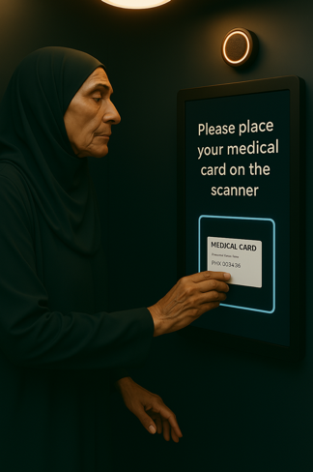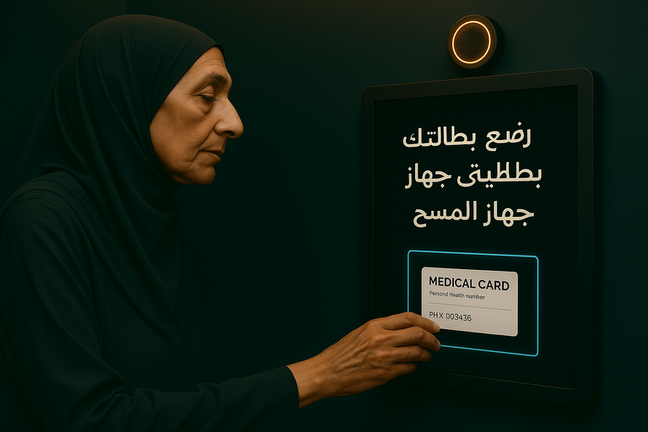

* 1. 1st prompt: The inner door opens. Soft LED floor lights guide her to a small waiting area just outside Pod 2. A robot gently rolls toward her.

Final: Let it be a clinic layout with good seating arrangement.

* 1. 1st prompt: Patient seated on a futuristic medical smart chair measuring blood pressure, temperature, oxygen saturation, and body weight using automated sensors, inside a health

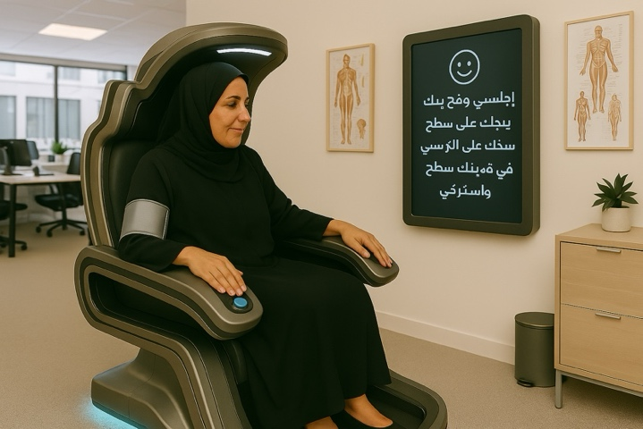Final: Let screen instructions be Arabic

* 1. 1st prompt: Health pod screen showing a remote nurse speaking in Arabic via secure video link with a patient seated inside the pod.

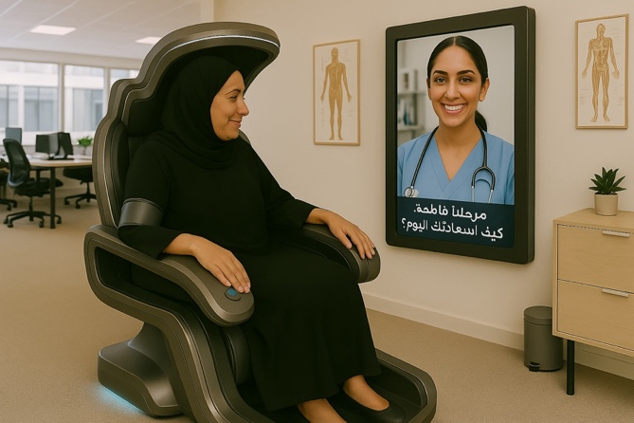Final: let there be translation in Arabic

* 1. 1st prompt: A community health aide assisting her in exiting a healthcare pod and leading her out.

Final: Make her look like the same person in previous pictures.

* 1. Side-by-side comparison showing a long queue in a hospital emergency room versus a patient easily accessing care in a neighborhood health pod. Make it look very realistic.

**Benefit:** Improved access to timely health care.

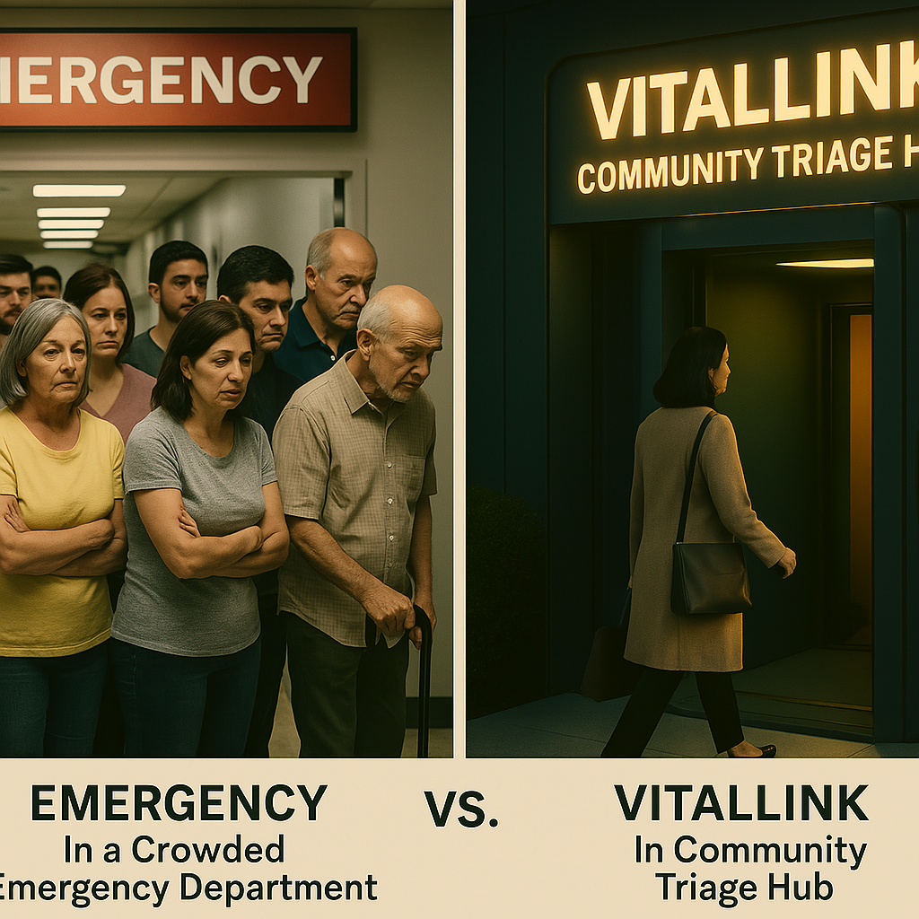

* 1. Show a patient holding her tummy in the room with the nurse on the screen

**Challenge:** Not appropriate for complex cases, for instance requiring hands on assessment.

* 1. 1st prompt: Show Vitallink in a multicultural neighborhood with signage in English, Arabic, and Mandarin, surrounded by local shops and transit signs.

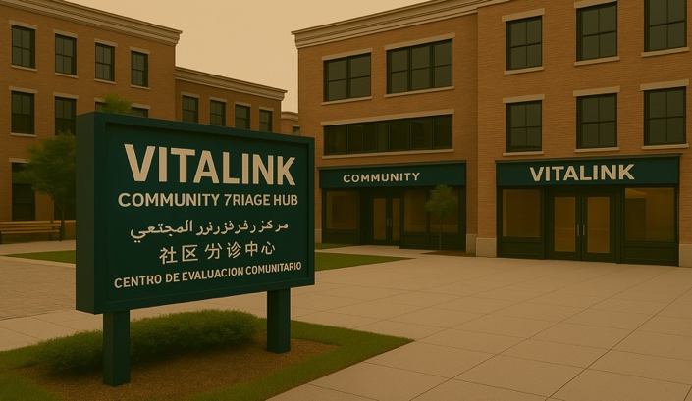Final: Let the signage have different translations.

**Narrative: Fatima’s story.**

Fatima is a 58-year-old Syrian woman who recently immigrated to British Columbia, Canada. Though she is enrolled in the provincial Medical Services Plan (MSP), she does not have a family doctor and has limited understanding of how to access care in her new environment. Fatima speaks primarily Arabic and often avoids healthcare services due to language barriers, unfamiliarity with digital tools, and the fear of being misunderstood. For several days, she has felt increasingly fatigued and lightheaded, but the uncertainty of navigating the system alone has kept her from seeking help.

While walking through her neighborhood, she notices a modern structure near the community center labeled “VITALLINK: Community Triage Hub.” A soft-blue light pulses gently beside the entry button. With growing discomfort and curiosity, she approaches and presses the button. The glass doors slide open, and Fatima steps into a rounded, glass-walled entry booth.

Immediately, a voice welcomes her and asks her to select a language. On the touchscreen in front of her, she sees multiple options and taps the one labeled “العربية” (Arabic). The system immediately switches and begins to explain the purpose of the VitalLink Pod in her native language. It offers walk-in triage, automated vital sign assessment, and virtual nurse consultations, all without needing an appointment. The system then prompts her to scan her provincial health card. She places it on the illuminated panel. Since she has no previous digital record, a new electronic health profile is automatically created using her Personal Health Number (PHN), linked securely to the provincial system.

“Your queue number is 304,” the voice announces in Arabic. “Please proceed to Pod 2 when your number is called.”

The inner door opens, and LED floor lights appear, guiding her to a quiet waiting area. A sleek, humanoid robot glides toward her and greets her warmly:

“مرحباً، فاطمة. الرجاء اتباعي إلى مقعدك.”

(“Hello, Fatima. Please follow me to your seat.”)

She is guided to a numbered pod, where the door slides open to reveal a clean, softly lit interior. Inside is a Smart Chair, equipped with automated sensors. As she sits, the chair adjusts to her height and prompts her, again in Arabic, to place her arm on the cuff and finger on a panel. Within two minutes, her blood pressure, temperature, oxygen saturation, and weight are measured and displayed on the screen beside her. Her blood pressure is elevated.

A moment later, a remote nurse appears on the screen, also speaking in fluent Arabic. They discuss her symptoms, and the nurse reassures her. She is advised to seek same-day evaluation at a nearby clinic. Before the call ends, the nurse arranges the referral and uploads her health summary securely.

As the screen fades, a community health aide enters the pod:

“Hello, Fatima. I’m here to walk you over to the clinic. They’re expecting you.”

For the first time since arriving in Canada, Fatima feels fully seen, heard, and supported. The technology didn’t just collect data, it provided a bridge between fear and care, between isolation and access. She did not need to navigate complicated systems, wait for hours in an emergency room, or struggle through due to language barrier. Instead, she received dignified, accessible care right within her community.

**References**

Basu, G., Costa, V. P., & Jain, P. (2017). Clinicians’ obligations to use qualified medical interpreters when caring for patients with limited English proficiency. *AMA Journal of Ethics, 19*(3), 245–252. <https://doi.org/10.1001/journalofethics.2017.19.3.ecas2-1703>

Canadian Institute for Health Information. (2022). Emergency department wait times: Long stays and increased acuity. <https://www.cihi.ca/en/emergency-department-wait-times>

CityNews Montreal. (2024, November 25). *Canada’s first telehealth station unveiled in Montreal’s West Island**.* <https://montreal.citynews.ca/2024/11/25/canada-first-telehealth-station-montreal-west-island/>

CloudMD Software & Services Inc. (2020, May 4). *CloudMD and Save-On-Foods partner to pilot on-demand virtual patient care by integrating telemedicine kiosks in pharmacies**.* <https://www.globenewswire.com/news-release/2020/05/04/2026642/0/en/CloudMD-and-Save-On-Foods-Partner-to-Pilot-On-Demand-Virtual-Patient-Care-by-Integrating-Telemedicine-Kiosks-in-Pharmacies.html>

Clove, D. (2023). Healthcare access disparities among rural populations in the United States. Ballard Brief, 2023(1), Article 5. <https://scholarsarchive.byu.edu/ballardbrief/vol2023/iss1/5>

Dimakou, S., Dimakou, O., & Basso, H. S. (2015). Waiting time distribution in public health care: Empirics and theory. *Health Economics Review, 5*(25). <https://doi.org/10.1186/s13561-015-0061-7>

Greenhalgh, T., Shaw, S. E., Alvarez Nishio, A., Byng, R., Clarke, A., Dakin, F., Faulkner, S., Hemmings, N., Husain, L., Kalin, A., Ladds, E., Moore, L., Rosen, R., Rybczynska-Bunt, S., Wherton, J., & Wieringa, S. (2022). Remote care in UK general practice: Baseline data on 11 case studies [version 2; peer review: 2 approved]. *NIHR Open Research, 2*, 47. <https://doi.org/10.3310/nihropenres.13290.2>

Infermedica. (2023, December 13). *Infermedica expands global reach with support for 24 languages on AI-powered medical guidance platform.* <https://www.prnewswire.com/news-releases/infermedica-expands-global-reach-with-support-for-24-languages-on-ai-powered-medical-guidance-platform-302013606.html>

Kelen, G. D., Wolfe, R., D’Onofrio, G., Mills, A. M., Diercks, D., Stern, S. A., Wadman, M. C., & Sokolove, P. E. (2021). Emergency department crowding: The canary in the health care system. *NEJM Catalyst Innovations in Care Delivery*. <https://doi.org/10.1056/CAT.21.0217>

Kontos, E., Blake, K. D., Chou, W. Y. S., & Prestin, A. (2014). Predictors of eHealth usage: Insights on the digital divide from the Health Information National Trends Survey 2012. Journal of Medical Internet Research, 16(7), e172. <https://doi.org/10.2196/jmir.3117>

LanguageLine Solutions. (2020, October 6). *Kiosks are bringing language access to self-service technology.* <https://www.languageline.com/blog/kiosks-are-bringing-language-access-to-self-service-technology>

MacKichan, F., Brangan, E., Wye, L., Checkland, K., Lasserson, D., Huntley, A., Morris, R., Tammes, P., Salisbury, C., & Purdy, S. (2017). Why do patients seek primary medical care in emergency departments? An ethnographic exploration of access to general practice. BMJ Open, 7, e013816. <https://doi.org/10.1136/bmjopen-2016-013816>

Microsoft Corporation. (2025). [AI-generated clinic environment images for the VitalLink Pod project]. Copilot in Microsoft 365. https://www.microsoft.com/en-us/microsoft-365/copilot

NHS England & NHS Improvement. (2020). A&E attendances and emergency admissions monthly return definitions (Version 5.0). <https://www.england.nhs.uk/statistics/statistical-work-areas/ae-waiting-times-and-activity/>

OnMed. (2024, January 5). *Hartford HealthCare & OnMed launch new healthcare experience Connecticut.* <https://www.onmed.com/resources/hartford-healthcare-onmed-launch-new-healthcare-experience-connecticut>

PharmaSmart International LLC. (2021, August 17). *PharmaSmart blood pressure kiosks recognized on US Validated Device List (VDL™).* <https://www.newswire.ca/news-releases/pharmasmart-blood-pressure-kiosks-recognized-on-us-validated-device-list-vdl-tm–894654011.html>

Squires, A. (2018). Strategies for overcoming language barriers in healthcare. *Nursing Management (Springhouse), 49*(4), 20–27. <https://doi.org/10.1097/01.NUMA.0000531166.24481.15>

Teslon Technologies. (n.d.). *Carenation kiosk – Teslon.* <https://teslon.io/carenation-kiosk/>

Topol, E. (2019). Deep medicine: How artificial intelligence can make healthcare human again. Basic Books.

UniDoc Health Corp. (2024, November 6). *UniDoc ships first AI-equipped H3 Health Cubes to commercial customers.* <https://unidoctor.com/unidoc-ships-first-ai-equipped-h3-health-cubes-to-commercial-customers/>

Urbach, D. R. (2018). Improving access to health services in Canada. *Healthcare Management Forum, 31*(6), 243–246. https://doi.org/10.1177/0840470418776995

Whittaker, W., Anselmi, L., Kristensen, S. R., Lau, Y.-S., Bailey, S., Bower, P., Checkland, K., Elvey, R., Rothwell, K., Stokes, J., & Hodgson, D. (2016). Associations between extending access to primary care and emergency department visits: A difference-in-differences analysis. *PLOS Medicine, 13*(9), e1002113. <https://doi.org/10.1371/journal.pmed.1002113>

World Health Organization. (2023). Universal health coverage (UHC). <https://www.who.int/news-room/fact-sheets/detail/universal-health-coverage-(uhc)>