Enhancing the Care of Palliative Patients at Home Through Technology
Description of Novel Idea
When my dad was receiving palliative care at home, a common question my mom and I would ask each other is “how do people manage if they don’t have a daughter who is a nurse?”. There seemed to always be new symptoms that required attention, new medications, new dosages and new schedules. We were connected to home care supports, but their scope of practice was limited, and they could not be in the home 24/7. We were concerned about tying up resources every time an ambulance was dispatched to administer fluids, or when a home care nurse came to our home only to call the doctor to request new meds. Our situation was not unique, medication management is one of the top stressors reported by caregivers supporting a palliative patient at home (Pollock, et al., 2021). My technology innovation aims to reduce caregiver burden and make at home medication safer for palliative patients through a medication vending machine placed in the home. The vending machine would provide patients and caregivers with access to a variety of necessary meds through its ability to dispense fluid bags with primed lines and accurately drawn up injectable medications. It would also support decision making and care planning through its unique interface which connects directly to the patient’s electronic health record (HER) facilitating communication with the medical team.
Improving access to medication
Timely access to appropriate medications for symptom control is essential for maintaining quality of life for palliative patents and decreasing caregiver distress. In a qualitative study caregivers reported having to access multiple pharmacies to obtain appropriate medications, sometimes needing to make multiple trips to pick up medications as they became available (Sheefy-Skeffington, et al., 2014). The vending machine provides a secure storage device, with a refrigeration compartment designed to keep medications stable for as long as possible. Reducing the need for frequent medication dispensing and multiple trips to the pharmacy. Ensuring the stability of medications increases the option of providers to engage in anticipatory prescribing. Anticipatory prescribing, in which families are given doses of medications that are to be used to manage serious or complex symptoms for palliative patients prior to them being required has become increasingly common. Storage and safety issues are commonly reported as deterrents to anticipatory prescribing and the prescription of high-risk drugs for homecare patients such as opioids (Pollock, et al., 2021). Ensuring that patients have access to a variety of medications, including medications they are projected to, but may not yet require enhances symptom management, increasing patient and caregiver quality of life.
Access to subcutaneous medications
The machine providing access to fluids and subcutaneous medications is what makes it uniquely beneficial for palliative homecare clients. As their disease progresses palliative patients’ medication regimes often get more complex. Palliative patients often require new routes of administration, such as subcutaneous sites, as their ability to swallow oral medications decreases. They may also have an increased need for pro-re-nata (PRN) medications and additional fluids to aid in symptom management and comfort (Pollock, et al. 2021). Caregivers have varying degrees of comfort in subcutaneous medication administration; however positive benefits are often acknowledged as they provide as their loved ones ability to tolerate oral medications declines (Sheefy-Skeffington, et al., 2014). Home care nurses are often tasked with assessing patient and family readiness for subcutaneous medications to be introduced to the patient plan of care. Factors such as caregiver abilities, safety and the home environment often influence nurse decision making (BC Centre for Palliative Care, 2024). The vending machine’s ability to accurately draw up medications ensures patients have equal opportunity to benefit from this route of administration. Pre-drawn injections have typically been used in palliative homecare settings however, they are given at risk of decreased potency and non-sterility (BC Centre for Palliative Care, 2024). Syringe drivers have also been used in palliative care to reduce the use of pre-drawn syringes however, this can increase stress of caregivers should the driver malfunction, or if they worry the medication will run out before the medical team is able to replace them (Sheefy-Skeffington, et al., 2014). Having a machine in home with the capability of drawing up medication ensures that patients have consistent access to effective medications.
Increasing Caregiver Decision Making
The vending machine will include a touch screen user interface which displays the patient medication schedules, and the available PRN medications within the machine. Caregivers report feeling empowered by their ability to give PRN medications to support their loved ones but acknowledge that it can also be a source of stress when more than one medication choice is available, or the same mediation was available in different formulations (Sheefy-Skeffington, et al., 2014). Using the interface, caregivers will be able to identify symptoms and then be shown the available PRN medications used to treat those symptoms. Members of the medical team would be able to see PRN administrations as the vending machine will automatically sync to the patient’s EHR. This ensures clear communication, and an accurate documentation of what treatments have been tried should the caregiver require escalated assistance with managing symptoms at home. Caregivers identified that having clear information and guidelines on all the medications their loved one was prescribed decreased stress and increased their use of PRN medications (Sheefy-Skeffington, et al., 2014). Ensuring they have information easily available can support them in effectively supporting their loved on eand increase their confidence in the ability to provide care at home.
Increasing Safety and Communication
Medication regimes often get more complex as the patient illness progresses. In a time, which is both emotionally and mentally taxing for the caregivers it is essential caregivers are supported in managing this increased complexity. While many caregivers may take on certain aspects of medication administration the process of medication management often falls on one individual (Pollock, et al., 2021). Caregivers will often develop their own methods of tracking administrations (Pollock, 2021). Consistent and clear communication between informal and formal caregivers is essential for appropriate management at home (Pollock et al., 2021).
Ensuring that the vending machine syncs to the patient EHR ensures that information is centralized and available to all members aids in communication and effective decision-making cross multiple levels. Having easy dispensing of medications also reduces caregiver burden. Pre-loaded packs with all scheduled medications can be dispensed with one push, reducing the risk of medication errors. The vending machine will have the ability to offer alerts and reminder for missed doses. Patient safety features will also ensure that mediations cannot be dispensed too early. There would also be a screen following dispensing which prompts the caregiver to double check the dispensed medications further increasing patient safety.
Google Search
Using the search prompts “medication vending machine” and at “home medication dispenser” resulted in articles which show that a company in British Columbia created an at home medication dispenser, Karie. Karie is an at home device which “organizes, schedules, and dispenses medications for users with remote monitoring capabilities for those unable to check up on their loved ones” (route65, n.d). My google search found that other models of at home medication dispensers exist, the website cdnhomecare.ca offers a breakdown of a comparison of the various models available. A disadvantage of the models shown is that they are all limited to oral tablets. Many of them are preloaded into packets which contain all medications required at a scheduled time. Some models are also capable of sending alerts when medications are due and notifying caregivers of upcoming med admin times.
These models are mainly geared toward patients receiving home care, but not specific to palliative patients who often lose their ability to tolerate oral medications as their disease progresses. The introduction of subcutaneous sites and injections adds an extra stressor to caregivers in the home who require additional training for drawing up medications, providing injections and accessing clysis sites (BC Centre for Palliative Care, 2024). This is why they additional feature of accurately drawing up medications and priming fluid lines is an essential feature for a machine that is specifically targeted to palliative homecare patients.
Searches specific to medication vending machines brought up articles about the harm reduction vending machines that were implemented in B.C. MySafe vending machines were preloaded by a pharmacy with daily doses in individual patient packages. The machine scans patient handprints and dispenses their daily prescription. (Bardwell, et al., 2023). There has been other utilization of medication or medical supply vending machines including dispensing of grooming supplies, covid-19 tests. Similarly to the at home dispensing products, these are limited to the dispensing of items, and tablets (Bardwell, et al., 2023). Throughout my search I found no machines that were capable of accurately drawing up medications that came in a liquid dose.
AI Generated Pictures
All images were created using Google Gemini AI
- An image showing the basic design of the vending machine which highlights the ability to dispense fluid lines and its ability to draw mediations into a syringe.
Prompt: Create an image of a small and compact at home vending machine that can dispense pills, subcutaneous meds and fluid lines

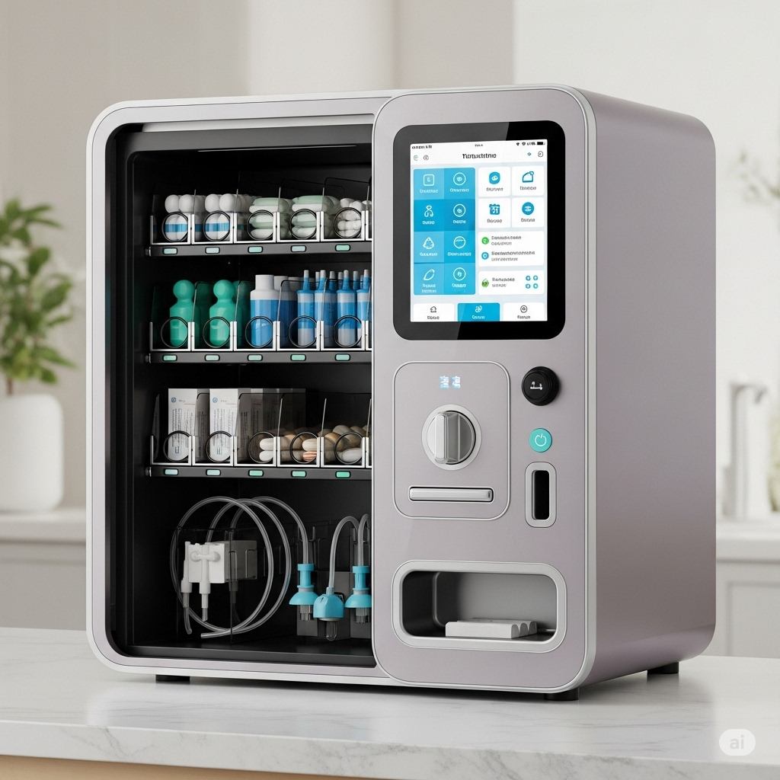

- An image that shows the technology within the vending machine that allows it to draw up medications into a syringe
Prompt: create an image showing how a small and compact at home vending machine that can dispense pills, subcutaneous meds and fluid lines draws meds into a syringe

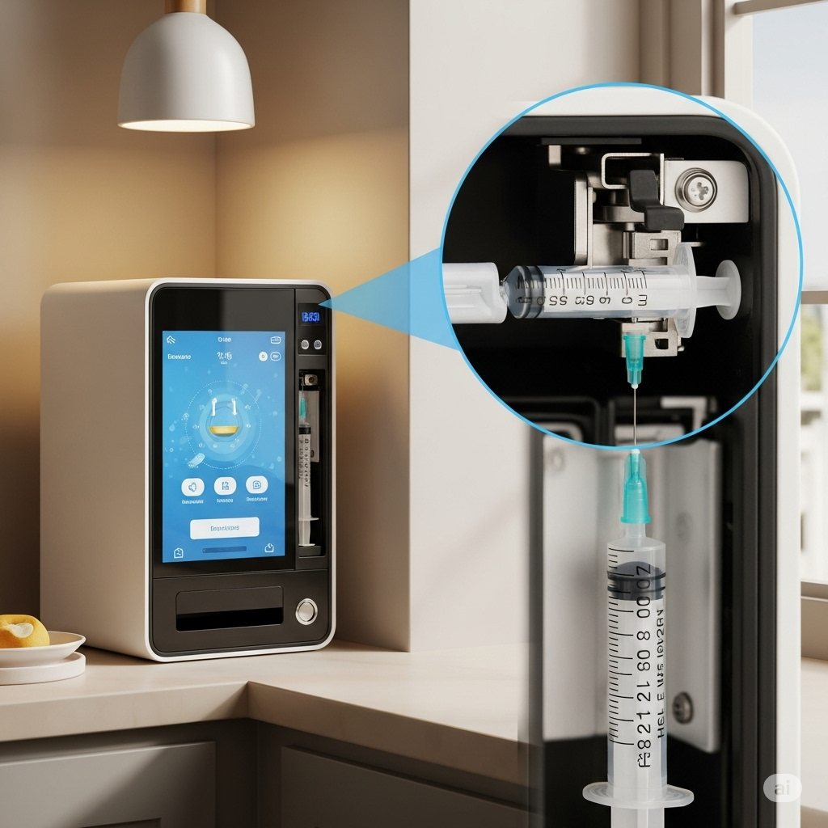

- An image showing the built-in safety mechanism which alerts caregivers when medication administration is requested too early and blocks the dispensing of medications.
Prompt: Create an image of the screen on the vending machine showing an alert for a medication being administered too early

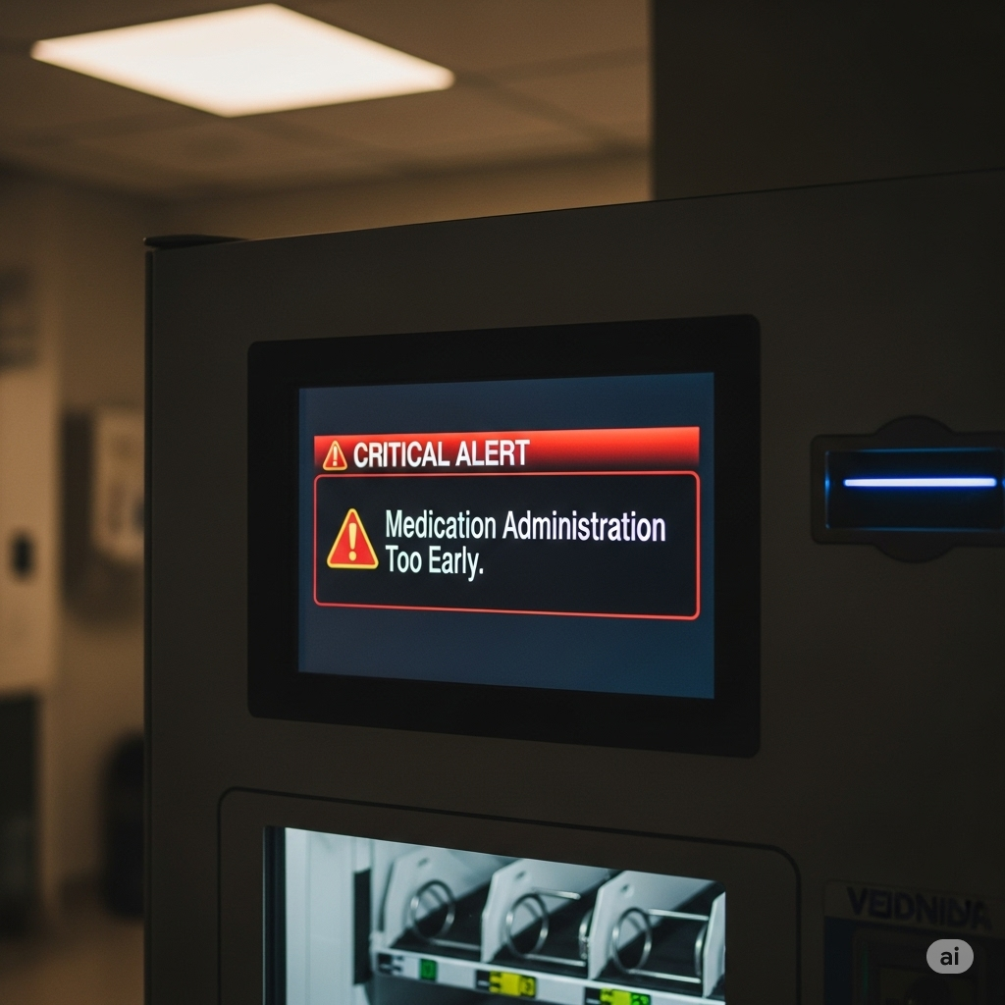

- An image which shows the vending machine prompting caregivers to input symptoms to assist with PRN medication administration.
Prompt: create an image of a small and compact at home medication vending machine screen prompting the input of symptoms

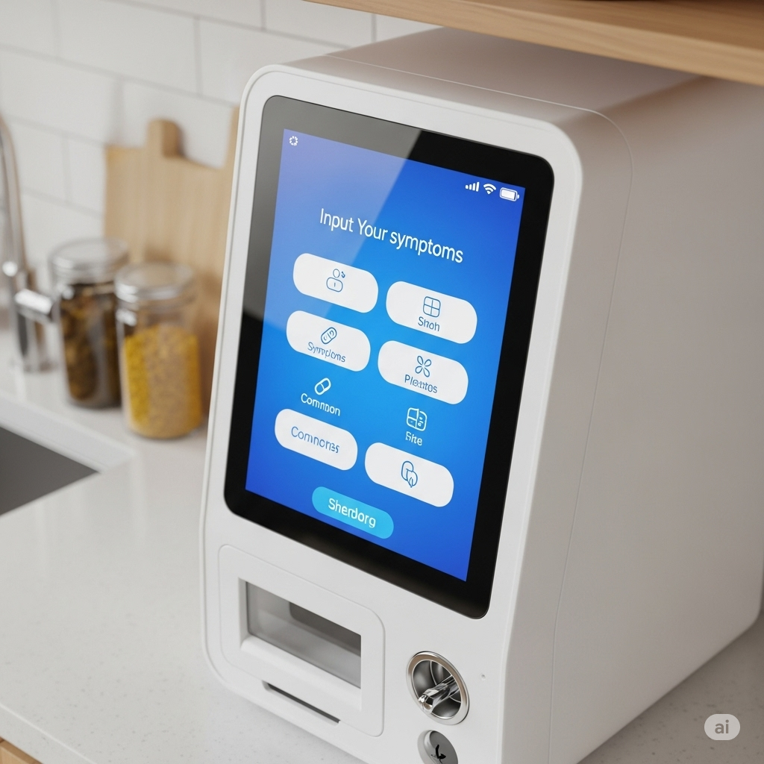

- An image which shows how the vending machine syncs to the patient’s EHR
Prompt: Create an image of a nurse on the phone with a patient viewing their medication record


- An image that shows the safety feature which prompts caregivers to double check the dispensed med and dose.
Prompt: Create an image of a family member checking they recieved the correct medication and dose from the machine
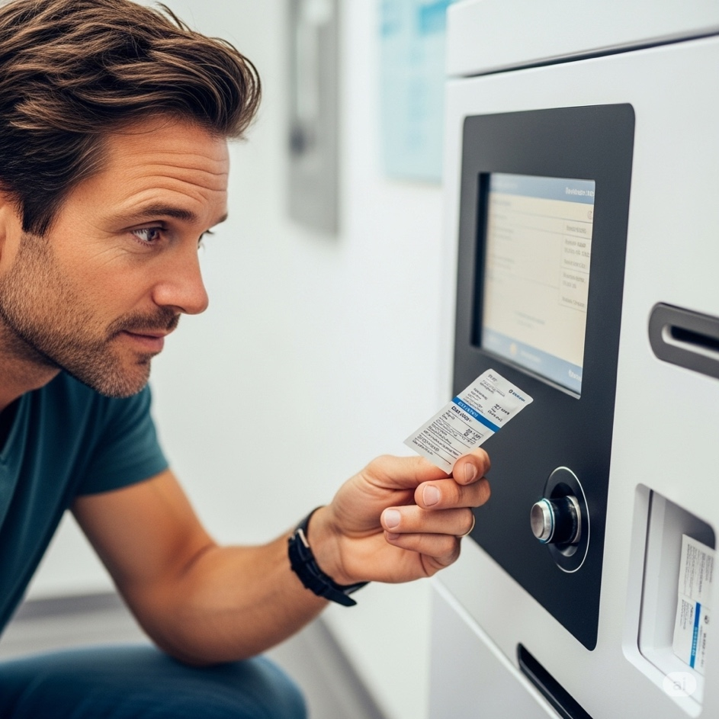

- An image that shows the benefit of anticipatory prescribing by having the vending machine loaded with medications that may not be required by the patient but will be expected to be as their disease progresses.
Prompt: Create an image of that vending machine being loaded with medications by a pharmacist
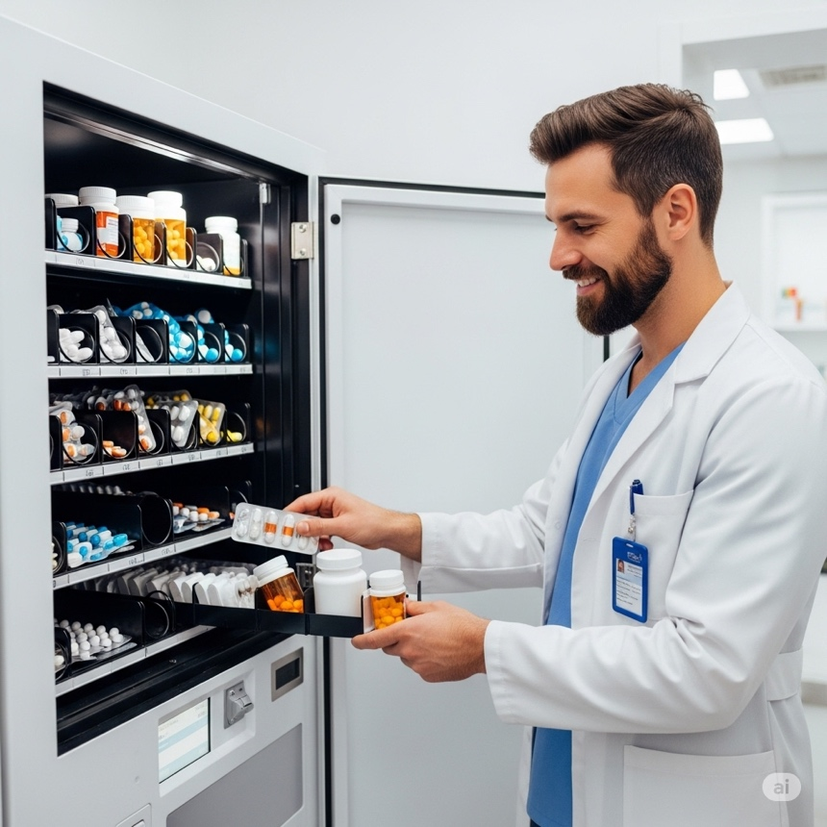

- An image which shows the administration of fluids that was dispensed from the machine being administerd by a caregiver at home.
Prompt: create an image of a family member administering medications to a palliative family member through a clysis at home
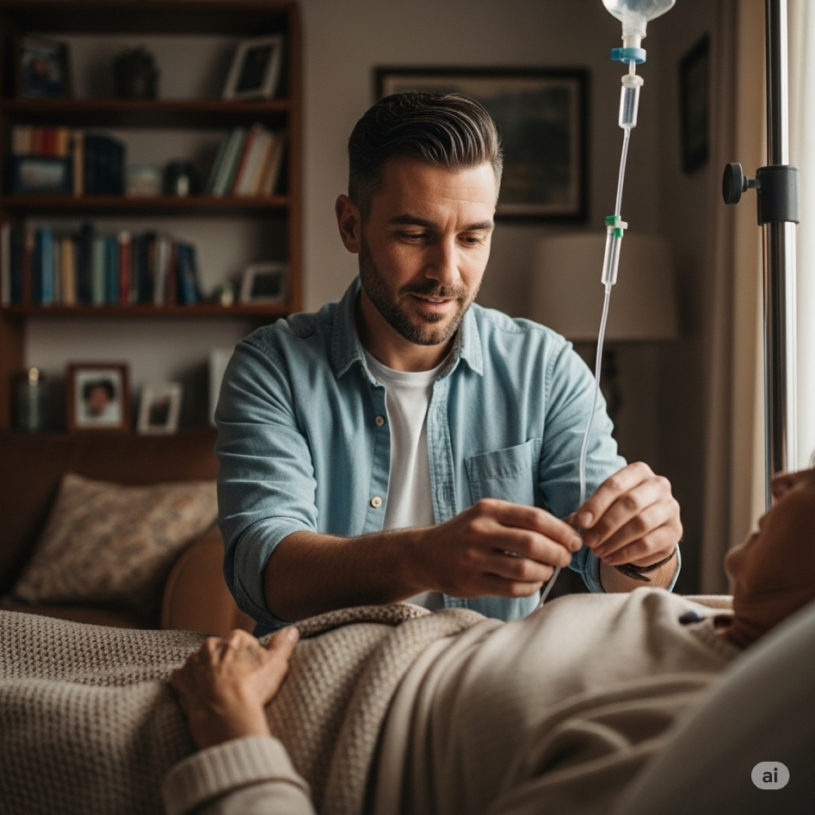

- An image which highlights the risk of technology failing and a medication getting stuck while being dispensed which can delay access to treatment.
Prompt: Create an image of the medication getting stuck inside the vending machine
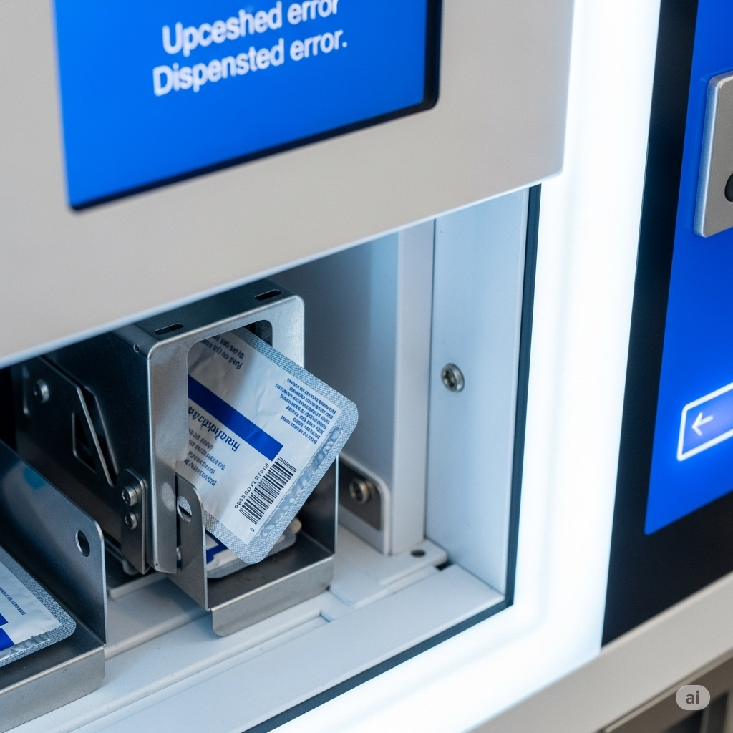

- An image which highlights the increased financial cost of having this machine in the home including increased power bills.
Prompt: create an image of a family being worried about bills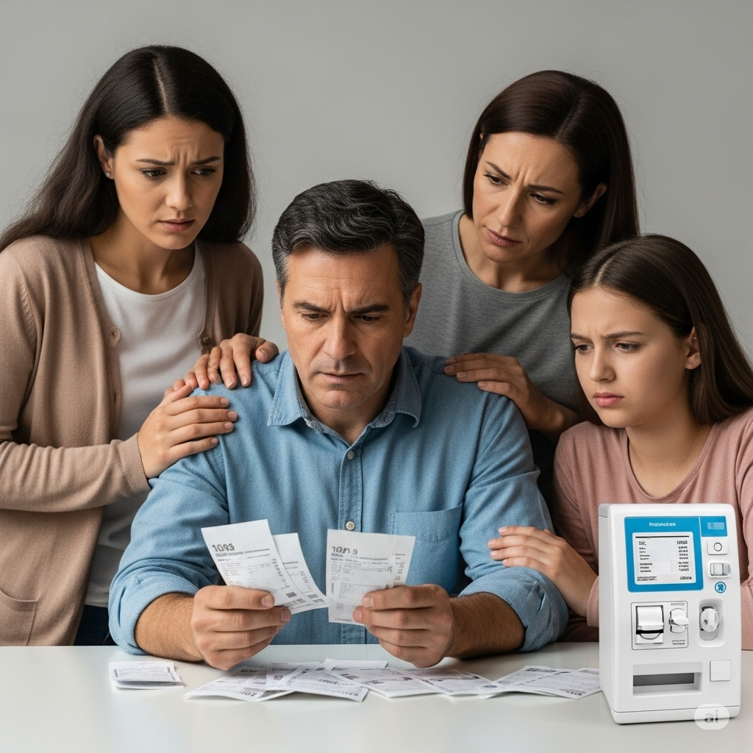

Narration
Carter is caring for his dad who has a terminal cancer diagnosis, it is his dad’s wish to remain at home. He wakes up in the morning and checks on his dad, his morning medications are due, so he goes to the medication vending machine on the countertop. “Morning Meds Due” flashes on the screen and with a press on the screen a packet of pills and a syringe is dispensed. Carter removes the meds from the machine, and a notification pops up on the screen “Please double check dosages and names of dispensed meds” Carter looks at the medication packages, comparing to the list now showing on the screen, he checks off each med as he makes sure they are correct and goes to give his dad his medication.
His dad is reporting more pain and nausea this morning. Carter goes to the machine and presses “symptoms” a list of symptoms come up Carter pushes “Pain” the machine prompts him to rate the pain on a scale of 1-10, he asked his dad and knows it is a 7. A list of the available pain medications comes up with a suggestion for a dose of hydromorphone, Carter clicks the med and a syringe is dispensed with the medication drawn up. Carter is again prompted to double check the amount of medication in the syringe. The screen turns back to the symptom list, Carter chooses nausea, a list of the medications come up and Ondansetron is dispensed. Carter goes to administer both medications to his dad.
An hour later Carters dad is still having nausea, Carter goes to the machine to get another dose of ondansetron but is notified that it is too soon for another dose. He is given an option for gravol, which Carter chooses and is dispensed. Carter’s father reports that his pain has subsided following the dose of hydromorphone, however he still has increased nausea. Carter is concerned and calls his homecare team, he speaks to a nurse who does an assessment over the phone, she accesses the EHR and reviews all the medications she sees were dispensed from the machine. She confirms with Carter that they were administered.
The nurse wants to connect with the physician to get new medication orders. She lets Carter know she will call him back as soon as they are updated. A few minutes later the nurse returns carters call to let him know that an extra dose of gravol is available and the doctor would like to try fluids. The nurse confirms that Carter remembers the education he received on hanging the line and attaching it to his dads clysis site, Carter confirms and goes to get the extra medication and fluid bag from the vending machine. He administers the meds and half an hour later the nurse calls to check in - his dad is feeling much better.

References
Bardwell, G., Ivsins, A., Mansoor, M., Nolan, S., & Kerr, T. (2023). Safer opioid supply via a biometric dispensing machine: A qualitative study of barriers, facilitators and associated outcomes. Canadian Medical Association Journal, 195(19). https://doi.org/10.1503/cmaj.221550
BC Centre for Palliative Care. (2024) Nursing decision-making for subcutaneous medication preparation and administration in home-based palliative care: Expert Consensus Statement. BC Centre for Palliative Care
Pollock, K., Wilson, E., Caswell, G., Latif, A., Caswell, A., Avery, A., Anderson, C., Crosby, V., & Faull, C. (2021). Family and health-care professionals managing medicines for patients with serious and terminal illness at home: A qualitative study. Health Services and Delivery Research, 9(14), 1–162. https://doi.org/10.3310/hsdr09140
Sheehy-Skeffington, B., McLean, S., Bramwell, M., O’Leary, N., & O’Gorman, A. (2014). Caregivers experiences of managing medications for palliative care patients at the end of life. American Journal of Hospice and Palliative Medicine®, 31(2), 148–154. https://doi.org/10.1177/1049909113482514
Route65.(n.d). Get the free karie remote medication dispensing system today!. Route65.ca. (2023, November 6). https://route65.ca/news/get-the-free-karie-remote-medication-dispensing-system-today/

