Smart Companion Robots for Elderly Healthcare in British Columbia

Fiona Finnegan
Student ID: T00748295
Thompson Rivers University

HLTH 5500: Integrating Information Technology in Healthcare

Dr. Anila Virani
May 26, 2025

Smart Companion Robots for Elderly Healthcare in British Columbia
Abstract
British Columbia's (BC) aging population faces a tough reality in that most seniors want to stay in their own homes (Binette & Vasold, 2019, however managing complex health conditions alone is becoming increasingly difficult (Sawik et al., 2023). This paper explores a critical gap in BC's healthcare system where elderly residents often need ongoing medical support, but current technology falls short (BC Ministry of Health, 2023). While basic companion robots exist for entertainment and simple reminders (NT, 2020), nothing on the market today combines comprehensive medical monitoring, medication management, and emergency response in one integrated system designed for this unique healthcare problem (Trafton, 2020). The proposed Smart Companion Robot could significantly improve quality of life allowing elderly British Columbians to age in place by seamlessly connecting with BC PharmaCare, local health authorities, and emergency services while providing the medical oversight typically only available in institutional care (Statistics Canada, 2023).

Description of a Novel Idea

The Problem BC's Seniors Face
Over 250,000 seniors in BC are trying to manage multiple chronic conditions while living independently (Statistics Canada, 2023). The average senior over 75 takes more than ten medications daily, and many struggle with conditions like diabetes, heart disease, and mild to moderate cognitive problems all at once (Chiu et al., 2022). When COVID-19 hit, the problem became worse as even basic home care visits from health care practitioners became risky, leaving many to manage their health alone (BC Ministry of Health, 2022).
The real issue is that BC's current system leaves potentially dangerous gaps. Home care nurses might visit every two weeks, but health emergencies do not follow schedules (Sawik et al., 2023). Medical alert buttons only work after something goes wrong and are not proactive at prevention. For seniors living in rural BC, help can be hours away (BC Emergency Health Services, 2023). Meanwhile, families worry, and many seniors end up in long-term care facilities not because they need full-time nursing, but because there is no middle ground between living alone and institutional care (BC Ministry of Health, 2023).

A New Solution: Smart Companion Robots
After researching what is available today, I discovered that no current technology truly solves this problem, especially within BC's healthcare system (Trafton, 2020; Sawik et al., 2023). Existing companion robots like ElliQ can chat and provide reminders, but they cannot check vital signs or manage medications (NT, 2020). Diabetes monitoring devices exist, but they do not connect with broader health management (BC PharmaCare, 2023). Emergency response systems react to crises but do not prevent them (BC Emergency Health Services, 2023).
My proposed innovation integrates five key capabilities into one companion robot specifically designed for BC seniors:
Medical Monitoring That Actually Works: The robot would continuously track vital signs, blood sugar, blood pressure, and heart rhythms without requiring seniors to remember multiple daily checks (Trafton, 2020). Unlike current devices that work in isolation, this system would learn each person's patterns and detect problems before they become emergencies (Chiu et al., 2022).
Smart Medication Management: Instead of hoping seniors remember complex medication schedules, the robot would automatically prepare and dispense medications, check for dangerous interactions, and adjust insulin doses based on real-time blood sugar readings (Chiu et al., 2022). Everything would connect directly with BC PharmaCare to ensure medication coverage and refills happen seamlessly (BC PharmaCare, 2023).
Predictive Health Analytics: Using artificial intelligence, the robot would analyze patterns in a senior's health data to predict problems 24-72 hours before they happen (Sawik et al., 2023). For example, it might notice that blood sugar patterns suggest a diabetic emergency is likely and automatically schedule a telemedicine appointment with the person's doctor (BC Ministry of Health, 2022).
Integrated Emergency Response: When emergencies do occur, the robot would not just call for help but would provide BC Emergency Health Services with complete medical history, current vital signs, and exact location data, making response faster and more effective (BC Emergency Health Services, 2023).
Real Companionship for BC's Diverse Population: Many BC seniors speak languages other than English as their first language (Statistics Canada, 2023). The robot could communicate in Cantonese, Punjabi, Dutch or other prevalent languages among BC's elderly population, providing culturally appropriate support and companionship while reducing isolation (Berridge et al., 2023).

Why This Matters for BC
My Smart Companion is not simply about cool technology but about allowing people to age with dignity in their own homes while reducing strain on BC's healthcare system (Binette & Vasold, 2019). Currently, many seniors end up in emergency rooms or long-term care not because they need intensive medical intervention, but because no one was monitoring their conditions closely enough to prevent a crisis (BC Ministry of Health, 2023).
This innovation could help thousands of BC seniors stay independent longer while improving their health outcomes (Statistics Canada, 2023). For families, it means peace of mind knowing their loved ones have comprehensive support. For the healthcare system, it means fewer emergency calls, fewer hospitalizations, and better use of limited resources (Sawik et al., 2023).

Google Search

Finding Out What Already Exists
I conducted research to determine whether anything like this Smart Companion Robot system exists in British Columbia or elsewhere. My research included multiple databases, government websites, and healthcare technology companies.
Search Process: I used specific queries like "smart companion robots elderly healthcare British Columbia," "medical companion robot diagnostic capabilities," and "integrated medical assessment robot elderly BC." I also searched BC government sites, health authority websites, and medical technology databases.
What I Found: The search revealed significant gaps in current technology, particularly in BC. While various pieces exist separately, no integrated system addresses the comprehensive needs of aging in place.
I also learned that Israel, America, and Japan are leaders in the field of artificial intelligence and robotics.
Current Companion Robots: Robots like ElliQ focus on social interaction and basic reminders but lack medical capabilities (NT, 2020; Berridge et al., 2023). They cannot monitor health conditions or manage medications, and they do not integrate with BC's healthcare system.
Medical Monitoring Devices: BC PharmaCare covers continuous glucose monitors and other diabetes supplies, showing the province supports health technology (BC PharmaCare, 2023). However, these devices work independently without broader health system integration (Chiu et al., 2022).
BC-Specific Technologies: During COVID-19, BC implemented telepresence robots in some long-term care homes for family visits, demonstrating openness to robotic healthcare solutions (Sawik et al., 2023). The province also runs Mobile Diabetes Telemedicine Clinics for rural and Indigenous communities, showing commitment to innovative care delivery (Dawson et al., 2021).
The Gap: Despite these various technologies, nothing combines comprehensive medical monitoring, medication management, emergency response, and companionship into one system designed for home use within BC's healthcare framework (Trafton, 2020; Sawik et al., 2023).

Narration

Target Population: BC Seniors with Multiple Health Conditions
The target population includes elderly British Columbians aged 75 and older who live independently while managing multiple chronic conditions. This represents over 250,000 people in BC who want to age in place but face significant challenges managing complex medical needs (Statistics Canada, 2023).

Margaret's Story: Life Transformed
Margaret Smith, 82, moved to Richmond, BC from Amsterdam forty years ago. She raised her family in Richmond and worked at the local European Bakery for 25 years. Margaret and her family built deep community connections. Margaret’s husband died two years ago, and she now lives alone in her townhouse, managing diabetes, high blood pressure, and mild memory issues while taking eight different medications daily.
Before the Robot: Margaret's days were filled with anxiety. Did she check her blood sugar this morning? Which pills did she take already? Her medication routine was complicated, and she often felt confused about timing and dosages (Chiu et al., 2022). During doctor visits, language barriers made it hard to explain her symptoms clearly (Statistics Canada, 2023). Her daughter in Toronto worried constantly, calling every night but knowing that emergencies could happen anytime (BC Emergency Health Services, 2023).
Last winter, Margaret had a scary episode where her blood sugar dropped dangerously low while she was alone. She managed to call her son, but it took him 45 minutes to drive from North Vancouver in traffic. The incident left everyone shaken and wondering what would have happened if she had been unable to call for help.
After Getting AIDAN (Her Smart Companion Robot): Everything changed when Margaret received AIDAN through a Vancouver Coastal Health pilot program. From day one, the robot communicated with her in English and Dutch, immediately making her feel more comfortable with its presence. AIDAN learned her routine, playing soft Dutch music during her morning medication time and respected her cultural preferences around health and food.
The robot's medical monitoring capabilities transformed Margaret's diabetes management (Chiu et al., 2022). Instead of worrying about forgetting blood sugar checks, AIDAN monitors her levels continuously and adjusts her insulin automatically. When the robot detected a pattern suggesting potential problems with her new arthritis medication, it scheduled a video appointment with her doctor two days before any symptoms appeared (Sawik et al., 2023).
The Real Impact: Margaret's medication errors disappeared completely. Her blood sugar control improved dramatically (Chiu et al., 2022). Most importantly, she sleeps peacefully now, knowing that AIDAN is monitoring her health around the clock. One night, the robot detected irregular heart rhythms but determined it was sleep apnea, not a heart attack, scheduling appropriate follow-up care instead of calling an ambulance unnecessarily (Trafton, 2020).
Margaret’s family notices the difference too. Her daughter calls to chat about grandchildren instead of checking on Margaret's health. Her son's weekly visits are more enjoyable because he is not worried about her medical management (Binette & Vasold, 2019).
Healthcare System Benefits: In eight months with AIDAN, Margaret has not had a single preventable emergency room visit. Her doctor reports that her health data is now more comprehensive than what they typically see from patients living in assisted care facilities (BC Ministry of Health, 2023). The robot's integration with BC PharmaCare ensures her diabetes supplies are always available, and its connection to Vancouver Coastal Health means her care team has real-time access to her health status (BC PharmaCare, 2023).

The Broader Impact
Margaret's experience shows how Smart Companion Robots could transform healthcare for thousands of BC seniors (Statistics Canada, 2023). This technology enables people to age safely in their own homes while improving their health outcomes (Binette & Vasold, 2019). For BC's healthcare system, it means fewer emergency interventions, better resource allocation, and seniors who remain healthier longer (BC Ministry of Health, 2023).
The cultural competency features are particularly important in BC's diverse communities (Statistics Canada, 2023). Many elderly immigrants struggle with language barriers that compromise their healthcare (Berridge et al., 2023). AIDAN's multilingual capabilities and cultural sensitivity help ensure that language differences do not become barriers to good health outcomes.
The Companionship Dimension: Addressing Social Isolation
Beyond medical capabilities, the companionship aspect of Smart Companion robots address a critical but often overlooked dimension of aging in place, social isolation, and loneliness. Research demonstrates that social isolation among elderly individuals significantly impacts both physical and mental health outcomes, with isolated seniors experiencing higher rates of depression, cognitive decline, and premature mortality (Berridge et al., 2023). For individuals like Margaret living alone, the absence of regular human interaction compounds the challenges of managing complex medical conditions.
Current companion robots like ElliQ focus primarily on social interaction through conversation, entertainment, and basic reminders, but they lack the medical integration necessary to provide comprehensive support (NT, 2020). The innovation lies in combining meaningful companionship with clinical medical capabilities thus creating a system that can serve as both a trusted companion and a sophisticated health monitor (Chiu et al., 2022). This dual functionality addresses the reality that elderly individuals do not just need medical monitoring, they also need emotional support, cognitive stimulation, and social connection to maintain their overall well-being while aging in place.
The companionship features of a Smart Companion would include natural language processing for meaningful conversations, emotional recognition to detect signs of depression or anxiety, cognitive engagement through games and mental exercises, and social connectivity to facilitate communication with family members and healthcare providers (Sawik et al., 2023). Unlike purely social companion robots, Smart Companion’s would integrate companionship with health monitoring, allowing them to recognize when social isolation might be contributing to health deterioration and alert family members or healthcare providers accordingly (Berridge et al., 2023).
Research indicates that elderly individuals are more likely to accept and interact with robotic systems that provide clear, immediate benefits while demonstrating reliability in real-world conditions (Chiu et al., 2022). By combining companionship with essential medical capabilities, these robots could build trust and engagement that enhances their effectiveness as health monitoring systems. The companion relationship becomes the foundation for successful medical intervention, as elderly users develop confidence in the system's ability to support both their emotional and physical well-being (Binette & Vasold, 2019; Sawik et al., 2023).
Conclusion
Smart Companion Robots represent more than just innovative technology as they offer a practical solution to one of BC's most pressing healthcare challenges (BC Ministry of Health, 2023). By integrating comprehensive medical monitoring with BC's existing healthcare infrastructure, these robots could enable thousands of seniors to age safely and independently in their homes while reducing costs and improving outcomes for everyone involved (Statistics Canada, 2023; Sawik et al., 2023). Margaret's story demonstrates that this innovation is not just possible, it is necessary for BC's aging population (Binette & Vasold, 2019). The Smart Companion honors the fundamental human desire to maintain autonomy and dignity while aging, ensuring that complex medical needs do not force unwanted transitions to institutional care (Sawik et al., 2023). For millions of elderly individuals like Margaret, innovation is the difference between remaining in their beloved homes or facing unwanted institutionalization making innovation a moral imperative (Binette & Vasold, 2019).

AI-Generated Pictures and a Visual Representations of My Smart Companion Innovation
I developed ten image prompts to illustrate various aspects of the Smart Companion Robot. All AI images were generated from Microsoft Co Pilot (2024).
1.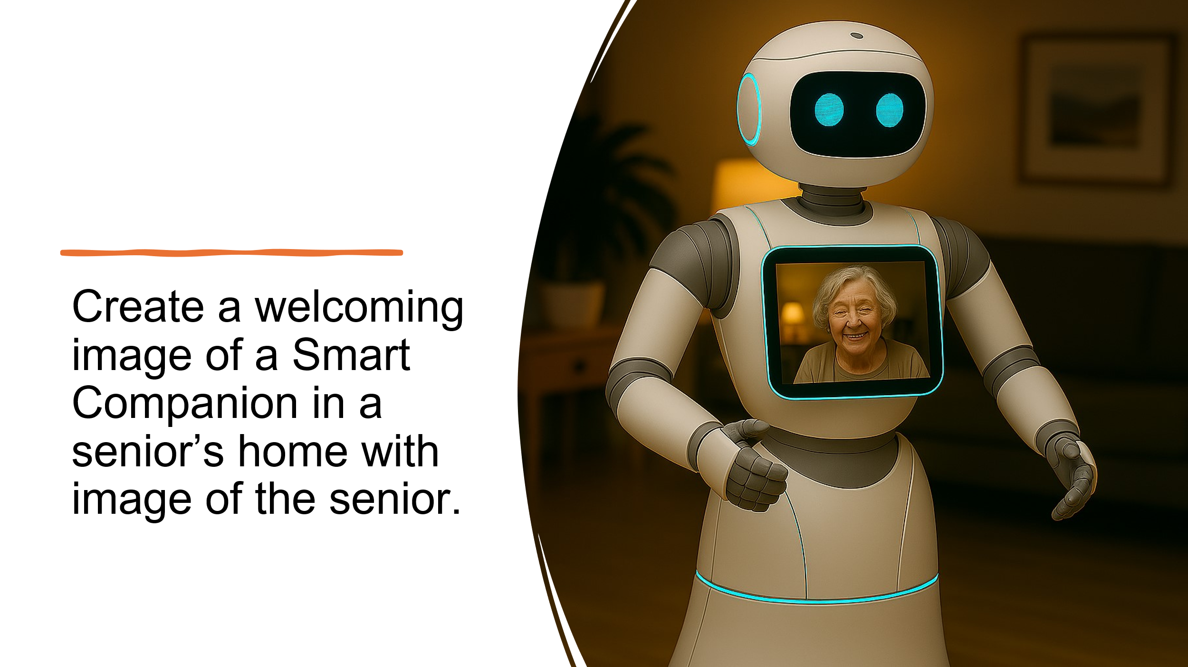

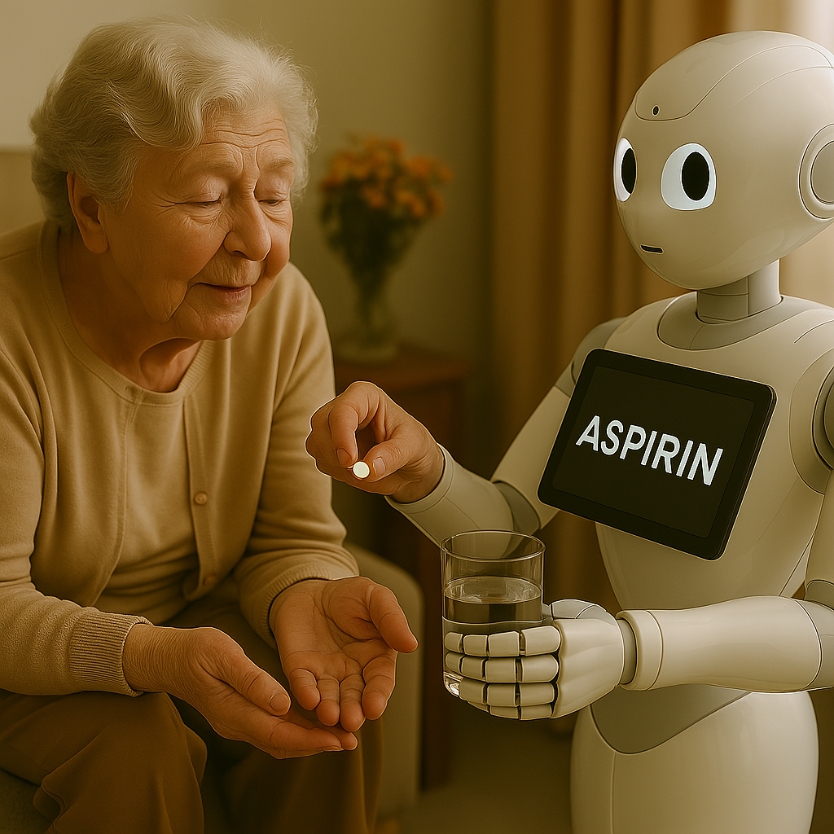
2. Create an image of a Smart Companion providing medication assistance to a senior in her home.

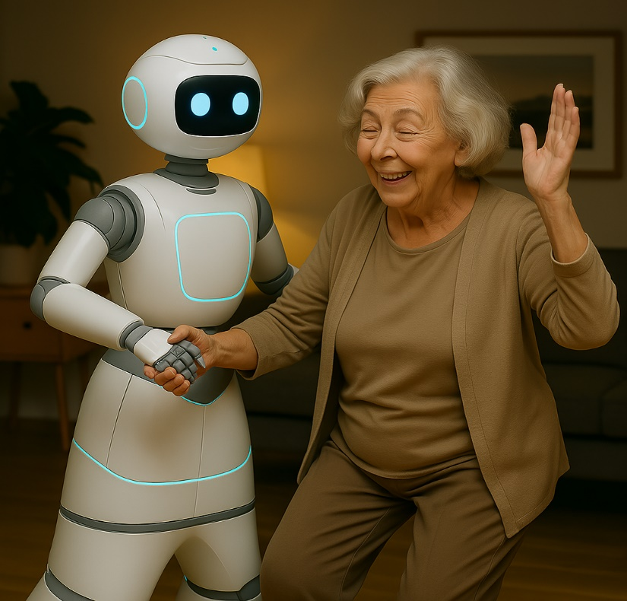
3. Create an image of a senior enjoying companionship with her Smart Companion.

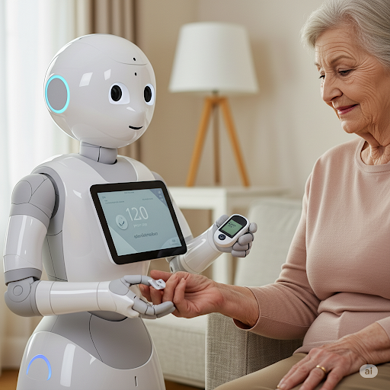
4. Create an image of a Smart Companion assessing a senior’s blood glucose in her home.

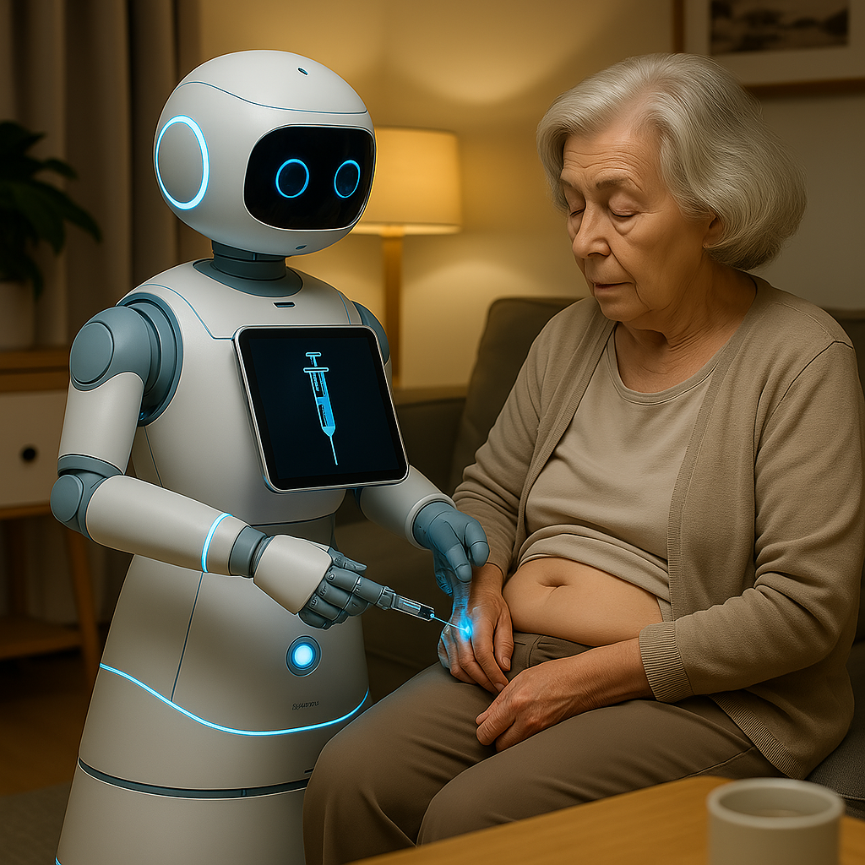
5. Create an image of a Smart Companion administering insulin to a senior in her home.

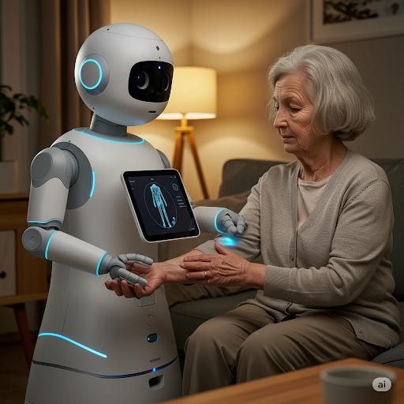
6. Create an image of a Smart Companion assessing and x-raying a senior’s wrist after a fall in her home.

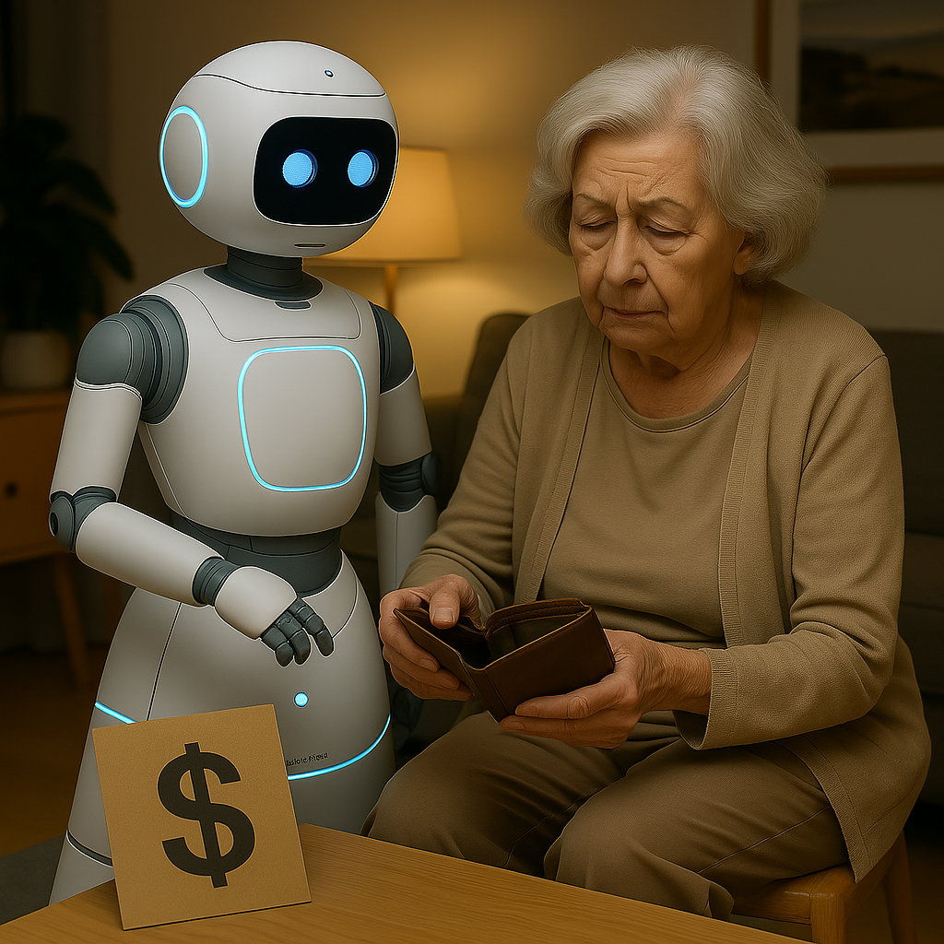
7. Issues with innovation: COST!
Create an image of a senior worrying about the cost of a Smart Companion which could make this technology inaccessible for many seniors.
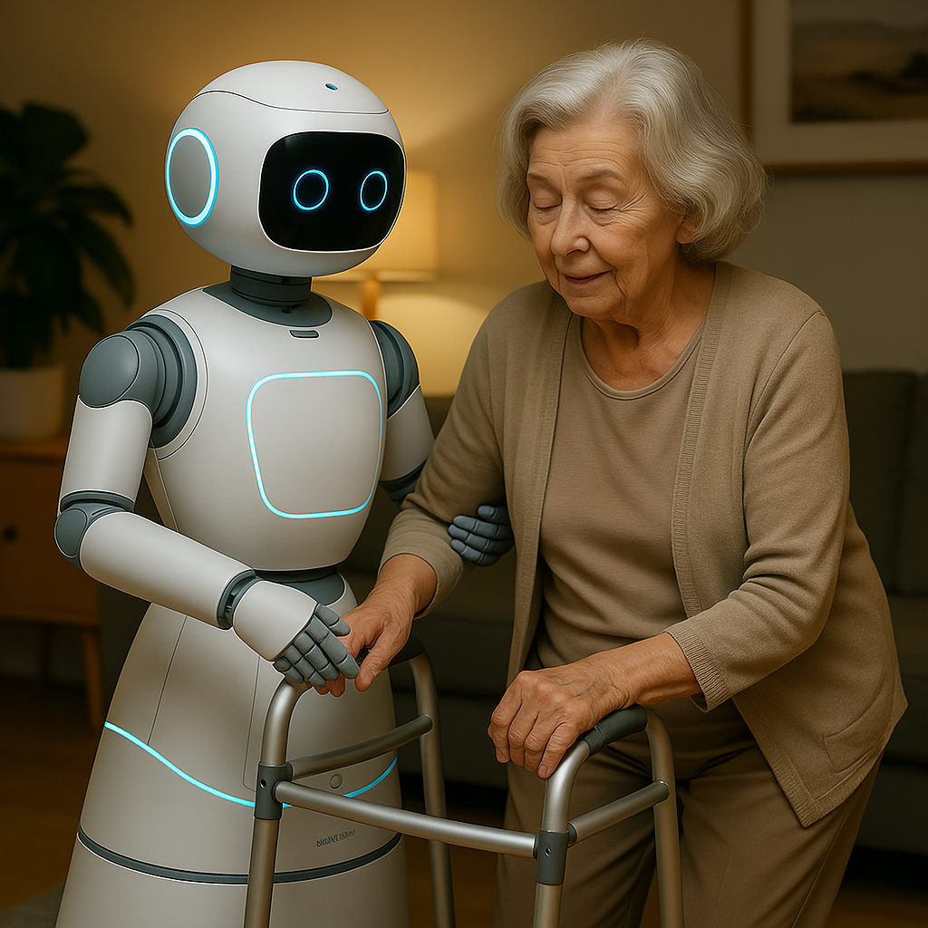
8. Strength: Smart Companion supporting a senior to age in place independently for longer in their home, escorting senior to bed.
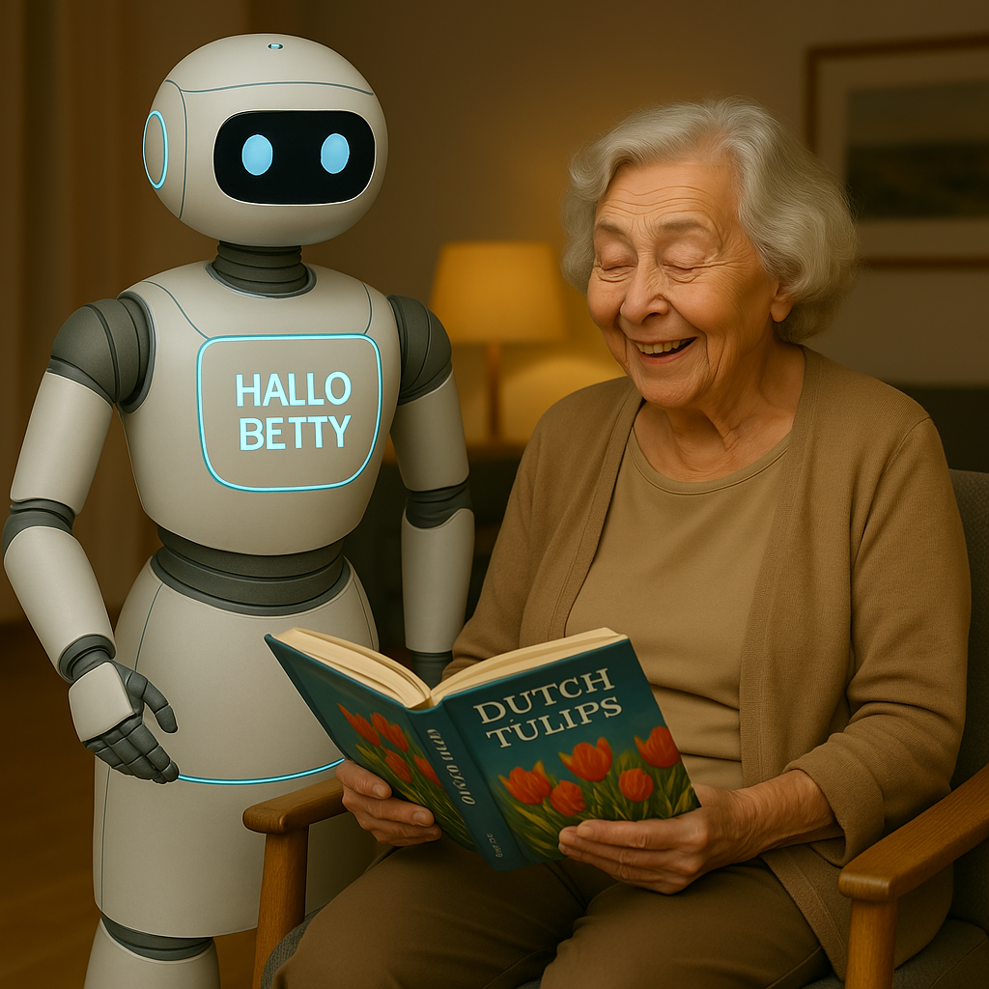
9. Create an image of a Smart Companion communicating with Betty in Dutch and include a book with tulips.
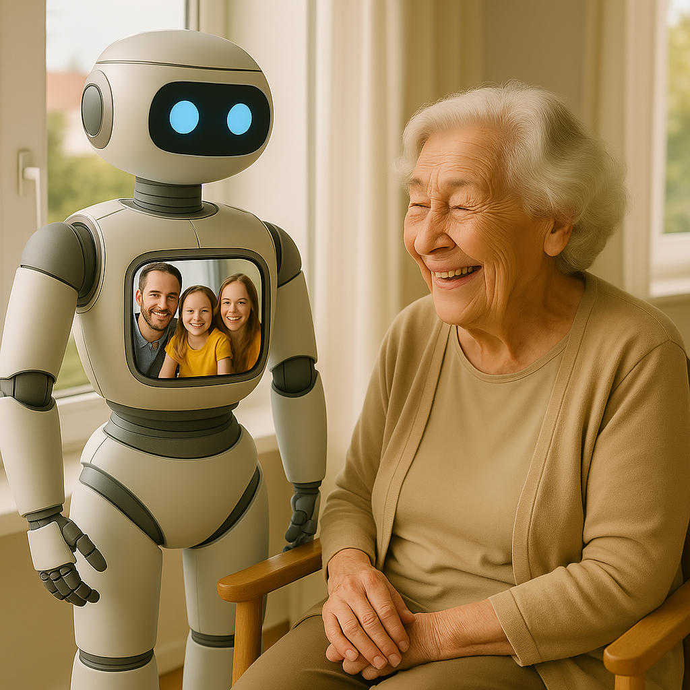

10. Create an image of a Smart Companion with Betty having a virtual visit with her family on the Smart Companion’s screen in the daytime.

References
AARP. (2018). 2018 Home and community preferences: A national survey of adults aged 18-
plus. AARP Research. https://doi.org/10.26419/res.00231.001
BC Emergency Health Services. (2023). Emergency response times and rural coverage report.
Government of British Columbia.
https://www2.gov.bc.ca/gov/content/safety/emergency-management/emergency-management/reports
BC Ministry of Health. (2022). Telemedicine infrastructure development during COVID-19.
Government of British Columbia.
https://www2.gov.bc.ca/gov/content/health/about-bc-s-health-care-system/health-priorities/bc-digital-health#digitalhealth
BC Ministry of Health. (2023). Home and community care services annual report. Government
of British Columbia.
https://www.bcbudget.gov.bc.ca/Annual_Reports/2022_2023/pdf/ministry/hlth.pdf
BC PharmaCare. (2023). Diabetes supplies coverage and eligibility. Government of British
Columbia. https://www2.gov.bc.ca/gov/content/health/health-drug-coverage/pharmacare-for-bc-residents/what-we-cover/medical-supplies-coverage/diabetes-supplies
Berridge, C., Zhou, Y., Robillard, J. M., & Kaye, J. (2023). Companion robots to mitigate
loneliness among older adults: Perceptions of benefit and possible deception. Frontiers
in Psychology, 14, Article 1106633. https://doi.org/10.3389/fpsyg.2023.1106633
Binette, J., & Vasold, K. (2019, July 31). 2018 Home and community preferences: A national
survey of adults ages 18-plus. AARP Research. https://doi.org/10.26419/res.00231.001
Chiu, C. J., Hua, L. C., Chou, C. Y., & Chiang, J. H. (2022). Robot-enhanced diabetes care for
middle-aged and older adults living with diabetes in the community: A small sample size
mixed-method evaluation. PloS one, 17(4), e0265384.
https://doi.org/10.1371/journal.pone.0265384
Dawson, K. G., Jin, A., Summerskill, M., & Swann, D. (2021). Mobile diabetes telemedicine
clinics for Aboriginal First Nation people with reported diabetes in British Columbia.
Canadian Journal of Diabetes, 45(8), 765-773.
https://www.sciencedirect.com/science/article/abs/pii/S1499267120301763
Google Gemini. (2024, May 15). Discussion on renewable energy sources [Large language
model]. https://gemini.google.com/
Microsoft Copilot. (2024, May 15). Response to query about climate change [Large language
model]. https://copilot.microsoft.com/
NT, B. (2020). Top seven companion and social robots for elderly people. RoboticsBiz.
https://roboticsbiz.com/top-seven-companion-and-social-robots-for-elderly-people/
Sawik, B., Tobis, S., Baum, E., Suwalska, A., Kropinska, S., Stachnik, K., Pérez-Bernabeu, E.,
Cildoz, M., Agustin, A., & Wieczorowska-Tobis, K. (2023). Robots for Elderly Care:
Review, Multi-Criteria Optimization Model and Qualitative Case Study. Healthcare
(Basel, Switzerland), 11(9), 1286. https://doi.org/10.3390/healthcare11091286
Statistics Canada. (2023). Population projections for Canada, provinces and territories: 2018 to
2068. Government of Canada.
https://www150.statcan.gc.ca/n1/en/pub/91-520-x/91-520-x2019001-eng.pdf?st=V_T0hv4y
Trafton, A. (2020, August 31). Robot takes contact-free measurements of patients' vital signs.
MIT News. https://news.mit.edu/2020/spot-robot-vital-signs-0831

