Assisted-Feeding Robots in Hospitals

Kulvir K. Moudgil
Master of Nursing, Thompson Rivers University
HLTH 5500: Integrating Information Technology in Healthcare
Dr. Anila Virani
May 26, 2025

Assisted-Feeding Robots in Hospitals
Malnutrition is a frequent issue in hospitalized elderly patients, significantly impacting their health (Edwards et al., 2017; Bellanti et al., 2022). In these settings, poor oral dietary intake can result from various factors, including acute illness, diminished appetite, side effects from medications, or gastrointestinal problems (Edwards et al., 2017; Bellanti et al., 2022). Research indicates that over 60% of hospitalized elderly patients experience malnutrition (Edwards et al., 2017; Hestevik et al., 2020). Moreover, 42-56% of these patients consume fewer nutrients than required for their basal metabolic rate while in the hospital (Edwards et al., 2017). Functional challenges such as impaired cognition or mobility due to conditions like stroke, dementia, motor impairments, or arthritis can hinder their ability to eat properly (Bellanti et al., 2022). Additionally, staffing shortages often shift the focus away from feeding, as clinical units face increased workloads (Kovacs & Lagarde, 2022). Inadequate nutritional intake can lead to malnutrition, weight loss, and compromised immunity (Hestevik et al., 2020). While nasogastric tubes (NG) are sometimes used to compensate for insufficient oral intake and fulfill caloric needs for recovery (Sigmon & An, 2022), technology-driven innovations—such as assisted-feeding robots—may offer a more proactive solution than relying solely on NG tubes for nutrition and hydration.
Novel Idea: Assisted-Feeding Robots in Hospital
Assisted-feeding refers to the help that individuals, particularly elderly patients, require from another person to eat (Park et al., 2020). Research indicates that up to 70% of hospitalized elderly patients need assistance, with one in three elderly patients who have experienced an acute stroke being dependent on others for eating (Shune, 2020). To tackle this issue, technology interventions like assisted-feeding robots have been proposed for use in hospitals (Obi, 2025; Miller, 2025). These robots are designed to mimic the function of a human arm during feeding (Obi, 2025; Miller, 2025; Park et al., 2020). This technology is particularly beneficial for individuals with impairments that hinder their ability to eat independently (Obi, 2025; Sadiq, 2025). Assisted-feeding robots empower users to eat what they want and whenever they choose, enhancing their autonomy in meal consumption (Obi, 2025; Miller, 2025; Park et al., 2020).
Google Search
The United States of America (USA) has emerged as a global leader in robotic self-feeding technology with innovations like Obi, which enables users to select food from four compartments and directs the device to deliver it to their mouth with just a customizable switch (Obi, 2025). Similarly, the University of Washington has developed robotic feeding assistance aimed at aiding those with motor impairments (Sadiq, 2025). Stanford University is also at the forefront, currently working on novel robotic algorithms that enhance autonomy and comfort during the feeding process for people with motor disabilities (Stanford University, 2023).
In Sweden, Bestic serves as an eating assistance device tailored for patients with neurological disorders (Medical Expo, 2025). These devices often feature mobile bases and human-like arms, designed to help individuals navigate their physical limitations effectively (Park et al., 2020; Obi, 2025).
In Canada, Northwood Atlantic is implementing robotic feeders to restore independence and autonomy to individuals (Uhlarik, 2025). Northwood has introduced fully voice-controlled feeder robots in addition to switch-operated versions, further aiding in self-feeding performance (Uhlarik, 2025).

While the US has pioneered the development of assisted feeding robots focused on helping those with motor impairments and Northwood is similarly making strides in Canada, neither country has yet addressed the issue of malnutrition among hospitalized elderly through these robotic solutions (Obi, 2025; Sadiq, 2025; Uhlarik, 2025). Additionally, British Columbia has not yet implemented the use of assisted feeding robots in their healthcare system.
Figure 1
Obi- manufactured in the USA (Obi, 2025)
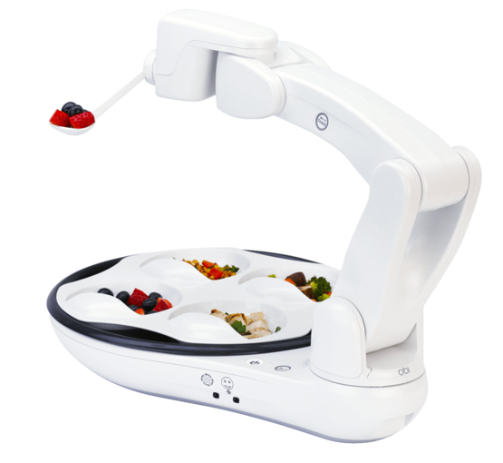
Figure 2
Assisted-feeding robots feeding people with motor impairment (Park et al., 2020)
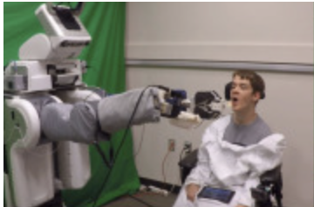
AI-Generated Pictures
Figure 3
Create an image of elder patient with left sided deficits admitted to hospital (OpenAI, 2023)

Figure 4
Create an image of elder patient with left sided deficits not eating in hospital (OpenAI, 2023)

Figure 5
Create an image of elder patient with left sided deficits appears malnutrition, weak, and frail in hospital (OpenAI, 2023)


Figure 6
Create an image of frail & malnutrition elder patient with left sided deficits interacting with assisted feeding robot (OpenAI, 2023)
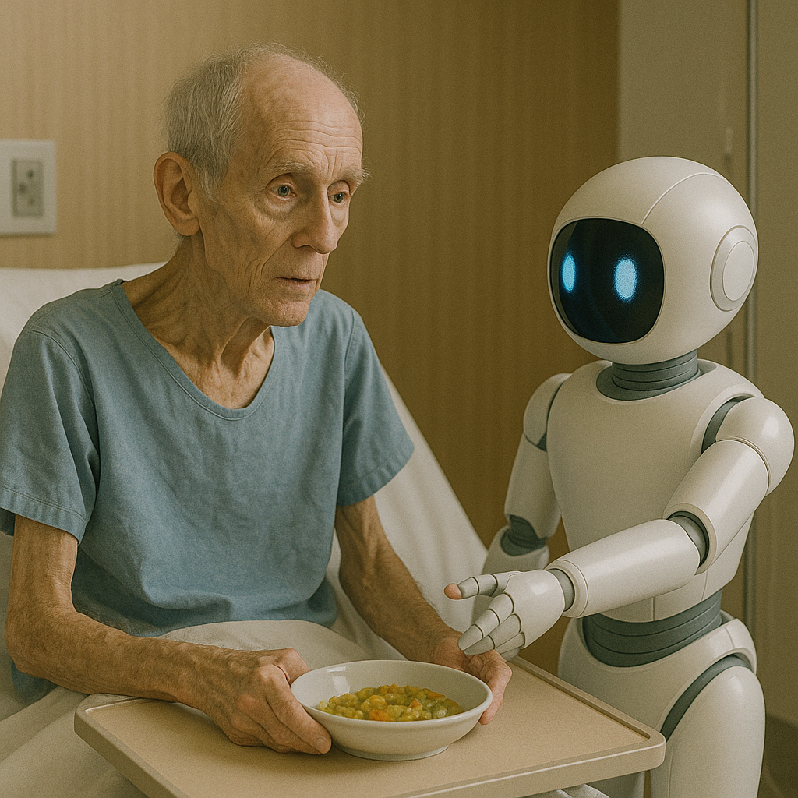
Figure 7
Create an image of elder patient with left sided deficits is fed by assisted feeding robot in hospital (OpenAI, 2023)
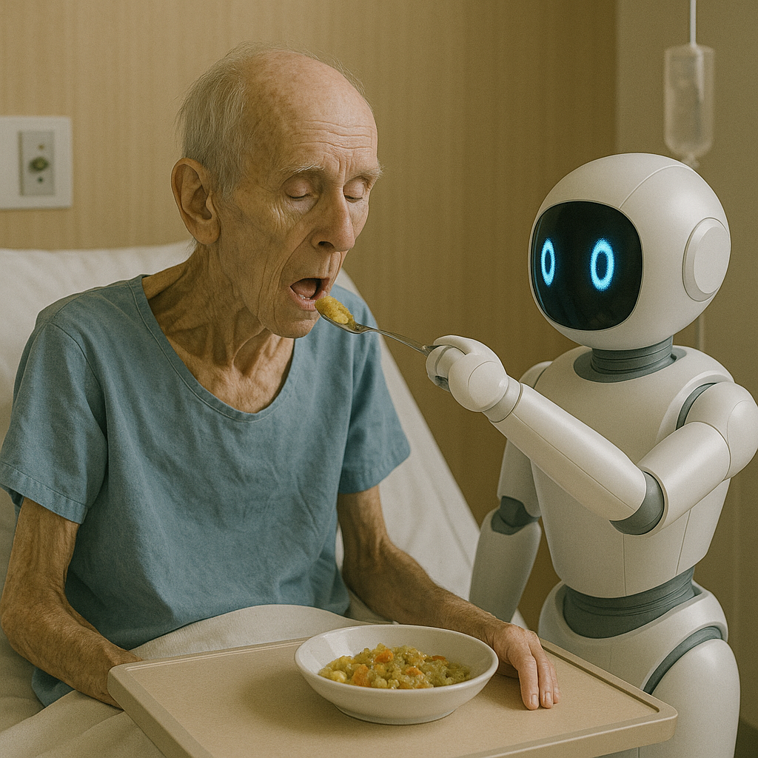
Figure 8
Create an image of elder patient with left sided deficits fed by assisted feeding robot finishes his meal in hospital (OpenAI, 2023)
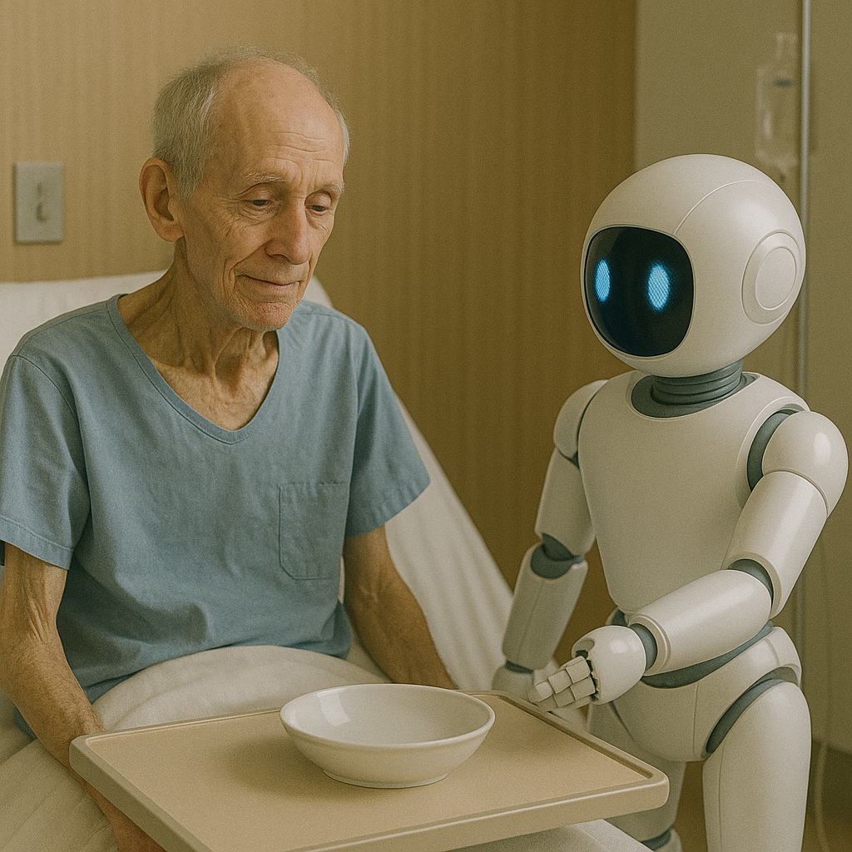
Figure 9
Create an image of elder patient with left sided deficits getting out of bed with two robots in hospital (OpenAI, 2023)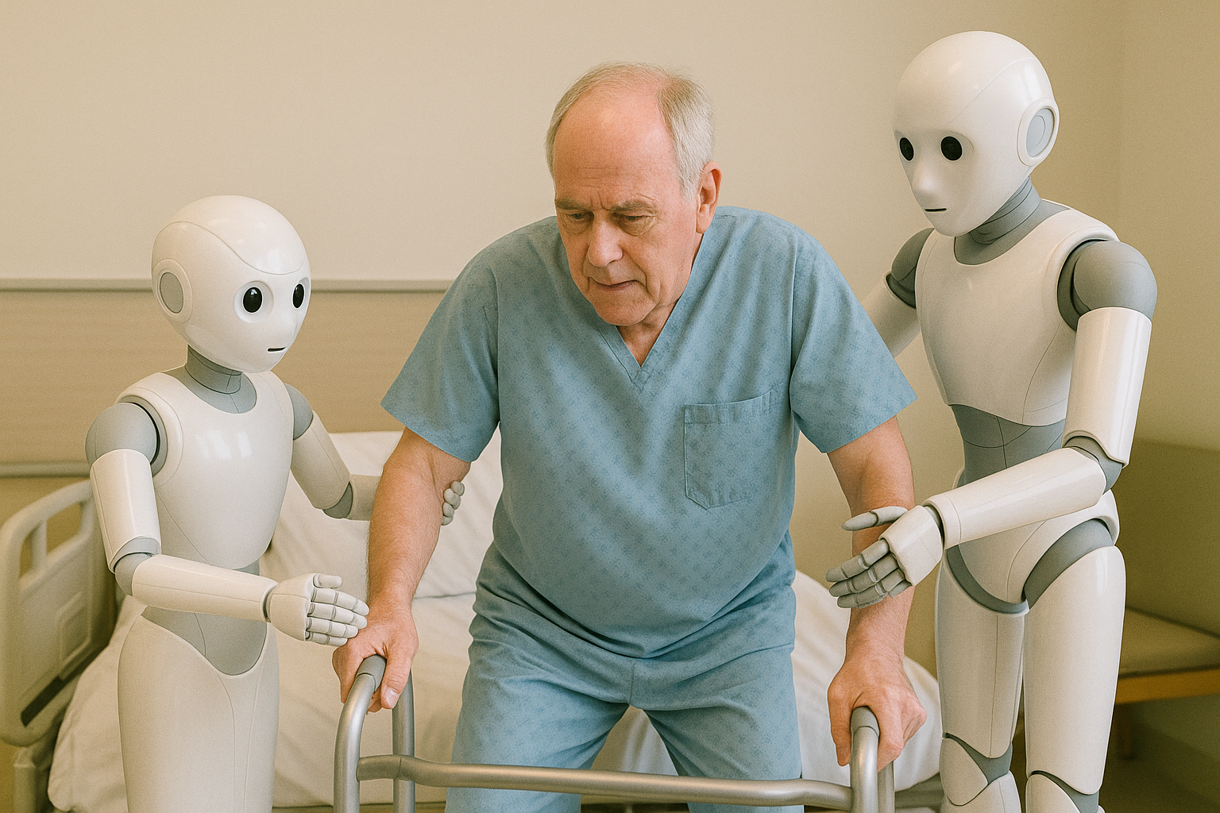
Figure 10
Create an image of elder patient with left sided deficits has working on regaining his strength and appears in better spirit in hospital interacting with robots and staff (OpenAI, 2023)
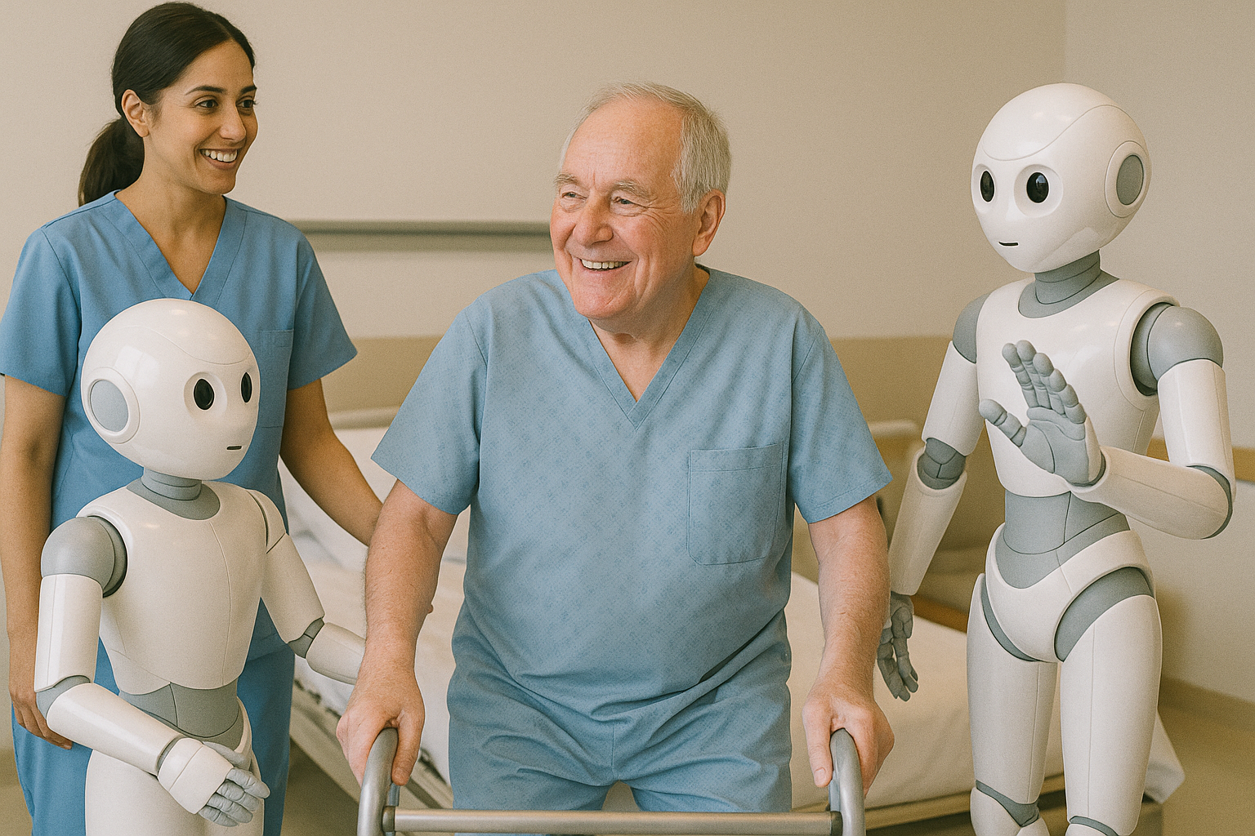
Figure 11
Create an image of elder patient with left sided deficits showing gratitude to assisted-feeding robot while getting ready to be discharged from hospital (OpenAI, 2023)
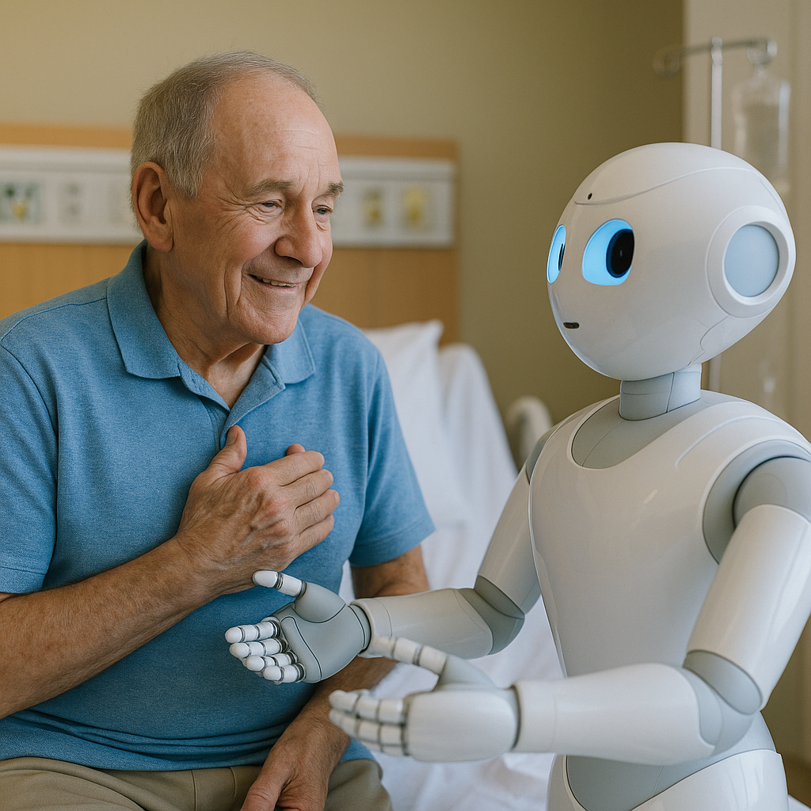
Figure 12
Create an image of elder patient with left sided deficits leaving the hospital and waving bye in great spirits interacting with robots and staff (OpenAI, 2023)
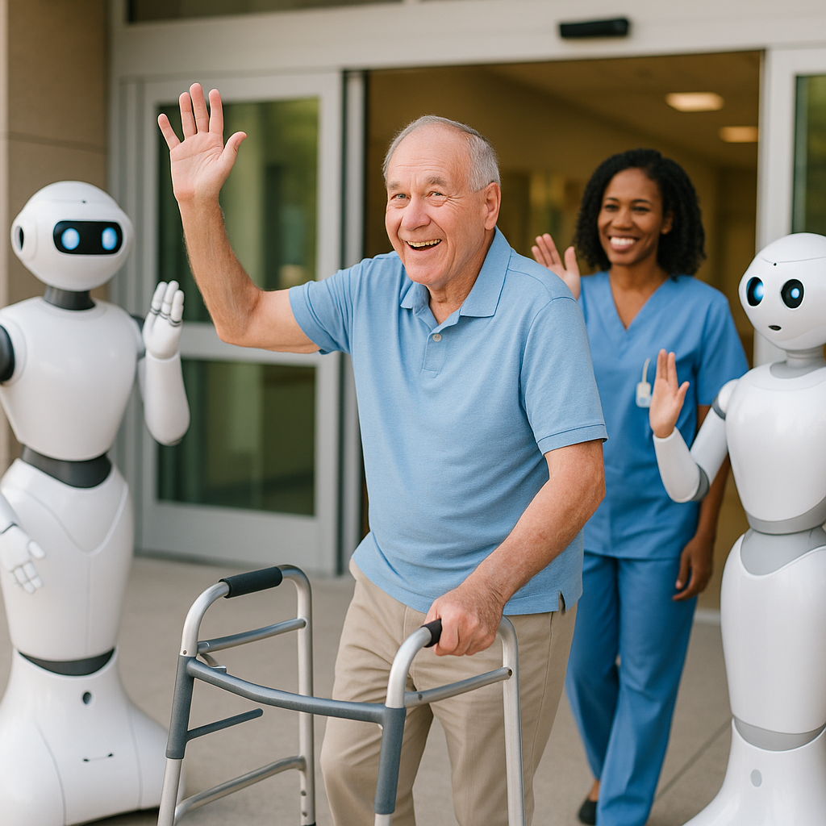
Benefit
Figure 13
Create an image of multiple assisted feeding robots feeding stroke patients in hospital (OpenAI, 2023)
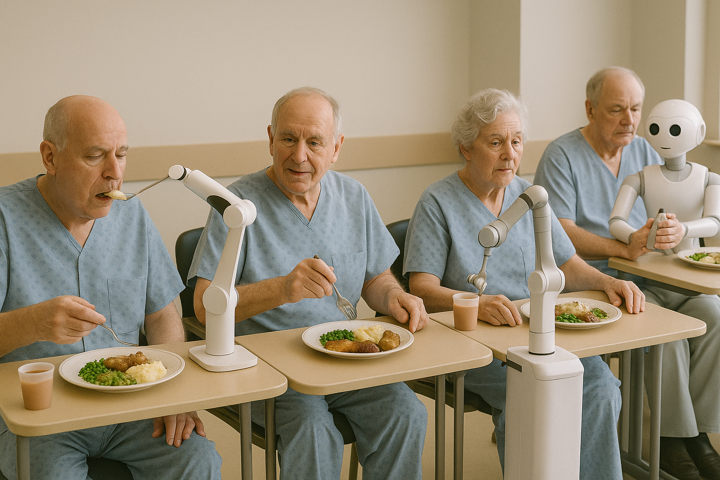
Challenge
Figure 14
Create an image of elder patient surrounded by robots and missing human interaction to share his feelings (OpenAI, 2023)
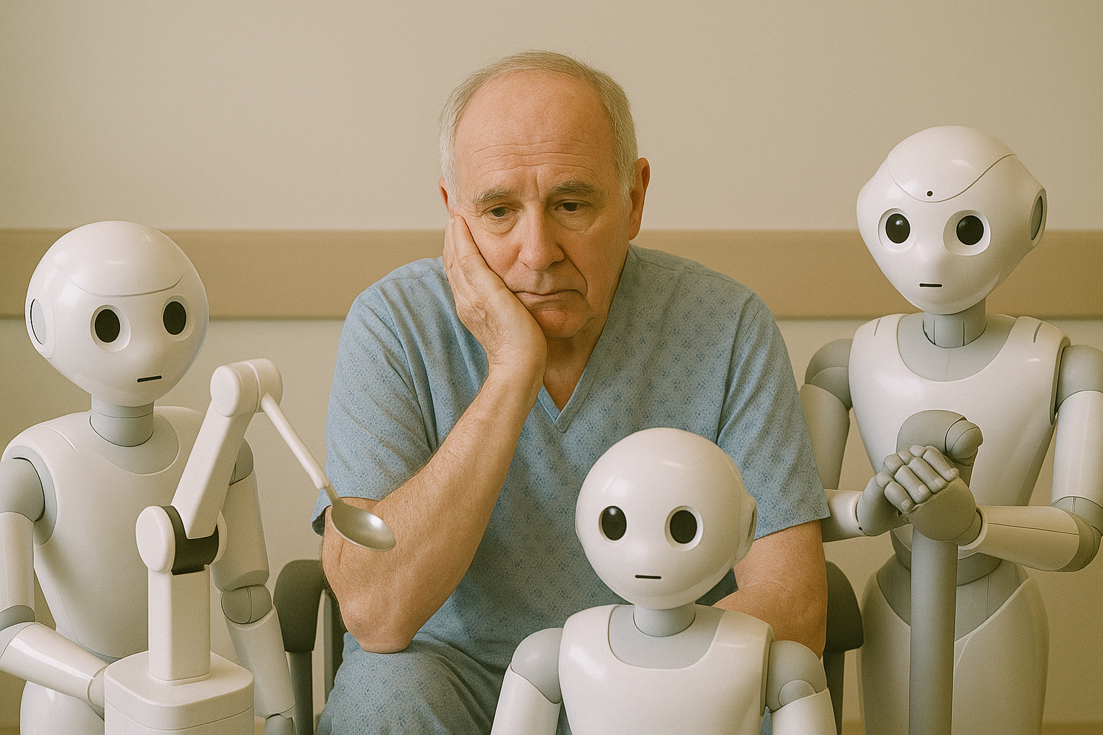
Narration
Mr. Miller Anderson, an 82-year-old male, was admitted to the hospital due to a stroke. Following the implementation of the hot stroke protocol, he required hospitalization for monitoring. After the stroke, Mr. Miller experienced a left-sided deficit. He was cleared to eat and perform rehabilitation to gain strength.
He was transferred to the rehabilitation unit, where he struggled to feed himself due to the left-sided weakness. Mr. Miller was taken aback when he first encountered a robot named Row, which introduced itself and recognized his condition.
Row brought Mr. Miller’s meal tray, sat with him, and offered to help him eat. Mr. Miller agreed, and Row efficiently noted which foods from the tray he wanted to consume. He was impressed with Row's sophistication and communication abilities.
Throughout his hospital stay, Mr. Miller actively worked to regain his strength and adapt to his new baseline, interacting with Row for meal assistance and eating well. As he prepared for discharge, he expressed his gratitude to Row, stating he wouldn’t have progressed without its help. He reflected positively on his experience and felt thankful for the advancements in technology that aided his recovery.
The use of assisted feeding robots in the unit has shown a significant decline in malnutrition rates and reduced the number of nasogastric (NG) tubes inserted. Elderly patients who suffered strokes were observed to be in much better spirits, demonstrating improved energy levels and greater recovery rates since the integration of assisted feeding robots at the unit.
References
Bellanti, F., Lo Buglio, A., Quiete, S., & Vendemiale, G. (2022). Malnutrition in hospitalized old patients: Screening and diagnosis, clinical outcomes, and management. Nutrients, 14(4), 910. https://doi.org/10.3390/nu14040910
Edwards, D., Carrier, J., & Hopkinson, J. (2017). Assistance at mealtimes in hospital settings and rehabilitation units for patients (>65years) from the perspective of patients, families and healthcare professionals: A mixed methods systematic review. International journal of nursing studies, 69, 100–118. https://doi.org/10.1016/j.ijnurstu.2017.01.013
Kovacs, R., & Lagarde, M. (2022). Does high workload reduce the quality of healthcare? Evidence from rural Senegal. Journal of health economics, 82, 102600. https://doi.org/10.1016/j.jhealeco.2022.102600
Mashrur, T., Ghulam, Z., French, G., & Abdullah, H. A. (2023). Assistive feeding robot for upper limb impairment—Testing and validation. International Journal of Advanced Robotic Systems, 20(4). https://doi.org/10.1177/17298806231183571
Medical Expo. (2025). Bestic, the eating assistance device. https://trends.medicalexpo.com/medicalexpo-e-magazine/project-118905-423917.html
Miller, K. (2023). Building a precise assistive-feeding robot that can handle any meal. Stanford University. https://hai.stanford.edu/news/building-precise-assistive-feeding-robot-can-handle-any-meal
Obi. (2025). What is Obi. https://meetobi.com/?srsltid=AfmBOooUM0EJkGCtyLv8vkbhn6fN5xcaoEl7X4SNB-5_6BY5Ie_QKJwd
OpenAI. (2023). ChatGPT (May 23 version). https://chatgpt.com
Park, D., Hoshi, Y., Mahajan, H. P., Kim, H. K., Erickson, Z., Rogers, W. A., & Kemp, C. C. (2020). Active-robot-assisted feeding with a general-purpose mobile manipulator: Design, evaluation, and lessons learned. Science Direct, 124(2020), e103344. https://doi.org/10.1016/j.robot.2019.103344
Sadiq, S. (2025). People with motor impairments help develop robotic feeding assistant at University of Washington. https://www.opb.org/article/2025/03/31/think-out-loud-robotic-feeding-assistant-robotics-motot-impairments-food-disabilities-caregivers/
Shune S. E. (2020). An altered eating experience: Attitudes toward feeding assistance among younger and older adults. Rehabilitation nursing: The Official Journal of the Association of Rehabilitation Nurses, 45(2), 97–105. https://doi.org/10.1097/rnj.0000000000000147
Sigmon DF, An J. (2022). Nasogastric Tube. In: StatPearls [Internet], Treasure Island (FL). StatPearls Publishing. https://www.ncbi.nlm.nih.gov/books/NBK556063/
Tsang, M. F. (2008). Is there adequate feeding assistance for the hospitalized elderly who are unable to feed themselves? Wiley Online Library, 65(3), 222-228. https://doi.org/10.1111/j.1747-0080.2008.00249.x
Uhlarik, M. (2025). Restoring mealtime independence: Robotic feeders empower people. Canadian Healthcare Technology. https://www.canhealth.com/2025/02/28/restoring-mealtime-independence-robotic-feeders-empower-people/

