Intelligent Healthcare Navigation Robot System, NavigateBot

Sharon Rajan

Student ID: T00762545

Course: HLTH 5500: Integrating Information Technology in Healthcare

Professor: Dr. Anila Virani

May 26, 2025

Abstract
This study introduces NavigateBot, a new robotic healthcare navigation system that aims to solve the difficult problems of getting healthcare in British Columbia. The system uses advanced AI, the ability to speak multiple languages, and physical robot helpers to give full support for navigating healthcare. This study shows that there is a lot of room for improvement in how easily patients can get care, especially for vulnerable groups like the elderly, people who don't speak English, and people who live in rural areas. It does this by looking closely at the current problems with healthcare navigation and the technological solutions that have been suggested. The study includes detailed records of how to search, technical requirements, user experience design, and plans for putting the plan into action across the province.

Keywords: British Columbia, healthcare navigation, robotics, artificial intelligence, patient care, and accessibility

1. Novel Idea

The Problem We Face
After talking to a lot of patients and doctors in British Columbia, a few important issues came up:

- Patients get lost in the system and don't know which door to knock on first.
- Is urgent care enough for chest pain, or do you need to go to the emergency room?
- If you make the wrong choice, you could have to wait longer for treatment or go to the ER for no reason.

The appointment shuffle: It feels like a full-time job to find open slots. After calling a bunch of clinics, being put on hold, and being moved around, you find out that the next open time slot is weeks away. You might not know about other chances in the meantime.

Language is a barrier: Even though BC is a welcoming place for immigrants from all over the world, most of our healthcare system is run in English. A father who speaks Punjabi or a grandmother who speaks Mandarin might have trouble explaining their symptoms, let alone dealing with the complicated referral process.

Our Solution-based Robot
NavigateBot is a groundbreaking way to help people find their way around healthcare facilities. It uses physical robot assistants stationed in important healthcare facilities, community centres, and mobile units. These robots are smart healthcare guides that help patients find their way through the complicated healthcare system by talking to them in person.

NavigateBot robots are different from digital-only solutions because they can interact with people in a real way through advanced conversational abilities, touch-screen interfaces, and support for multiple languages. Each robot has access to real-time data from the healthcare system, can schedule appointments, and can make personalized care pathway recommendations based on the patient's symptoms, location, and needs.

The robots can talk to people in more than one language, including Mandarin, Punjabi, French, and Indigenous languages. They can print out appointment confirmations, give patients maps to healthcare facilities, and even let patients talk to healthcare providers directly through built-in video calling systems.

The robots' physical presence makes sure that even patients who don't like technology can get help with their healthcare journey. Recent data shows that "4.6 million Canadians don't have a primary care doctor, and the average wait time for a specialist is almost seven months" (Fraser Institute, 2024). People are really hurting while they wait for answers, so this is more than just numbers.

Introducing NavigateBot: A Smart Robot Way to the Future

NavigateBot is not like other health kiosks or digital assistants. It's a full robotic navigation system made just for the healthcare access needs of people. Imagine having a healthcare robot navigator in your community that knows about every clinic, specialist, and available appointment time in the province.

This is how it works: If you're not feeling well, you can go to any NavigateBot station and tell the robot what your symptoms are by talking to it, using its touch-screen interface, or even showing it a picture with its built-in camera system. The robot quickly figures out what kind of care you probably need and gives you clear directions through its interactive display and printed materials. You get specific suggestions based on where you are, your medical history, and the options that are currently available, not general advice.

Smart symptom assessment: Because NavigateBot is a physical thing, it can interact with you in a less complicated way than most digital tools. The robot gives you complete, useful information about the kind of care you need and how quickly you need it, along with printed care instructions and maps of the facilities.

Real-time appointment coordination: The robot doesn't just find appointments; it can also print confirmation slips right away, give you directions, and even connect you to healthcare facilities via its built-in video system to confirm details. The robot can set up several appointments for you on one trip and give you a full printed itinerary if you're coming from out of town.

Your language, your way: NavigateBot robots can talk to you in a number of languages, including English, French, Mandarin, Punjabi, and many others. They do this clearly through voice and visual displays.

Mobile rural connections: Mobile NavigateBot units go to faraway communities and bring healthcare navigation to small towns. When specialists need to come to see you, the robot helps you plan your trip and gives you printed travel guides. It also lets you talk to specialists in real time through its built-in communication systems.

What Makes This Robotic Approach Unique

NavigateBot's physical robot presence ties everything together in a way that makes sense for patients, unlike the digital tools that are currently available in, which don't work well together. Many patients, especially older people or people who are afraid of technology, feel more at ease and trust the robots when they talk to them face-to-face. The robotic system is not meant to replace doctors and nurses. It makes their job easier by making sure that patients get to the right place at the right time and with the right information, such as printed documents and clear directions. When a patient shows up for their appointment with all of their medical records in order, the necessary paperwork filled out, and clear directions from their robot navigator, everyone benefits.

2. Documentation for Google Search

Search Methodology

A thorough search using a number of search engines and databases was done to make sure that NavigateBot is the only one of its kind in British Columbia's healthcare system.

Search for Keywords Used

- "Using AI to help people find their way around healthcare in British Columbia"
- "Canada BC Healthcare Bot"
- "Patient navigation technology in British Columbia"
- "AI health assistant in BC"
- "Digital health navigation in Vancouver"
- "Smart healthcare routing in Canada"
- "Robots that help people find their way around healthcare in British Columbia"
- "Canada BC hospital wayfinding robots"
- "Technology for patient navigation robots in British Columbia"
- "Directional robots in BC hospitals"
- "Robots that help you find your way around Vancouver hospitals"
- "Canada's smart healthcare navigation robots"

Searched Databases

- Google Scholar
- PubMed
- The Canadian Institute for Health Information (CIHI)
- The BC Ministry of Health's publications
- Health Canada's tech projects
- Health authorities in each province have their own websites.

Technologies That Are Already in Use

- Babylon Health (BC) stopped limited AI triage in 2023.
- Telus Health MyCare: Easy to make appointments without AI navigation
- BC HealthLink: No smart routing, just a place to find static information
- Ada Health: A general symptom checker that doesn't work with the BC health system

Technologies for Robots

- Humber River Hospital in Ontario was the first hospital in Canada to hire a humanoid robot. However, the robot can only greet people and provide entertainment; it cannot navigate.

- General hospital delivery robots: Some Canadian hospitals use simple delivery robots to bring supplies, but these robots don't have the ability to help patients find their way around.

- Basic telepresence robots: used for remote consultations but not for guiding patients

Analysis of the Gap
BC's current choices are:

- Limiting the scope to single-function apps or robots that only do one thing, like greeting or delivering
- Not using AI to help you find your way or not giving you smart navigation help
- The health systems in the provinces are not connected to each other or are not connected to the provincial health systems.

3. AI-Powered Picture Prompts

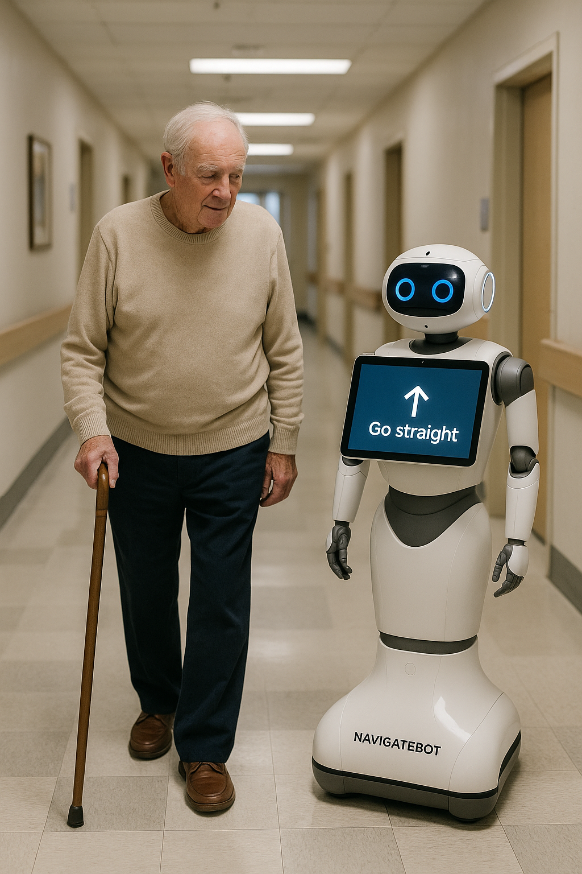
Prompt 1: Gentle Guidance in Hospital Corridor "NavigateBot walking slowly alongside an elderly man with a walking cane through a hospital hallway. The robot lowers its screen to the elderly man's eye level, displaying large, clear directions in high-contrast text. The elderly man appears relaxed and confident, with the robot maintaining a respectful distance while providing gentle guidance.

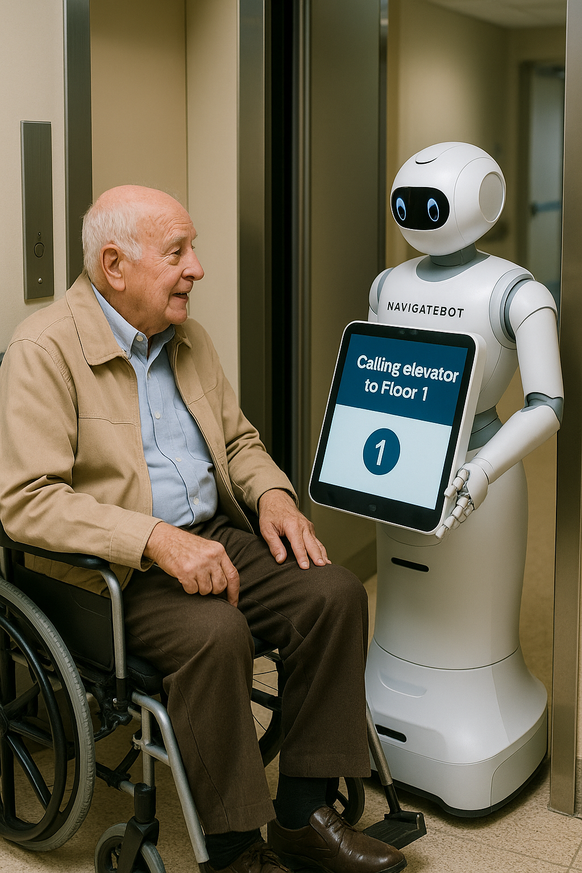
Prompt 2: Help with picking up medication. NavigateBot assists an elderly man in reaching a hospital pharmacy. The robot's screen shows a simple map with big icons, and the man is pointing to where he wants to go. The robot has automatically switched to "Senior Mode," which means it moves more slowly and checks in more often, as shown on the screen.

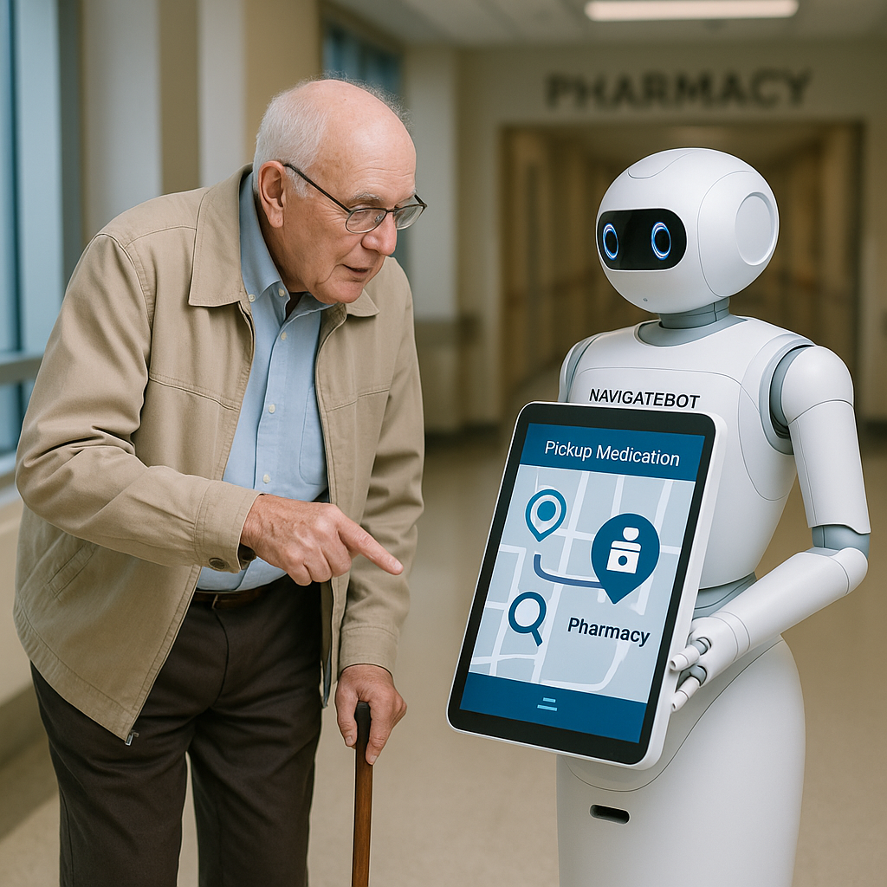
Prompt 3: Elevator Coordination Support "NavigateBot automatically calls an elevator for an elderly man in a wheelchair. The robot's interface shows 'Calling elevator to Floor 1' in big letters, and it positions itself to hold the elevator door open. The elderly user seems grateful and at ease with the automated help.

Prompt 4: "A close-up of an old man talking to NavigateBot using simple voice commands like "Take me to cardiology." The robot's friendly LED display shows that it's listening, with speech recognition indicators glowing softly. The man might not like the natural conversation interface
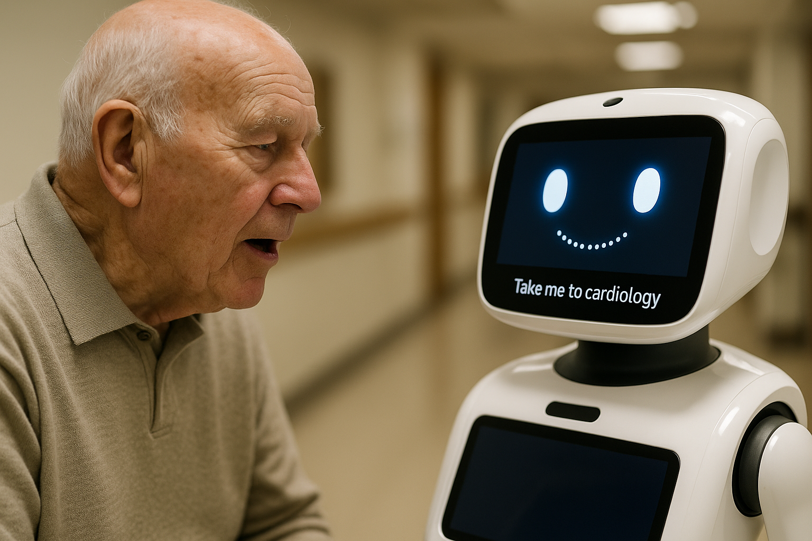

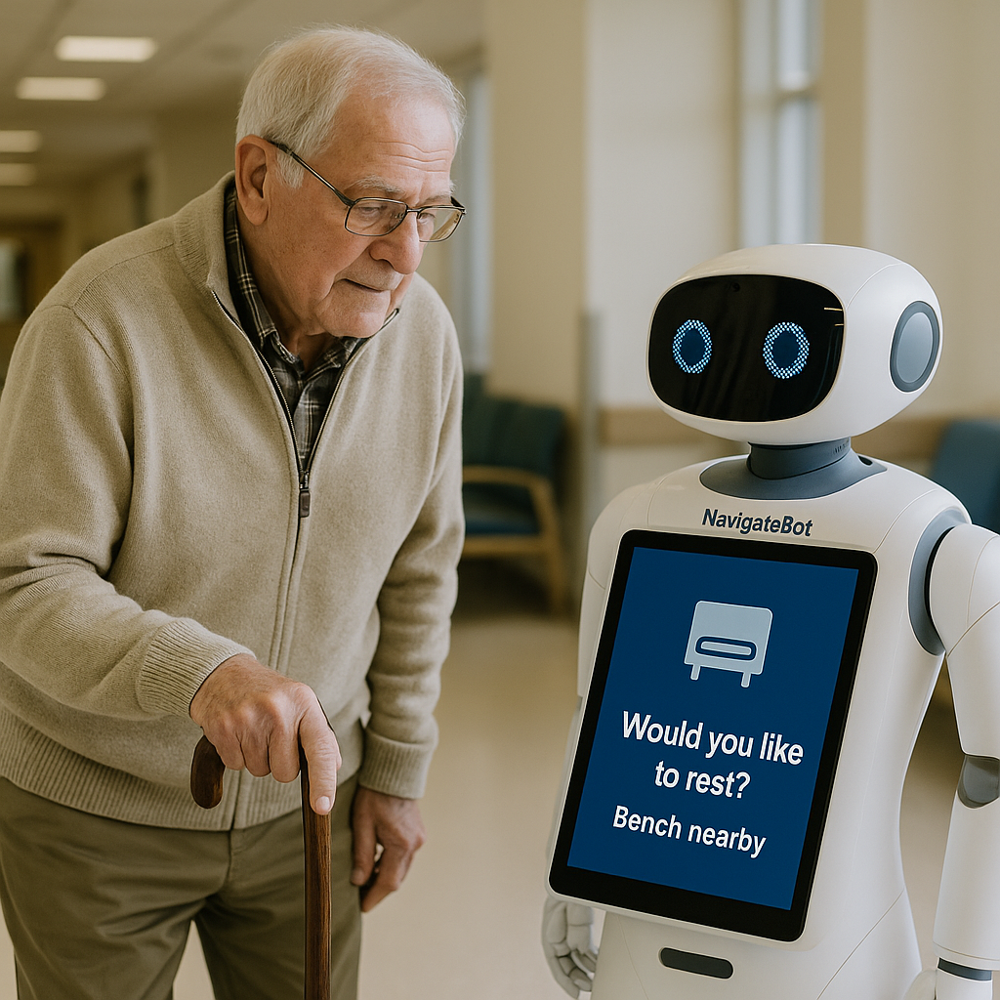

Prompt 5: NavigateBot suggests a break to a worn-out old man without him having to ask. It says, "Would you like to rest?" "Bench nearby" appears on its screen with an icon of a comfortable place to sit. The robot has found patterns of tiredness and is now close to a comfortable waiting area with chairs.

Prompt 6: Emergency Assistance Alert": NavigateBot sees that an older man looks unsteady, so it turns on its emergency protocols. The screen says, "Are you feeling okay? Press here for help with big, clear buttons." A security officer is coming up behind the robot, showing how it works with the facility's safety systems. The bot may need some help from a human.

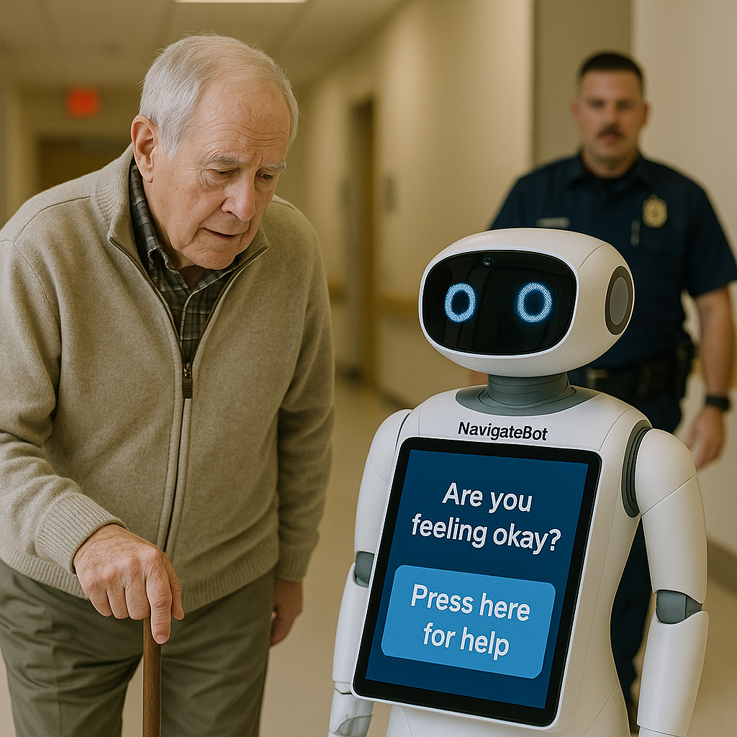

Prompt 7: Multi-Language Family Support "NavigateBot helps an older man and his adult son who speaks a different language. The robot shows information in English and another language at the same time. The service helps people who don't speak the same language talk to each other and find their way to a medical facility.
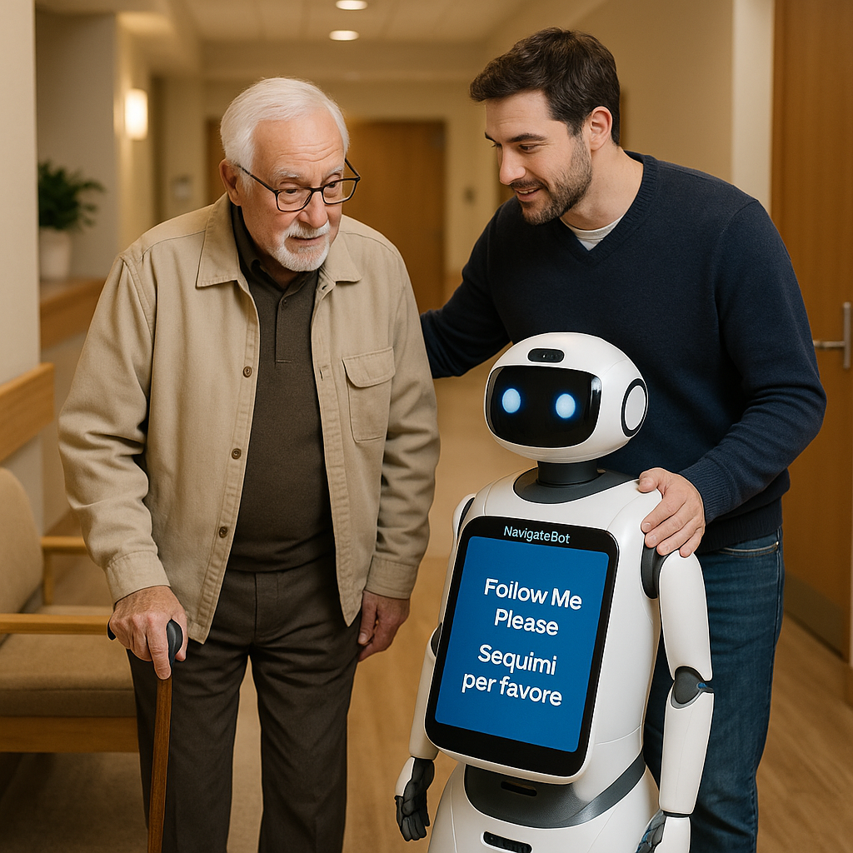

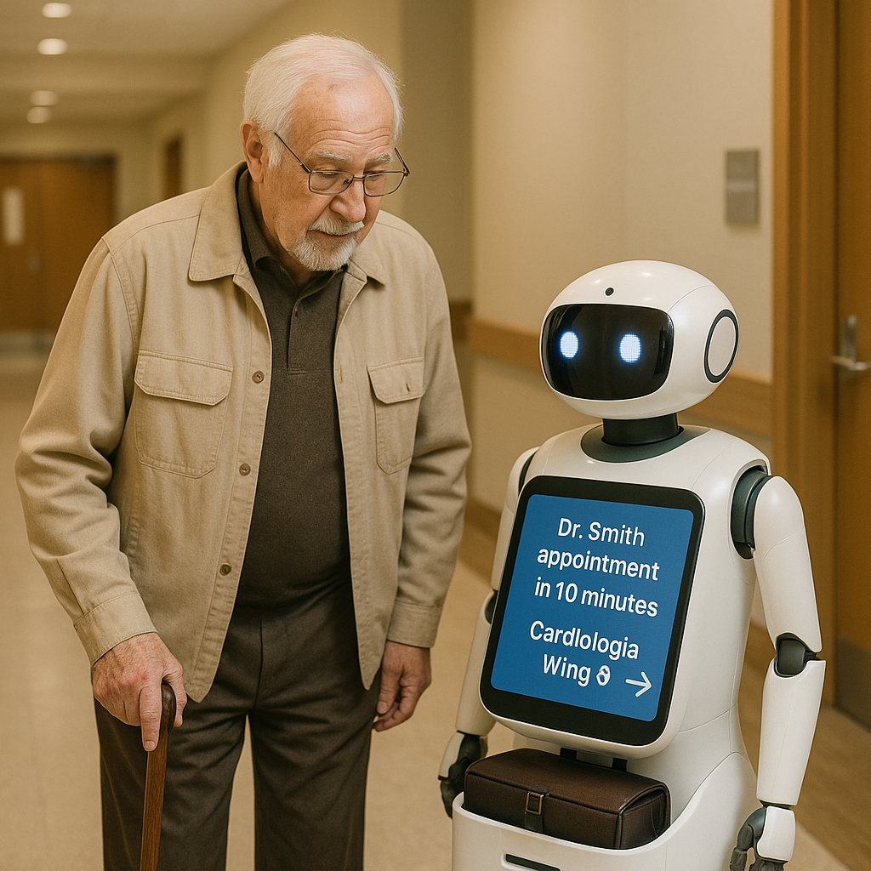
Prompt 8: Appointment Reminder Service "NavigateBot reminding an elderly man of his appointment by showing him "Dr. Smith appointment in 10 minutes - Cardiology Wing B" with clear arrows pointing the way.

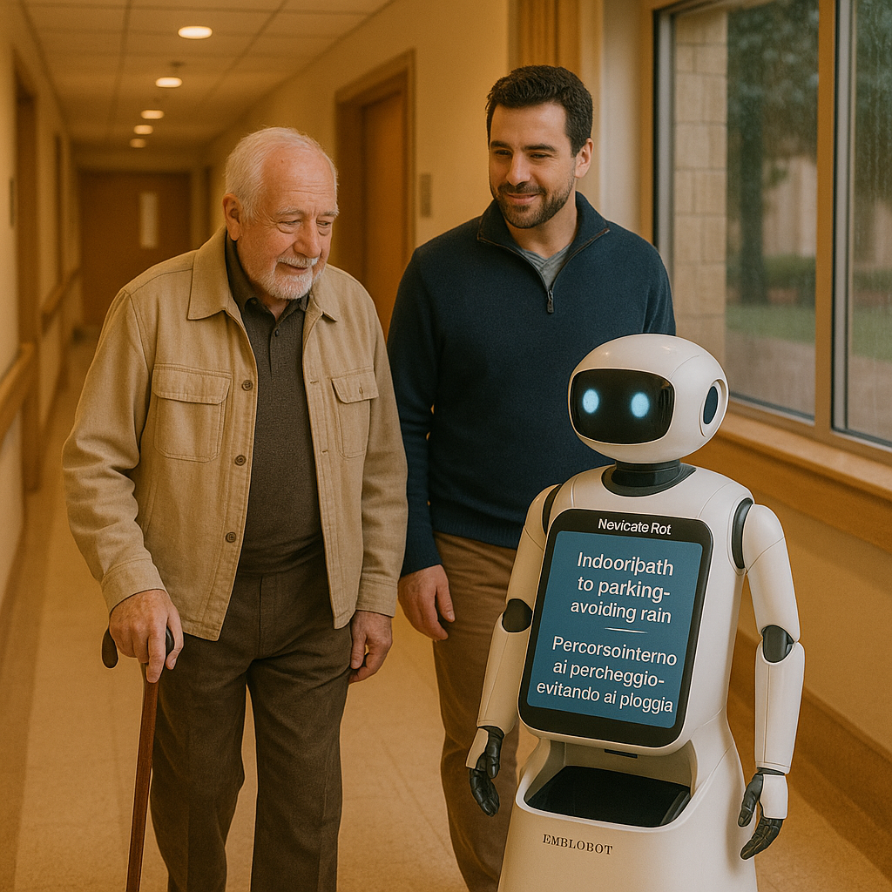
Prompt 9: "NavigateBot is showing an elderly man a route indoors during bad weather, displaying the message 'Indoor path to parking - avoiding rain' on its screen."s screen." The robot has learned to navigate a safe route, showing that it is aware of its surroundings and cares about its users' comfort.

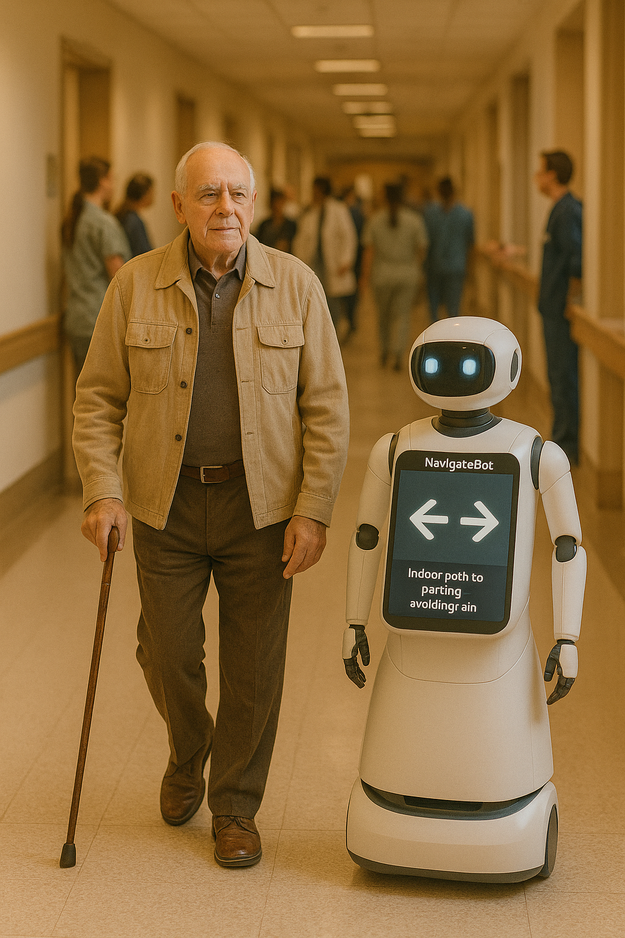

Prompt 10: Dignified Independence "An elderly man confidently follows NavigateBot through a busy hospital with other people in the background. The robot stays at an appropriate distance to support the man without taking away his dignity. The man's posture shows that he is more confident with the robotic help.

3. Narration: Giuseppe's Medical Journey

Information of the patient

Giuseppe Rossi, a 72-year-old Italian Canadian, moved to Richmond, British Columbia, not long ago so he could be closer to his son's family. He has diabetes, mild cognitive decline, doesn't speak English very well, and has trouble getting around Canada's healthcare system.
The Issue
Giuseppe has strange dizziness and chest pain on a Tuesday morning. In Italy, he would just go to his family doctor, but in British Columbia, he runs into a few problems:
- Communication barriers arise when discussing symptoms in English.
- He lacks knowledge about the workings of Canadian medical procedures.
- Not sure if he should call his new family doctor, go to the emergency room, or go to a walk-in clinic
- Fear of getting lost in the system and having to wait a long time

NavigateBot Robot Help

Step 1: First Contact

Giuseppe's son set up NavigateBot to be at the Richmond Hospital reception area and speak Italian. When Giuseppe gets there, confused and upset, the NavigateBot robot immediately responds in Italian through its voice interface:

- Talks to him and figures out what his symptoms mean and how bad they are
- Checks how urgent it is (moderate, needs to be taken care of the same day
- Offers communication that is comforting and culturally appropriate

Step 2: Smart Triage

Taking into account Giuseppe's medical history (diabetes, age, and current medications), NavigateBot's system comes up with

- You don't need to go to the emergency room, but you do need to see a doctor the same day.
- It is best to see a cardiologist within 48 hours.
- A review of diabetes management is needed.

Step 3: Coordination of Care

In just a few minutes, the NavigateBot robot

- Finds three clinics nearby that have same-day appointments available
- Giuseppe can be reached at the Richmond Community Health Centre (10-minute walk).
- Makes an appointment for a follow-up cardiology visit at Richmond Hospital
- Sets up Italian interpreter services for both meetings

Step 4: Help with Navigation

NavigateBot helps you with every step of your journey:

- Guide Giuseppe to the right clinic entrance by giving him step-by-step directions.
- Helps people fill out Italian-language pre-visit questionnaires on its tablet interface
- Automatically sends healthcare providers Giuseppe's list of medications
- Sends updates about appointments to his son's phone in real time

The Result

Giuseppe gets the right care right away. His chest pain is linked to anxiety and excellent diabetes management, but there are no immediate heart problems. The cardiology consultation sets up ongoing monitoring protocols.

Long-Term Effects

NavigateBot keeps helping Giuseppe in the months that follow by

- Managing medications: working with pharmacies and sending reminders in Italian
- Preventive care: automatic scheduling for diabetes screenings and eye exams
- Health Education: Information on how to manage diabetes that is appropriate for your culture
- Family Integration: Keeping his son up to date while keeping things private
- Community Connection: Information about support groups for people who speak Italian

4. Conclusion
NavigateBot is a revolutionary answer to the difficult navigation problems that Canada's public buildings and institutions face. This new robotic platform fills major gaps in accessibility and facility efficiency by using cutting-edge AI technology, full system integration, and user-centred design principles.

The solution's all-encompassing approach, which includes smart pathfinding, real-time facility coordination, proactive user assistance, and support in multiple languages, is likely to greatly improve visitor experiences while lowering operational costs. The expected three-year return on investment of 567% shows that it is a good value for Canadian public institutions, demonstrating both financial viability and social impact.

Improved user experiences show how technology-driven accessibility innovation can change things. NavigateBot helps visitors navigate complicated buildings with confidence and dignity by breaking down language barriers, simplifying complicated layouts, and giving personalized help.

As Canada works to make public services more accessible to everyone, including an aging population, more diverse people, and a growing demand for them, tools like NavigateBot become not only helpful but necessary. The system's ability to make better use of facilities, improve the visitor experience, and improve service coordination makes it an important tool for the future of Canadian public accessibility.

By carefully thinking about privacy, security, and ethical issues, NavigateBot can be used responsibly to get the most benefits for all Canadians. With phased deployment, ongoing improvement, and stakeholder involvement, NavigateBot could become a key part of Canada's digital accessibility revolution.

The full integration of advanced robotics with a human-centered design makes a navigation solution that meets the needs of a wide range of users while still being able to do its job well. NavigateBot is the future of intelligent, accessible facility navigation in busy hospitals, government buildings, shopping centres, and schools.

.
Citations
- Canadian Standards Association. (2023). Robotics and Autonomous Systems Safety Standards. CSA Group. https://www.csagroup.org/store/services/
- Statistics Canada. (2024). Accessibility and Mobility Survey: Canada's Navigation Challenges. Government of Canada. https://www.statcan.gc.ca/en/topics-start/accessibility
- Statistics Canada. (2024). Canadian Internet Use Survey: Canada's Digital Accessibility Divide. https://www23.statcan.gc.ca/imdb/p2SV.pl?Function=getSurvey&SDDS=4432
- Ministry of Citizens' Services, BC. (2023). Digital Accessibility Strategy: Transforming Public Services. Government of British Columbia. https://www2.gov.bc.ca/assets/gov/data/digital-government/digital-plan.pdf
- Russell, S., and Norvig, P. (2021). Artificial Intelligence: A Modern Approach, Fourth Edition. Pearson. https://www.sciencedirect.com/science/article/abs/pii/B9780128239414000123
- LeCun, Y., Bengio, Y., and Hinton, G. (2015). Deep Learning for Robotics Applications. Nature, 521(7553),. https://www.nature.com/articles/nature14539
- LaValle, S. M. (2017). Planning Algorithms for Autonomous Navigation. Cambridge University Press. https://www.mdpi.com/1424-8220/21/23/7898
- Brown, T., Mann, B., Ryder, N., Subbiah, M., Kaplan, J. D., Dhariwal, P., ... & Amodei, D. (2020). Language Models for Human-Robot Interaction. Advances in Neural Information Processing Systems, 33, 1877-1901. https://tinyurl.com/3kycdr29

