QuickScan: A Handheld Diagnostic Tool for Skin Injuries

Jamie Steele
T00745105
Thompson Rivers University
HLTH 5500 Integrating IT in Healthcare
Dr Anila Virani
May 26, 2025

QuickScan: A Handheld Diagnostic Tool for Skin Injuries
Children perceive and interact with the world in ways that often contrast with adult perspectives. They are naturally curious and inquisitive, often acting without considering the consequences or potential risks. Play is essential to both the psychological and physical development of children (Bauer et al., 2020). However, with exploration comes the risk of injury, ranging from minor to traumatic. While parents do their best to keep children safe, there is a fine line between being overprotective and allowing children the freedom to make mistakes and learn from them. Injuries are an inevitable part of growing up and developing life skills. Emergency rooms are increasingly overcrowded, and many visits are for non-emergent concerns, which further strains the healthcare system (Varner, 2023). But what if there was a device that could reduce unnecessary emergency room visits for minor injuries in children, while also providing reassurance to parents and supporting the healing process?
The purpose of this paper is to describe the novel concept of QuickScan; an at-home handheld diagnostic tool designed to assess minor skin injuries and conditions in children, offering treatment guidelines and ongoing monitoring. This device has the potential to reduce unnecessary emergency room visits for minor skin injuries, helping to ease pressure on the healthcare system.
Description of Novel Idea
Problem Identification
Appetite to Play was a government initiative launched in 2017 to ensure that children enrolled in early childhood education programs across the province have consistent standards for healthy outdoor active play (Buckler et al., 2023). This initiative mandates 60 minutes of outdoor active play daily and limits screen time to less than 30 minutes per day (Buckler et al., 2023). Similarly, the American Academy of Pediatrics encourages pediatricians to ‘prescribe’ free play and advises adults to intervene only when safety is a concern (Bauer et al., 2020). The Canadian Position Statement on Active Outdoor Play takes a similar stance and urges parents to step back and allow children to take risks during play in order to develop essential life skills (Bauer et al., 2020).
It is inevitable that when children play, the potential for injury is always present. Young children often lack the “fundamental movement skills” (Buckler et al, 2023, p.1), such as running, jumping, and balancing needed to protect themselves. These skills are typically developed through physical play and form the foundation for lifelong participation in physical activities. Encouraging physical activity early in life not only encourages skill development but also helps reduce rates of childhood obesity (Buckler at al., 2023). Establishing active habits in childhood contributes to healthy aging and long-term physical well-being.
Parenting is a rewarding experience, but it also comes with many challenges and fears. The pressure to keep children safe and protected from danger can lead to a reduction in the amount of free play children engage in, especially outdoors in uncontrolled environments (Bauer et al., 2020). A noteworthy generational shift is occurring, with fathers becoming more involved in raising children and participating in daily parenting tasks. This raises an interesting question: are fathers as likely as mothers to prioritize safety when it comes to allowing their children to engage in free play? (Bauer et al., 2020). In today’s society, it is reported that both mothers and fathers report feeling similar pressures to ensure their children's safety (Bauer et al., 2020). Bauer et al. (2020) also found that parents living in rural communities, where immediate access to healthcare is limited, often had differing views on risky play; as well as varying definitions of what constitutes minor versus serious injuries.
A clear problem has been identified: parents are doing their best to keep their children safe, while children naturally want to explore the world and gain independence, often resulting in minor injuries. At the same time, emergency rooms across Canada are overwhelmed, especially during the warmer months when outdoor activities and vacations are more frequent (Varner, 2023). So, how can we reduce unnecessary emergency room visits? Could a device help parents distinguish between minor and major skin injuries, offer immediate treatment guidance and warning signs, and provide a way to track healing progress? Introducing QuickScan-a handheld diagnostic tool designed to support parents in managing minor skin injuries confidently at home.
Proposed Solution
QuickScan is a handheld diagnostic device that uses artificial intelligence (AI) to visually assess skin injuries. Children are more prone to minor skin injuries, and parents may lack knowledge about appropriate treatment options or access to healthcare resources. QuickScan provides real-time analysis of the injury, offering an accurate assessment of severity, suggested treatment options, and monitoring recommendations. The device uses a built-in camera to capture an image of the injury. Using AI, it then analyzes the injury and displays information on a touchscreen interface. Tabs appear outlining the severity, recommended treatments, when to seek medical attention, and how to monitor the healing process. Parents gain peace of mind knowing they are making informed decisions based on evidence-based guidance, while also helping to prevent unnecessary emergency room visits. QuickScan also features an interactive healing tracker. By swiping to the next screen, parents can take progress photos, which can be uploaded to a child-friendly interface. This helps children actively participate in their recovery by seeing visual improvements over time. Additionally, QuickScan supports consistent care by ensuring all caregivers follow the same treatment plan.
The QuickScan device is compact, similar in size to a smartphone. It must be connected to a wireless internet connection to operate, charges via a USB-C cable, and offers a long battery life, lasting up to 12 hours of continuous use. A small red battery indicator light appears on the screen while charging and turns blue once fully charged. Alert banners will flash at the top of the screen when the battery drops below 50%, again at 25%, and finally at 5%. Users have the option to create a profile or use the device as a guest. For families using the device regularly, creating a profile is recommended, as entering the age of the child and any other related health concerns helps optimize injury identification and ensures age-appropriate treatment. QuickScan features a rear-facing camera that scans the affected area without needing to touch the skin. It functions best when held five to ten centimetres away from the desired area. While the device is water-resistant and can be wiped with disinfectant, it is not waterproof. The screen should only be cleaned with certified screen wipes. The durable outer casing offers protection against minor damage but has not been evaluated for drops greater than 24 inches. For best results and device longevity, QuickScan should be operated by an adult.
QuickScan utilizes AI to help diagnose, guide treatment, and support the healing of minor to moderate skin injuries. It is primarily intended for use on lacerations and abrasions commonly sustained by children during everyday activities. QuickScan can also assist in identifying and managing first and second-degree burns, insect bites or stings, and certain rashes; typically, allergic or fungal rashes. The goal is to provide parents with peace of mind by enabling them to manage their children's minor ailments at home, reducing unnecessary visits to already overcrowded emergency rooms. If the device is unable to determine the severity of the injury, it will automatically advise the user to seek medical attention. QuickScan also includes a healing tracker, allowing parents to track recovery while engaging children through a fun, child-friendly interface accessible via smartphone or tablet. Based on its assessment, QuickScan will recommend when to re-scan the injury, and each image is uploaded to the interface to allow for visual progress comparison. If healing is not occurring as expected, the device will prompt the user to seek professional medical care.
One key consideration in designing this device was its potential value in rural areas of British Columbia, where access to healthcare is often limited. The idea is that families could purchase their own QuickScan device, or local clinics could provide one for public use, helping to reduce unnecessary travel to distant healthcare facilities for non-urgent concerns. QuickScan could also be integrated with telehealth services, allowing physicians to remotely review the device’s input and either recommend monitoring the injury with provided guidelines or direct the patient to the nearest healthcare centre if needed. This approach would help reduce strain on rural healthcare resources and minimize unnecessary visits.
Obvious drawbacks of the QuickScan device include the potential for scanning errors that could lead to unnecessary visits to the emergency department. In addition, limited or weak internet connectivity may prevent the device from operating at its full potential. It is also important to note that the QuickScan is not a replacement for medical professionals; rather, it is intended to support decision-making for parents and adult guardians.
Online Search
An online search using Google revealed that no devices like QuickScan currently exist in British Columbia. The following search terms were used:
Portable scanning device for minor injuries in British Columbia
Handheld scanner for injuries
Pediatric scanner for injuries
Handheld diagnostic tool for abrasions
None of these terms yielded relevant results. However, a few companies were identified that offer portable ultrasound and x-ray machines within the province. For example, Clarius provides various models of handheld portable ultrasound devices available in British Columbia. These tools bring diagnostic testing directly to the patient, making them particularly valuable in doctors' offices or rural settings where access to care may be limited (Clarius, 2025). Similarly, ProMed Mobile Imaging advertises its ability to deploy ultrasound and x-ray machines anywhere in British Columbia, along with certified staff to perform the scans (ProMed, 2025).
One device that did appear in the search results under the term “handheld diagnostic tool for abrasions” was MolecuLight. Available in Canada and internationally, MolecuLight is marketed as an all-in-one device designed to detect harmful bacteria linked to infections, accurately measure wounds, and visualize skin temperature changes (MolecuLight, 2025). It uses a violet light to scan the skin, causing bacterial presence to fluoresce in different colours (red or blue) depending on bacterial load (MolecuLight, 2025). It also allows for digital wound measurements and tracking of healing over time. However, based on information from the company’s website, this device is tailored more toward managing chronic wounds in older populations, rather than minor injuries in young children. As noted, a device like QuickScan is not currently available in British Columbia, highlighting a clear gap in the market for a child-focused, handheld diagnostic tool.
AI Generated Images
The images were generated using Microsoft Co-Pilot, with the prompts used for creation listed below each image. Please see the images beginning on the next page.

Image 1: The QuickScan Device
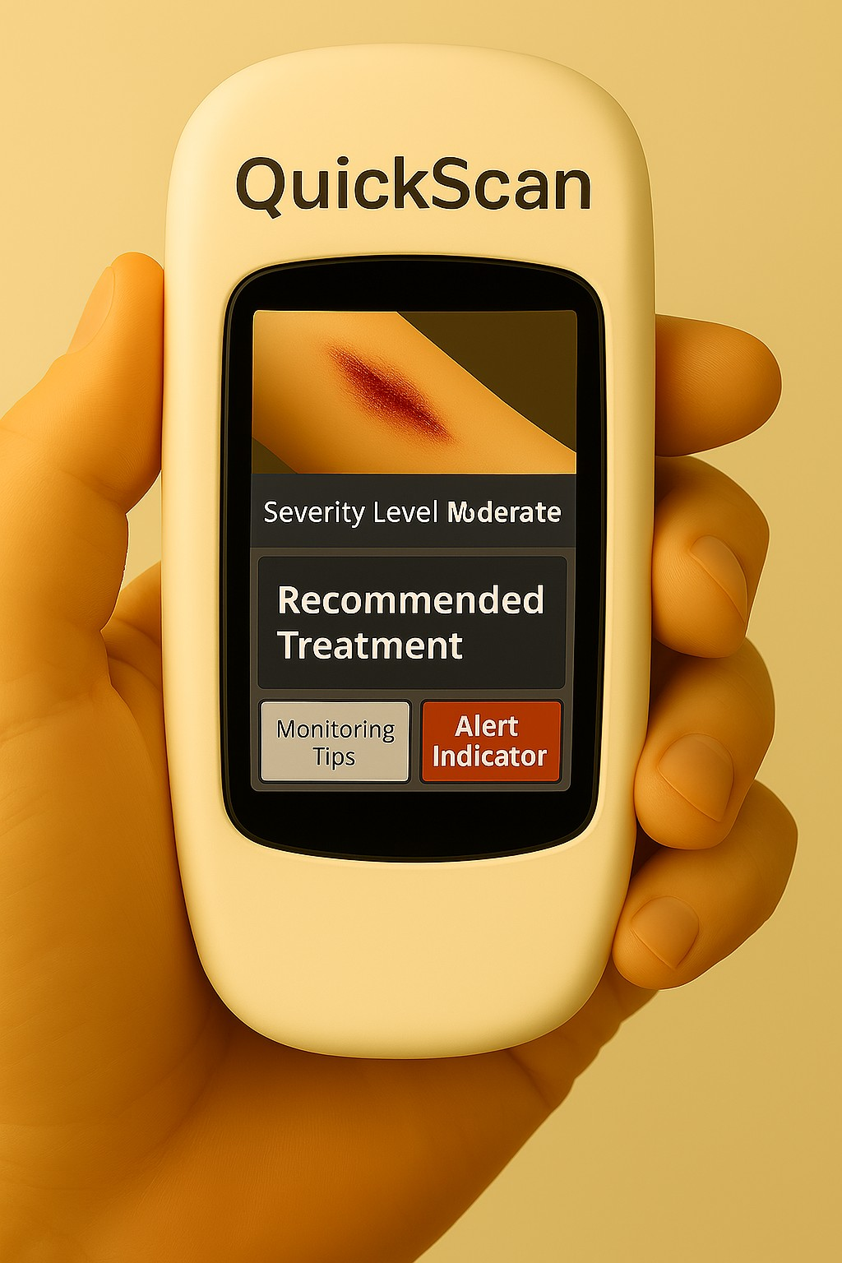

Prompt: A close-up of a hand holding the device, called QuickScan, which displays an image of a skin laceration on its screen. The device is white, similar to the size of a smartphone. The screen includes a photo of a skin laceration, a severity level marked as 'Moderate' and has options for 'Recommended Treatment,' 'Monitoring Tips,' and 'Alert Indicator.' The interface is clear and user-friendly; it is in English.

Image 2: The QuickScan Ensures Preparedness for Injuries at Home
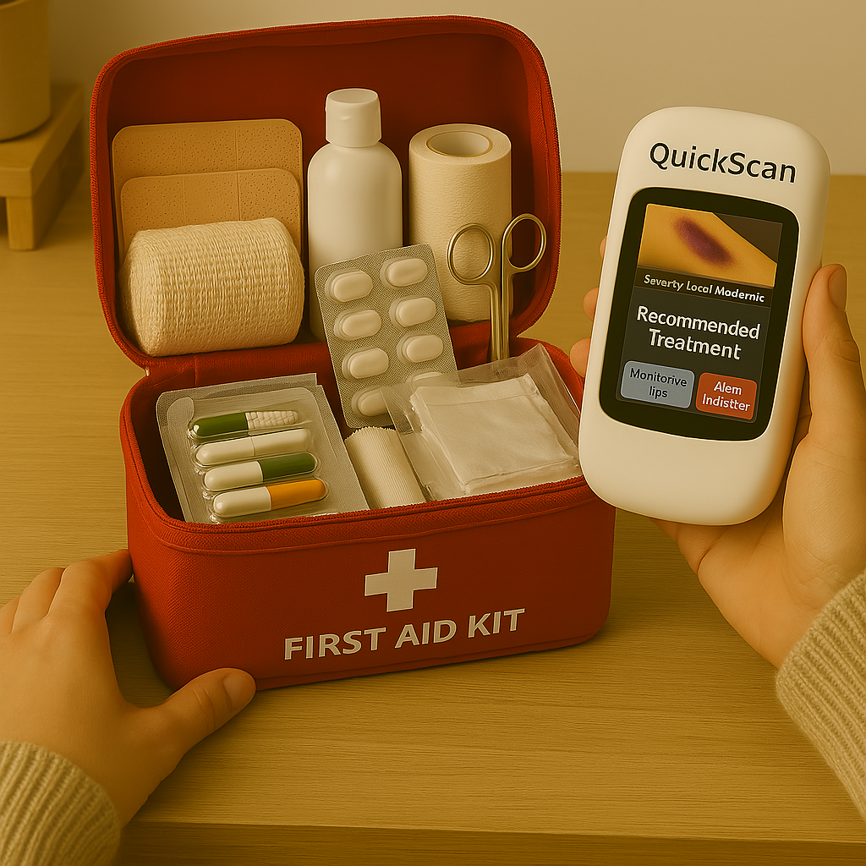
Prompt: Create an image using the QuickScan from the previous image we created. Show a person organizing a home first-aid kit with the QuickScan device placed alongside it. The scene highlights the importance of preparedness and how the device can assist in assessing minor injuries quickly.

Image 3: The QuickScan Device Being Used During a Vacation
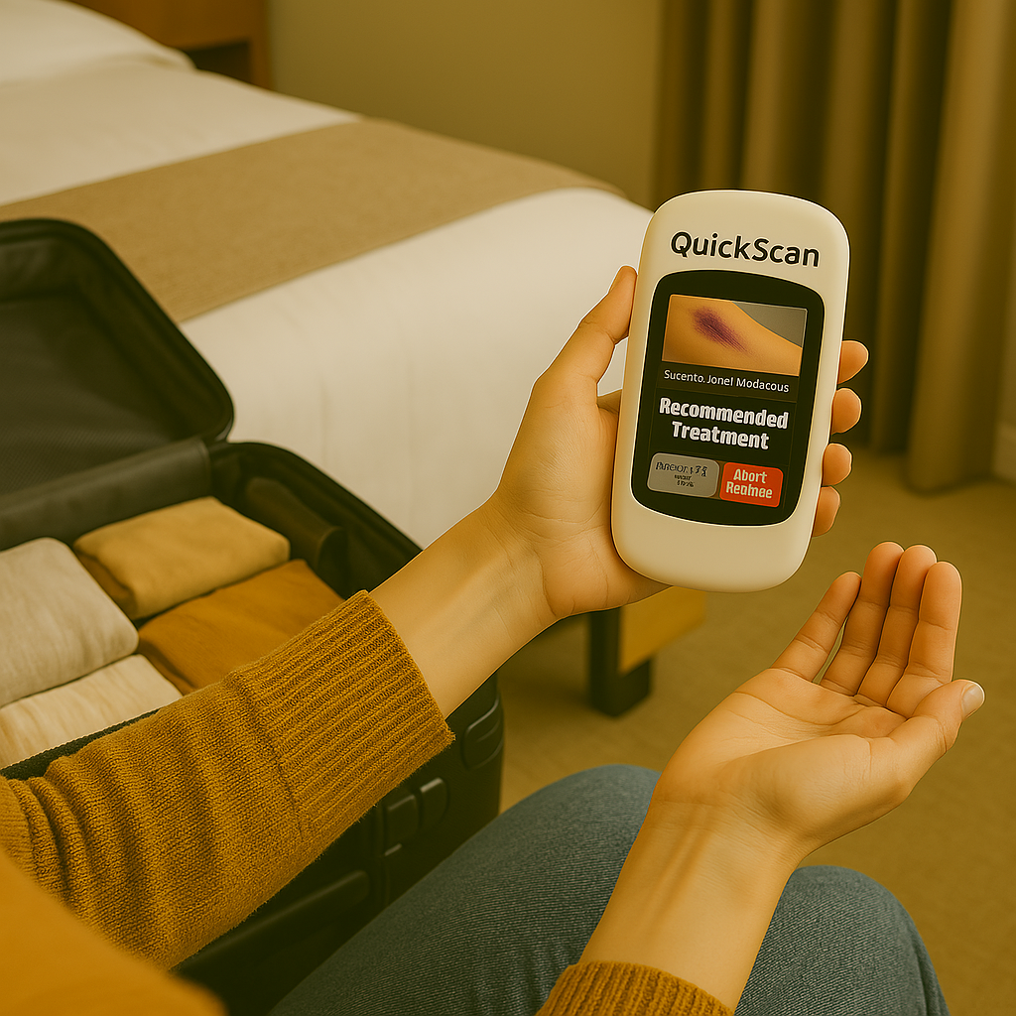
Prompt: Using the same white QuickScan device in the previous image, depict a traveler using the QuickScan device in a hotel room or near a suitcase. The image emphasizes how the device can be a valuable tool for those on the go, providing peace of mind in unfamiliar environments.

Image 4: A Healthcare Worker Explains How to Use the QuickScan Device
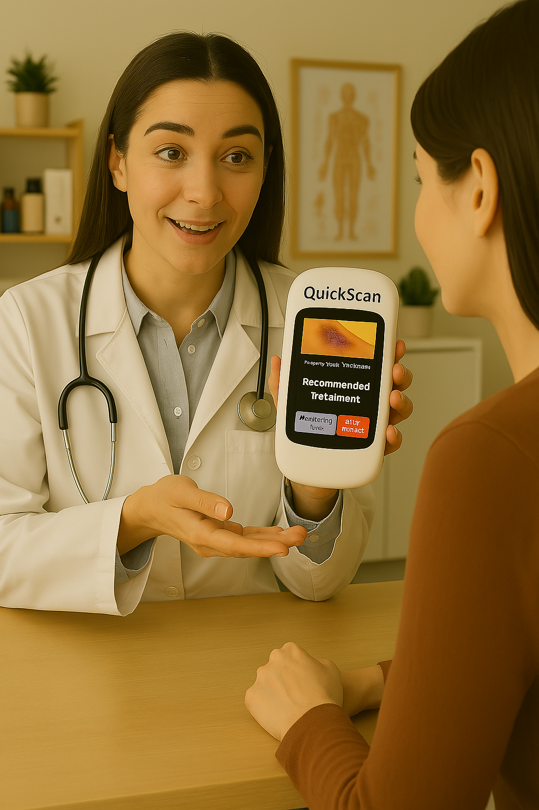
Prompt: Show a doctor or healthcare worker demonstrating the same QuickScan device in a clinic or pharmacy setting. They are explaining how it works to a patient, emphasizing its usefulness. The environment is welcoming, and the healthcare worker is professional and informative.

Image 5: QuickScan is Portable, Perfect for Adventuring Families

Prompt: Create an image of a family hiking in a wooded area. The dad is wearing a backpack with the pocket zipper slightly open, and the QuickScan device from previous images is half visible. they are standing at a trail sign that states 'waterfall' with an arrow.

Image 6: A Parent Scans a Child’s Minor Skin Injury at Home
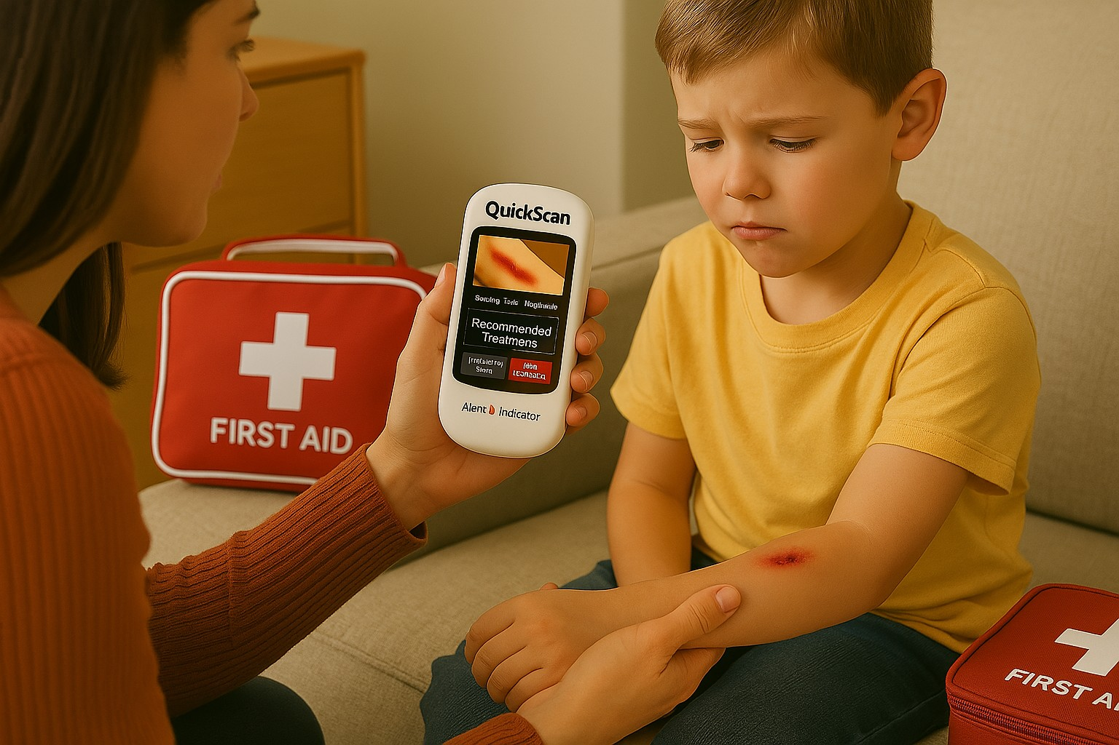
Prompt: Create an image using the same QuickScan device in a home environment, where a parent or caregiver is using the QuickScan device to check a child’s minor injury. There is a first aid kit nearby and the device is providing useful guidance on treatment.

Image 7: The QuickScan Child Friendly Healing Interface
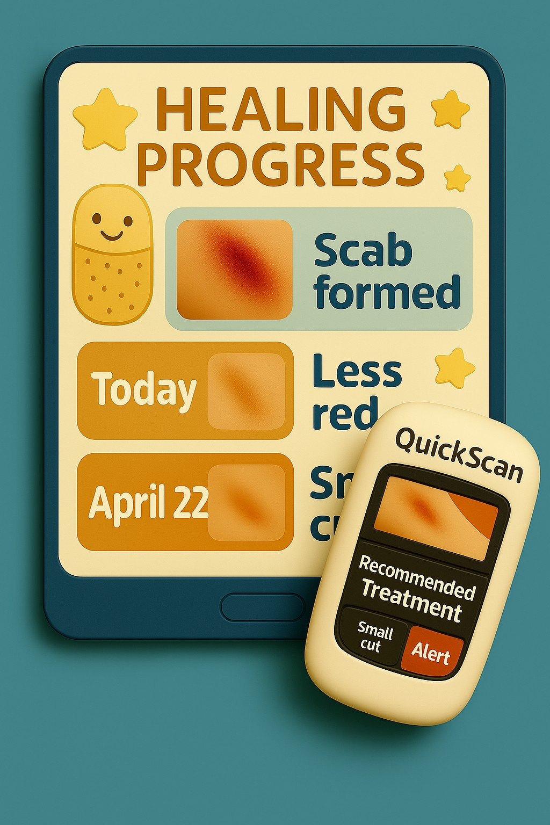
Prompt: Using the same scan device, create an image of a digital dashboard interface showing daily healing progress photos and updates for a minor injury. The scan tool is in the corner, indicating data is from QuickScan. Please make the dashboard face child friendly with happy images.

Image 8: A Parent Explaining How to Use the QuickScan Device to a Grandparent
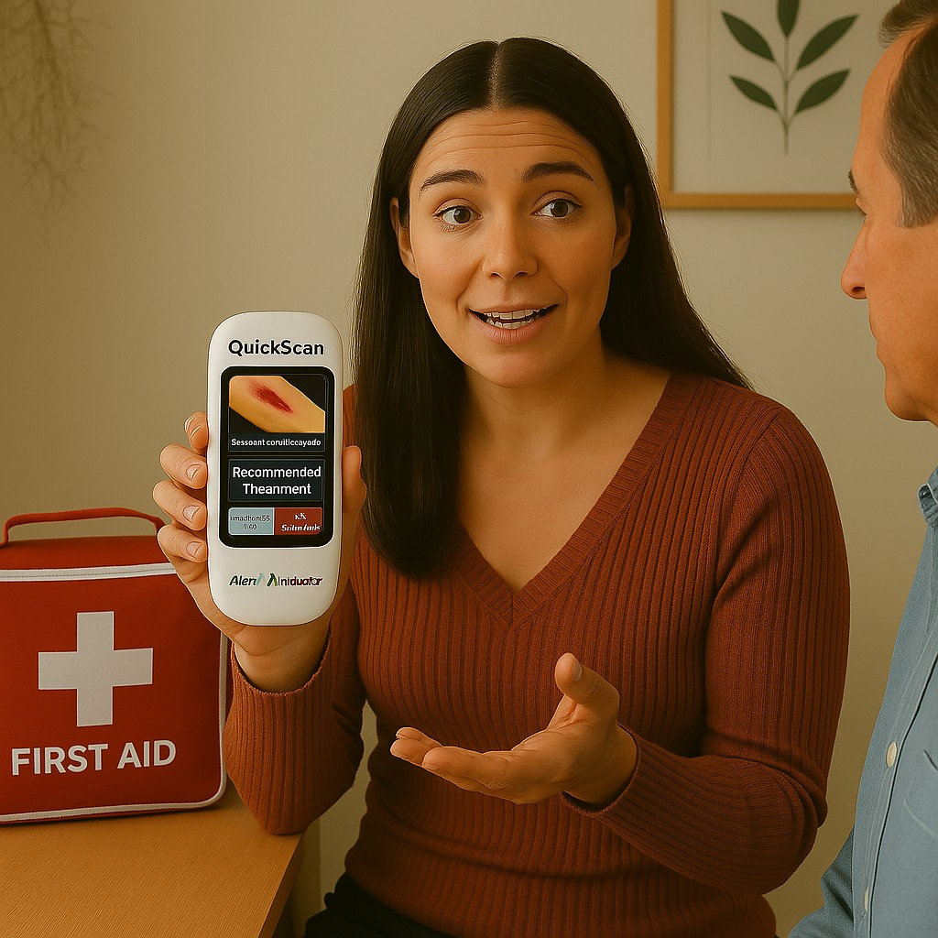

Prompt: Create an image using the same QuickScan device being held by a young mother; she is explaining how to use the device to an older male (her father). A First Aid Kit is in the background. Her expression is friendly as she is educating him.

Image 9: Challenge of the QuickScan Device
\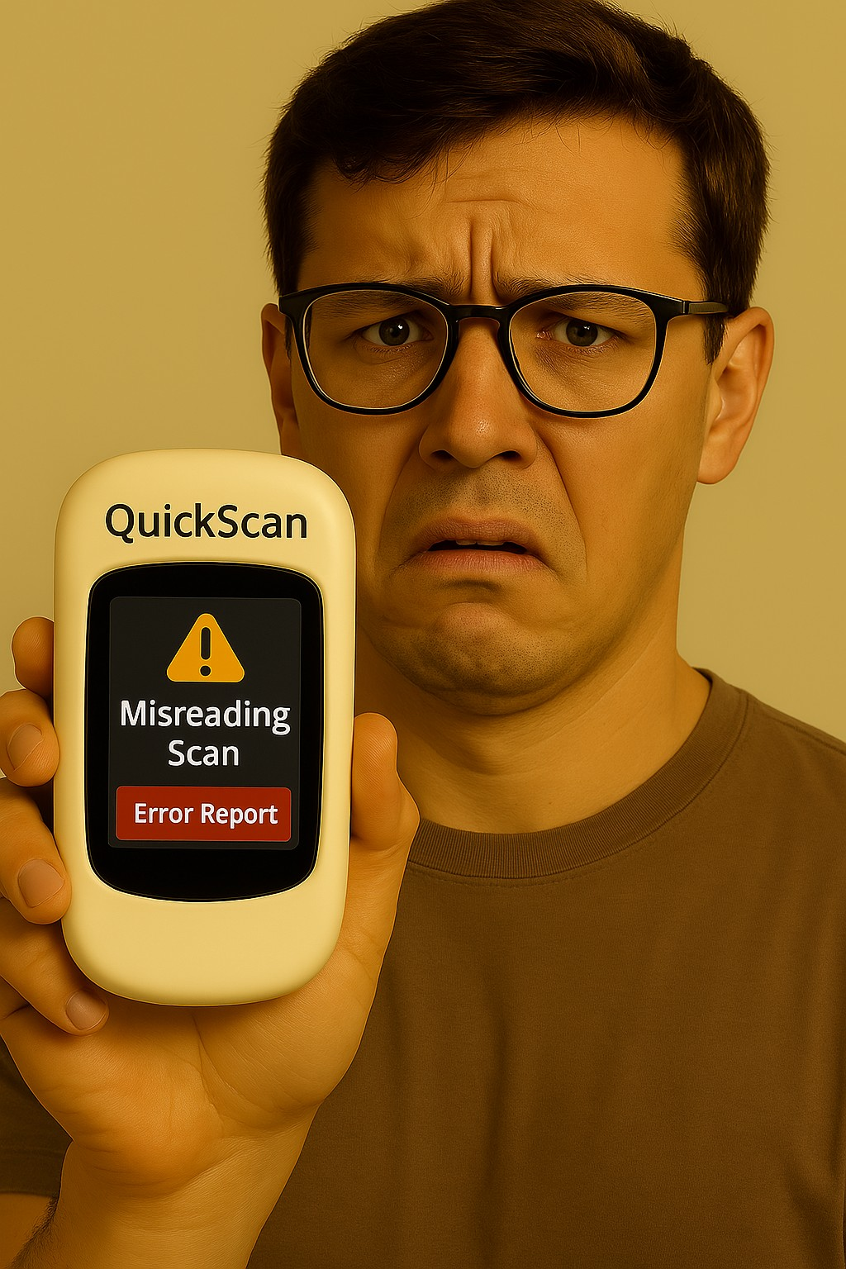
Prompt: Using the same QuickScan device created previously, create an image of a male trying to interpret the screen. He looks confused, and the screen states 'misreading scan' and the device shows an error report on the screen. Create him with the device in his left hand showing it to the viewer with a confused face.

Image 10: Benefit of the QuickScan Device

Prompt: Create an image of a hospital emergency room from outside in the parking lot looking in. Through the window, you can see shadows of many people waiting to be seen in the emergency department. An ambulance is waiting outside the hospital.

Narration
A young child is playing at the playground with her mother and a friend. She misjudges the monkey bars and falls onto her elbow, causing a small laceration. Her elbow begins to bleed slightly, and she runs crying to her mother, who is sitting on a nearby bench. The mother calmly wipes away dirt and debris from the wound with a soft wet wipe, then reaches into her bag and pulls out her QuickScan device. Using her phone as a hotspot to connect the device to the internet, she easily scans her daughter’s elbow. The device reads that the child has sustained a minor skin injury and provides treatment instructions, wound monitoring tips, and guidance on when to seek professional help. Other mothers at the park take notice and begin asking questions about the device. The mother and her daughter head home to clean the wound and continue monitoring it. They are able to avoid a visit to the overcrowded emergency room. Over the following days, the mother scans the laceration every 48 hours as recommended. At a routine appointment the following week, the mother brings her daughter to see their family doctor. The physician confirms that the device was used correctly and is pleased with the wound’s healing progress.
Conclusion
Children are naturally accident-prone due to their developing coordination skills and limited awareness of danger. Most injuries occur during play, making them a significant public health concern in both Canada and British Columbia (Wang et al., 2023). The rural nature of many regions in British Columbia makes QuickScan a desirable tool; however, potential connectivity issues in extremely remote areas must be acknowledged. Overall, the device has the potential to reduce unnecessary emergency room visits and empower parents to confidently manage their children's skin injuries from the comfort of home.
References
Bauer, M. E. E., Brussoni, M., & Giles, A. R. (2020). Categorizing mothers’ and fathers’ conceptualizations of children’s serious play‐related injuries: “You won’t grow a finger back.” Child: Care, Health & Development, 46(4), 530–536. https://doi.org/10.1111/cch.12761
Buckler, E. J., Mâsse, L. C., Faulkner, G. E., Puterman, E., McConnell-Nzunga, J., & Naylor, P.-J. (2023). Implementing active play standards: a qualitative study with licensed childcare providers in British Columbia, Canada. Health Promotion International, 38(3), 1–12. https://doi.org/10.1093/heapro/daac036
Clarius. (2025). High-Definition Ultrasound Imaging. Retrieved from https://ca.clarius.com/
MolecuLight. (2025). Start Seeing Wounds in a New Light. Retrieved from https://moleculight.com/
ProMed Mobile Imaging. (2025). Who We Are. Retrieved from https://www.promedmobileimaging.com/who-we-are
Varner, C. (2023). Emergency departments are in crisis now and for the foreseeable future. CMAJ : Canadian Medical Association Journal = Journal de l’Association Medicale Canadienne, 195(24), E851–E852. https://doi.org/10.1503/cmaj.230719
Wang, C., Toigo, S., Zutrauen, S., McFaull, S., & Thompson, W. (2023). Injuries among Canadian children and youth: an analysis using the 2019 Canadian Health Survey on Children and Youth. Health Promotion and Chronic Disease Prevention in Canada, 43(2), 98–102. https://doi.org/10.24095/hpcdp.43.2.05

