Technology Driven Healthcare Solutions: NurseLens

Shubhneet Grewal
Student ID: T00752718
Thompson Rivers University
HLTH 5500: Integrating Information Technology in Healthcare
Dr. Anila Virani
May 23, 2025

Description of a Novel Idea
Cognitive overload and workflow fragmentation among nurses is a growing concern in healthcare, particularly in high-acuity environments such as medical-surgical units, intensive care units, and emergency departments. Nurses are expected to juggle a wide array of responsibilities, including monitoring multiple patients, interpreting lab results, managing medication administration, responding to call bells and alarms, and coordinating care with interdisciplinary teams (Surendran et al., 2024). All of this occurs under strict time pressures and in highly unpredictable conditions. These tasks become even more challenging when nurses are expected to retain and synthesize large volumes of clinical data for each patient, often without real-time system integration or readily accessible support tools (Surendran et al., 2024). For example, a nurse may need to recall a patient’s code status, pain history, mobility level, allergies, and trending vital signs, all while addressing a new physician order or preparing for rounds.
Adding to this challenge is the fragmented nature of the digital systems nurses must use. They are required to interact with multiple electronic platforms, such as electronic health records and decision-support tools, many of which are not user-friendly. These systems often demand repetitive logins, navigating through multiple tabs, and entering data manually just to retrieve basic patient information (Harris et al., 2018). This constant toggling between hands-on care and digital documentation disrupts focus and increases the risk of errors (Harris et al., 2018). It also contributes to cognitive fatigue, leaving nurses with limited time to reflect, plan, or complete tasks in a logical and uninterrupted sequence. Instead, they find themselves pulled in multiple directions, often having to backtrack or rely on memory for critical details (Harvey et al., 2020). The consequences of this fragmentation are far-reaching. It undermines efficiency, delays critical interventions, and increases the risk of adverse events such as missed medications, incomplete assessments, and inadequate handovers (Gündüz & Öztürk, 2025). These breakdowns not only affect patient outcomes but also take a significant toll on the well-being of nurses, contributing to stress, burnout, and job dissatisfaction (Gündüz & Öztürk, 2025). Addressing this issue requires technology that enhances rather than hinders nursing practice. It should function as a seamless and intelligent assistant that integrates directly into clinical workflows while supporting safe, efficient, and patient-centered care.
NurseLens offers a promising solution to this long-standing issue. It is an augmented reality (AR) system that projects real-time, patient-specific data directly into a nurse’s field of vision through smart glasses or AR-enabled devices (Malungana & Chimbo, 2024). Instead of having to pause care to log into a computer or flip through charts, the nurse sees essential patient information as soon as they enter the room. Data such as allergies, fall risk, mobility status, and active orders are visually overlaid in an unobtrusive display. Interactive checklists guide the nurse through evidence-based assessments such as wound care, sepsis screening, or delirium evaluations. Voice and gesture controls allow for immediate, hands-free documentation, reducing the need for double-charting or relying on memory later in the shift (Malungana & Chimbo, 2024). NurseLens also includes a virtual floor map that displays task statuses for the entire unit, allowing for better coordination and minimizing redundant work. For novice nurses, the built-in prompts offer just-in-time guidance, reinforcing best practices and reducing uncertainty in fast-paced environments. This system reduces cognitive fragmentation by allowing nurses to focus on the patient in front of them while still meeting the demands of documentation and task prioritization (Malungana & Chimbo, 2024).
While institutions like the British Columbia Institute of Technology and the University of British Columbia have explored AR and virtual reality technologies, their applications are currently limited to educational settings such as simulation labs and interactive anatomy modules (Watties-Daniels et al., 2024). These tools enhance learning but are not integrated into live clinical workflows. To date, there is no evidence of a fully deployed AR system like NurseLens being used at the point of care in British Columbia. This makes NurseLens a novel and transformative concept that bridges the gap between training environments and real-world practice. Unlike passive educational tools, NurseLens functions as an active clinical assistant embedded into the fast-paced and complex reality of acute care. Its implementation could be the first of its kind in British Columbia’s healthcare system, directly targeting workflow inefficiencies and reducing the cognitive burden on nurses.
Google Search
After conducting a comprehensive search, there is no evidence of an existing system named "NurseLens" or any fully integrated AR solution with comparable functionality currently implemented in clinical nursing practice, particularly within British Columbia, Canada. The search process included the use of various search engines and academic databases, employing keywords such as "NurseLens augmented reality nursing assistant," "AR nursing assistant smart glasses," and "augmented reality nursing assistant British Columbia." In addition, I reviewed academic journals, healthcare technology publications, and industry reports for mentions of similar AR applications in nursing. Institutional research was also conducted, focusing on British Columbia based organizations such as the University of British Columbia and the British Columbia Institute of Technology, to examine whether AR technology was being used in clinical settings. While these institutions are exploring AR and virtual reality technologies, their efforts are primarily focused on education and training, such as nursing simulations, rather than point-of-care clinical tools. No current initiatives reflect a fully integrated AR system supporting bedside nursing practice as envisioned by NurseLens. Therefore, NurseLens is an original and innovative concept, offering a unique opportunity to pioneer the integration of AR technology into the daily clinical workflow of nurses in British Columbia.
AI-Generated Pictures
Prompt: Create a picture of augmented and virtual reality technologies made for a busy critical care nurse.
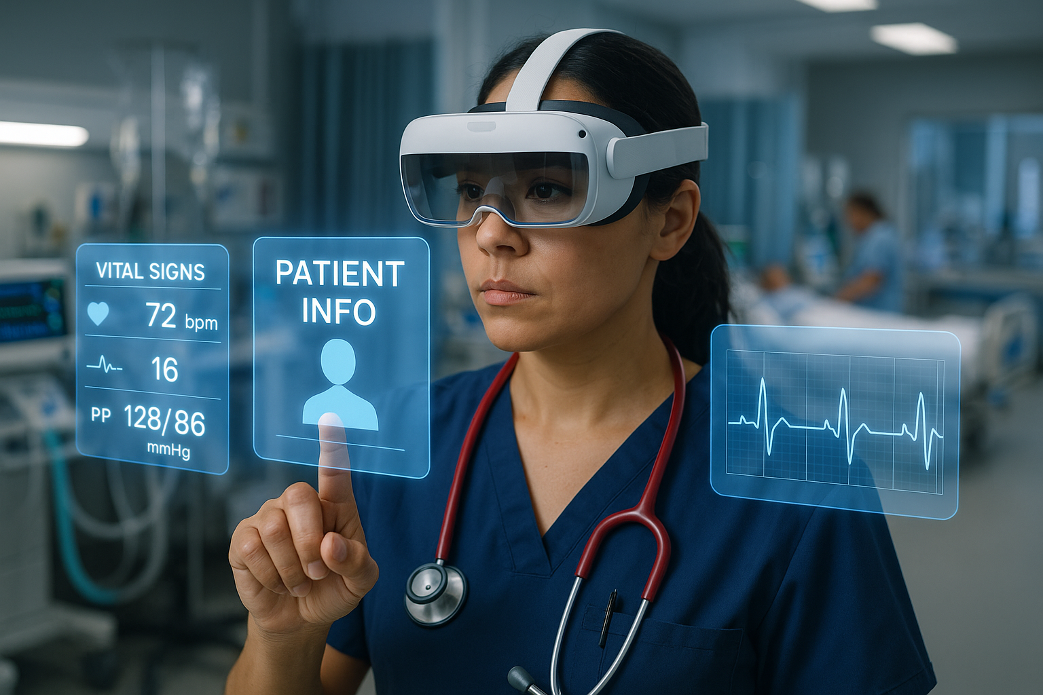

Note. AI-generated image from OpenAI (2025a). Retrieved from ChatGPT.
Prompt: Use this image to create a picture of augmented and virtual reality technologies pulling up important patient data for 4 patients.
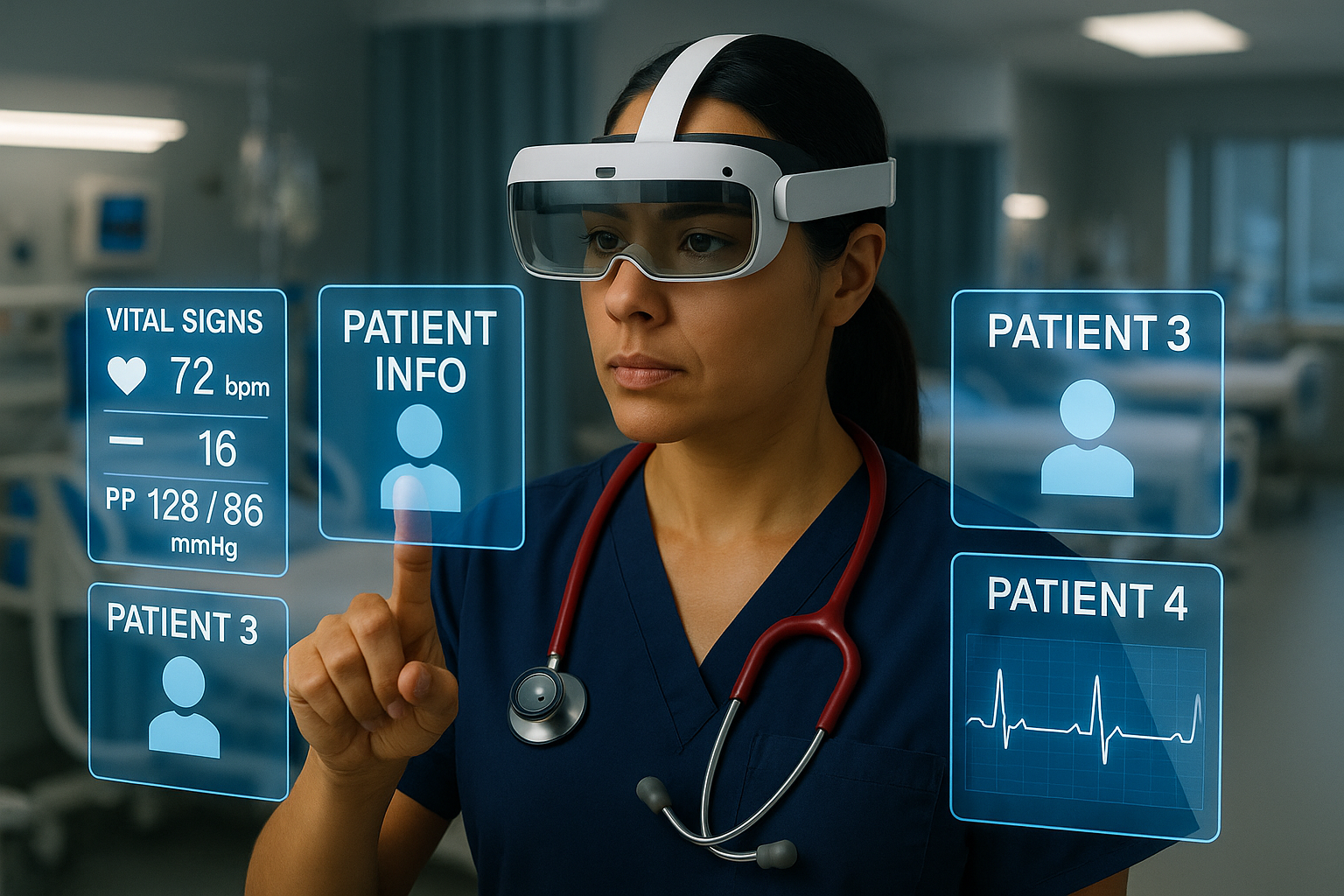

Note. AI-generated image from OpenAI (2025b). Retrieved from ChatGPT.
Benefits Prompt: Use this image and create a picture of augmented and virtual reality technologies alerting nurses of a critically deteriorating patient.
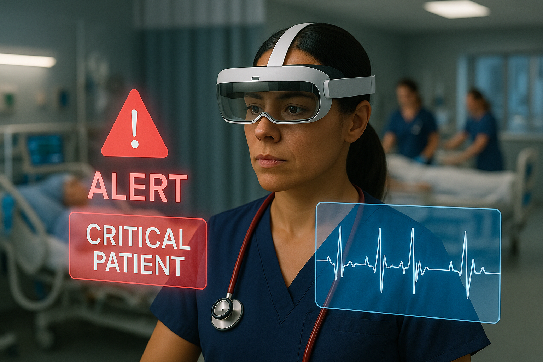
Note. AI-generated image from OpenAI (2025c). Retrieved from ChatGPT.
Benefits Prompt: Use this image and create interactive checklists for 4 patients that include critical assessments such as monitoring a low heart rate, fall risk, wound care, potassium replacements, fluid restriction, and titrating nitroglycerin infusions.
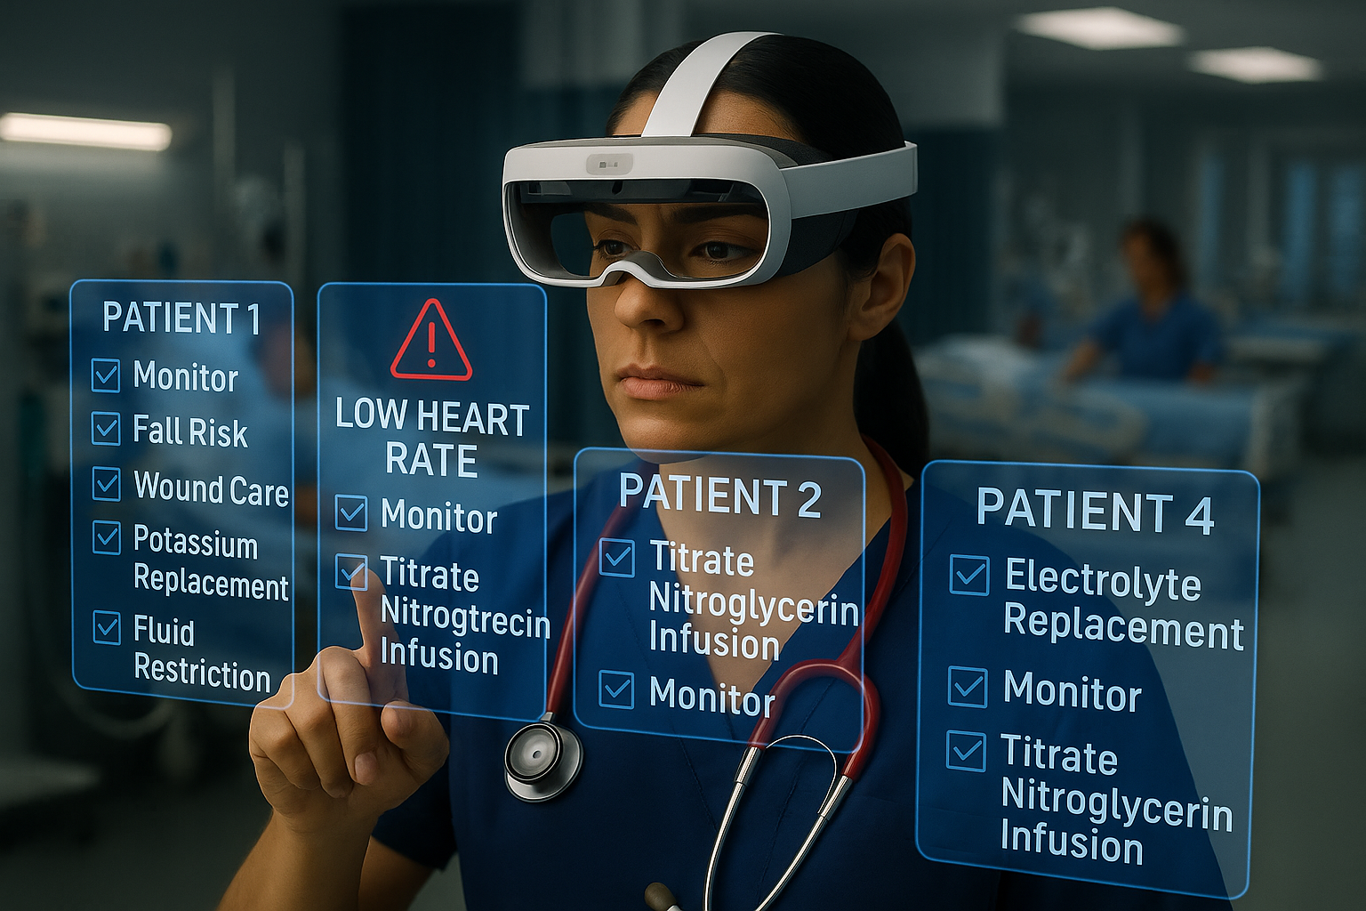

Note. AI-generated image from OpenAI (2025d). Retrieved from ChatGPT.
Benefits Prompt: Use this image and create checklist for a patient that has the steps for Blood Administration: 1) Check Order 2) Check for Consent 3) Reason for Transfusion: GI bleed 4) Patient Blood Type: B+ and insert another tab showing the Consent for Blood Administration has been obtained.
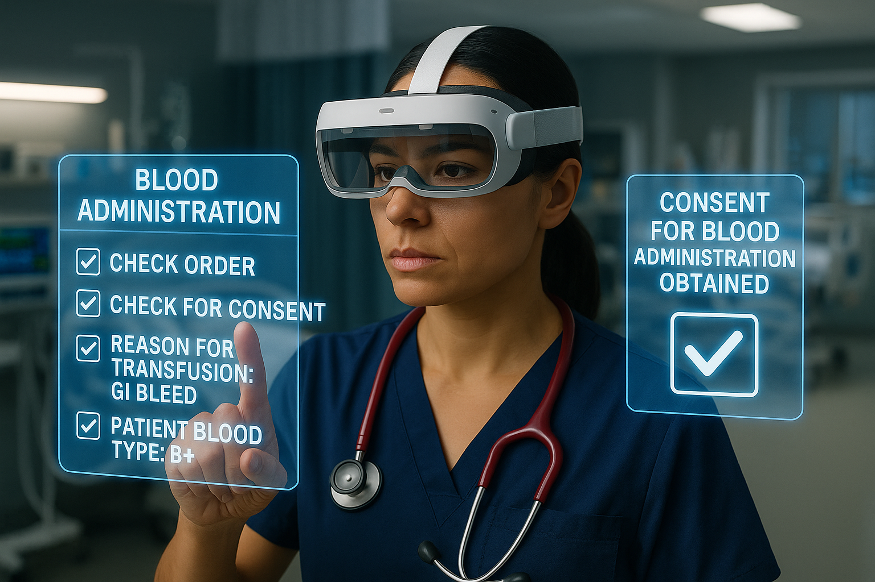

Note. AI-generated image from OpenAI (2025e). Retrieved from ChatGPT.
Benefits Prompt: Use this image and demonstrate how augmented and virtual reality technologies can help assess, diagnose and treat patients. Please include a patient in the picture.
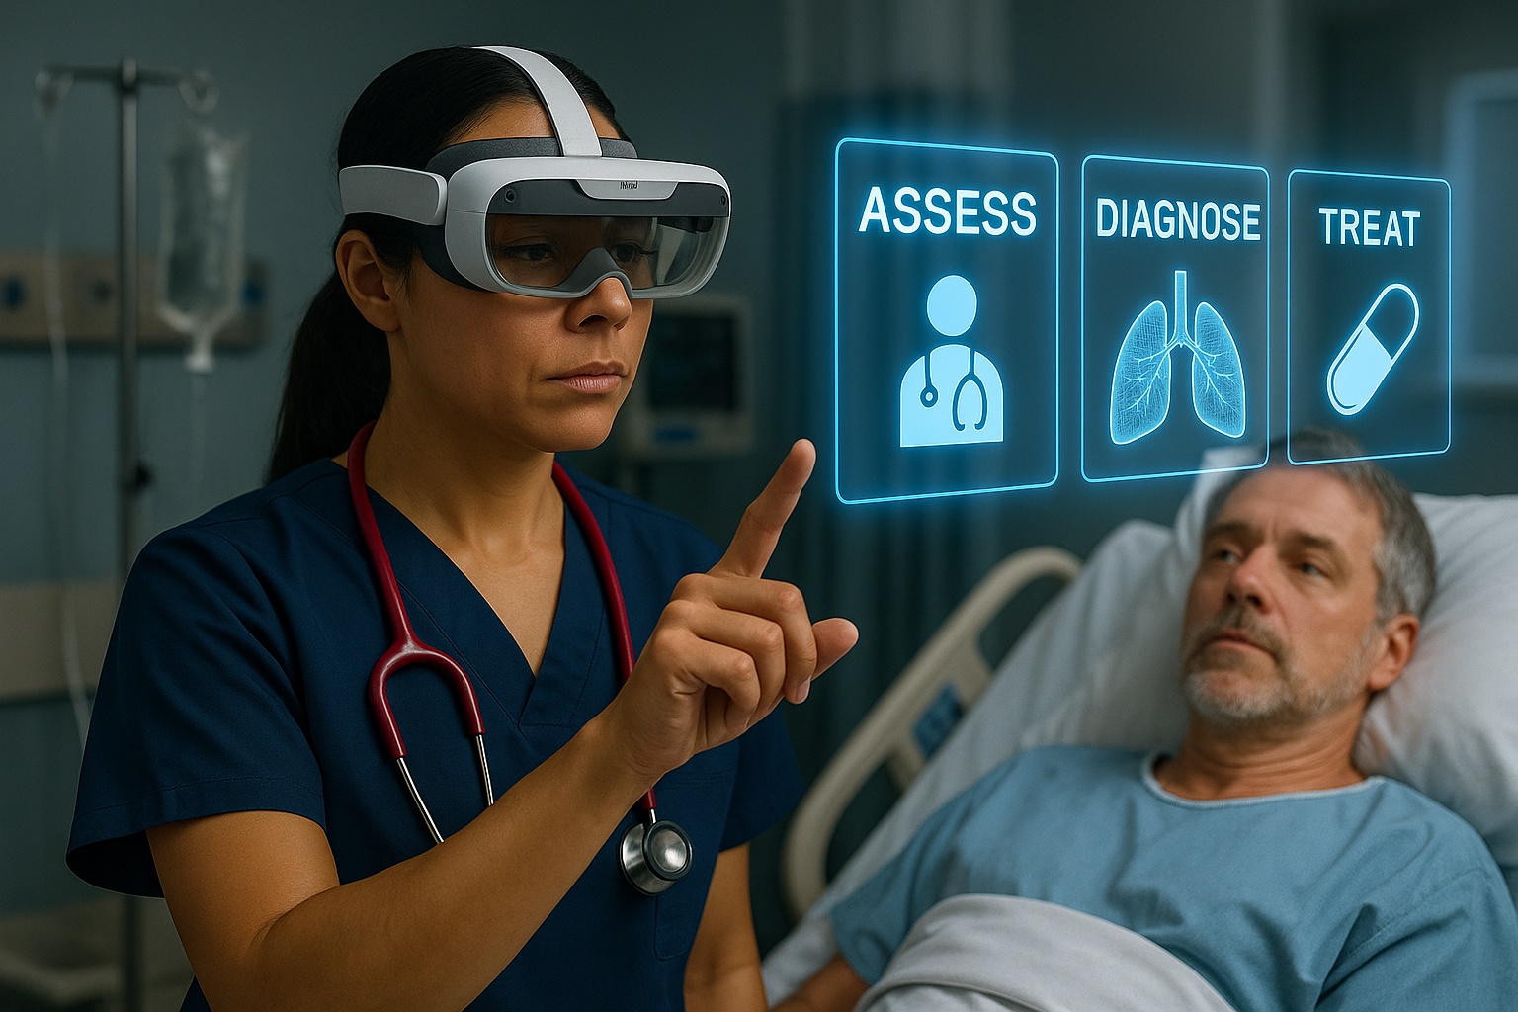
Note. AI-generated image from OpenAI (2025f). Retrieved from ChatGPT.
Challenges Prompt: Generate a picture of a nurse who is too dependent on prompts generated by the augmented and virtual reality technologies for patient care and now has impaired critical thinking and clinical judgment due to these technologies. Make it crazy and chaotic.
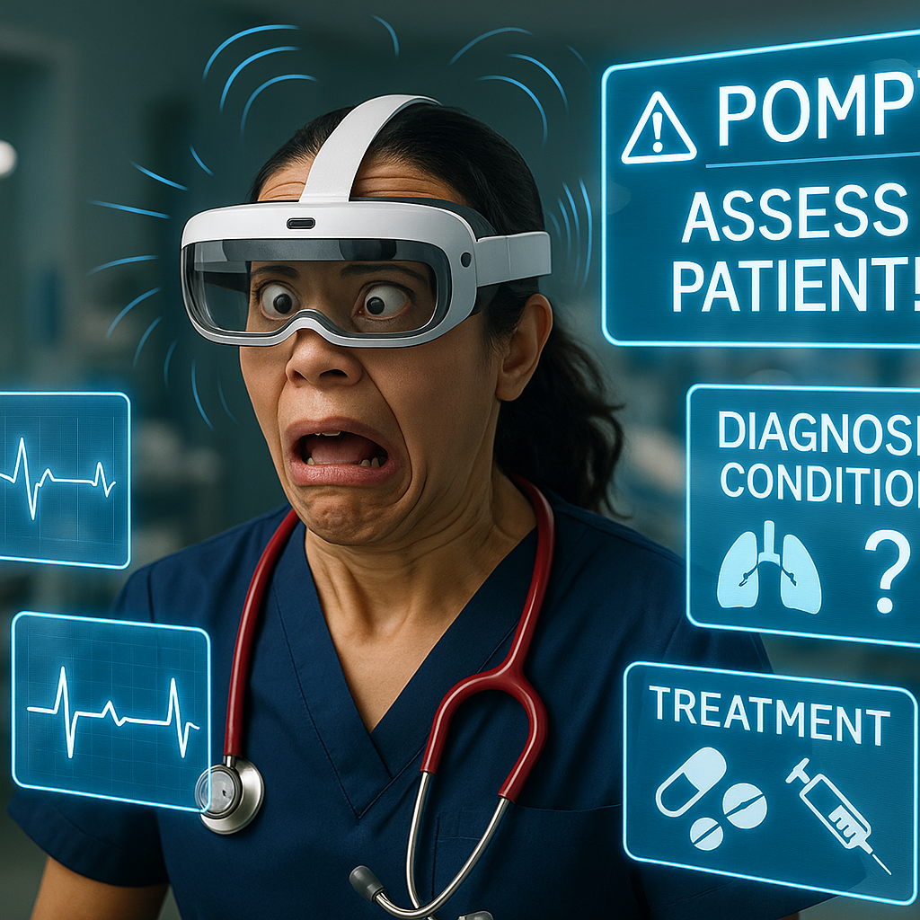

Note. AI-generated image from OpenAI (2025g). Retrieved from ChatGPT.
Challenges Prompt: Generate a picture of a nurse where augmented and virtual reality technologies headsets may be bulky, and uncomfortable, especially during long shifts and is annoyed by them.
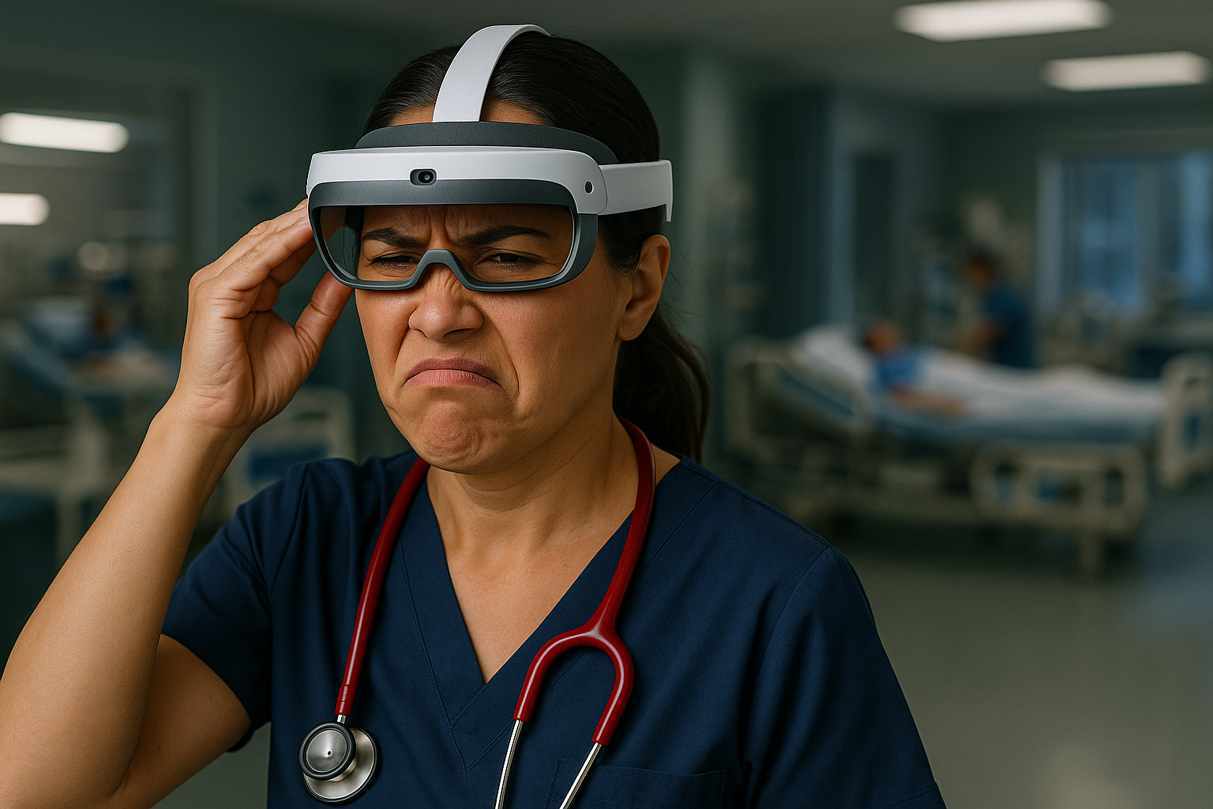
Note. AI-generated image from OpenAI (2025h). Retrieved from ChatGPT.
Challenges Prompt: Generate a picture of hospital managers and administration team being stressed regarding the high implementation costs related to augmented and virtual reality technologies and not having the infrastructure to adopt such advanced technologies.
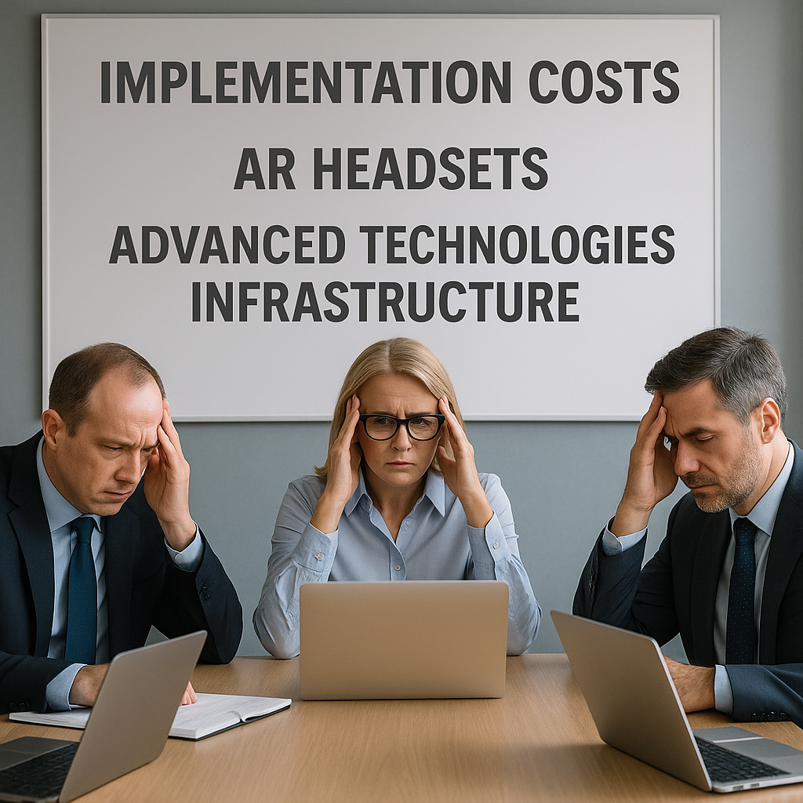

Note. AI-generated image from OpenAI (2025i). Retrieved from ChatGPT.

Prompt: Generate a picture of a critical care nurse happy with augmented and virtual reality technologies and is utilizing it on a busy unit.
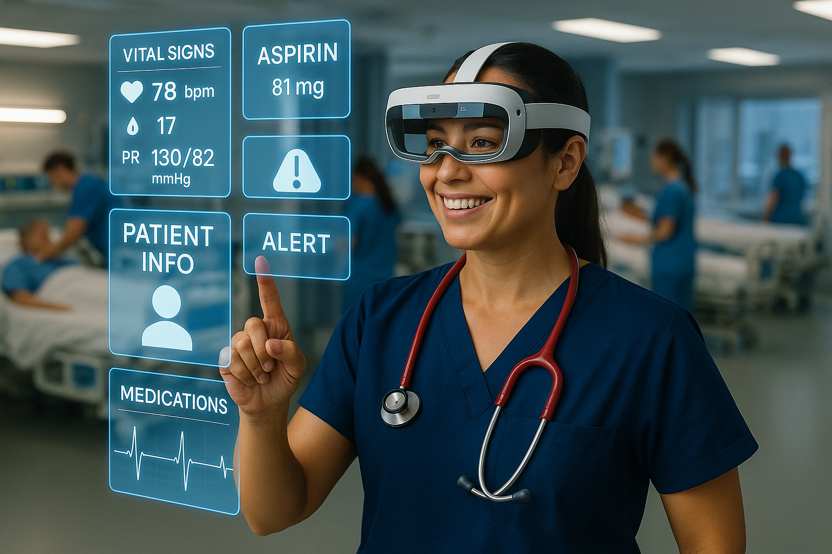

Note. AI-generated image from OpenAI (2025j). Retrieved from ChatGPT.

Narration
Maya adjusted the AR headset above her brow, the weight of both the gear and her new role settling in as she entered the busy ICU for her first official shift as a registered nurse. As a recent nursing graduate, she was still finding her rhythm, but today, her assignment was clear. Mr. Martin Douglas, an 82-year-old patient admitted overnight following emergency surgery for a perforated bowel. As Maya stepped into the room, NurseLens flickered gently to life. A patient overlay appeared in her line of sight: Douglas, Martin. Age 82. Allergies: Penicillin. Fall Risk: High. Code Status: Full. Post-op Day 1. Mild Delirium. The data floated seamlessly before her, eliminating the need to shuffle through charts or click through multiple EHR screens.
Mr. Douglas lay still but alert, his eyes darting with confusion. “Where am I? What day is it?” he mumbled. “Good morning, Mr. Douglas,” Maya said softly, touching his shoulder. “You’re in the ICU. I’m Maya, your nurse.” NurseLens pinged subtly, drawing her gaze to a care prompt: Delirium screening due. With a few spoken cues, “orientation questions asked, mildly disoriented”, the system logged the assessment instantly. Another bubble appeared: Risk of dehydration, fluid replacement ordered. Maya confirmed it with a simple nod.
Throughout the morning, the technology followed her workflow. A gentle chime alerted her to a lab result: potassium low. Before she had to dig for the information, a dosage prompt appeared, along with a checklist for safe administration tailored for elderly patients at risk of cardiac complications. As Maya administered the replacement, she never had to leave Mr. Douglas’s side or delay documentation. Everything happened in real time, hands-free. For Mr. Douglas, the experience was noticeably different. In his confused state, previous care interactions had felt rushed and impersonal. But today, Maya remained present. She wasn’t constantly turning away to log into a workstation or asking the same questions over and over. NurseLens allowed her to stay engaged, to notice when his breathing became shallower, when he seemed agitated, and when he whispered about missing his wife.
By early evening, his daughter arrived, worried and overwhelmed. Maya used the NurseLens “family view” to pull up a visual care summary. Lab trends, medications, and a real-time pain log were projected onto a tablet for the family’s review. “I’ve never had anyone explain things so clearly,” his daughter said, tears in her eyes. As Maya removed her headset at the end of her shift, her neck ached slightly, and she made a mental note to suggest lighter headgear in the post-shift debrief. But NurseLens had done more than help her function as a new nurse. It had transformed the way care was delivered to an elderly patient in a vulnerable state. For Mr. Douglas, it wasn’t just the surgery or medications that mattered. It was the feeling that his nurse was truly there with him and that made all the difference.

References
Gündüz, E. S., & Öztürk, N. K. (2025). Mental workload as a predictor of burnout in intensive care nurses. Nursing in Critical Care, 30(2), 1–9. https://doi.org/10.1111/nicc.13173
Harris DA, Haskell J, Cooper E, Crouse N, Gardner R. Estimating the association between burnout and electronic health record-related stress among advanced practice registered nurses. Applied Nursing Research. https://doi.org/10.1016/j.apnr.2018.06.014
Harvey, C., Thompson, S., Otis, E., & Willis, E. (2020). Nurses’ views on workload, care rationing and work environments. Journal of nursing management, 28(4), 912-918. https://doi.org/10.1111/jonm.13019
Malungana, L., & Chimbo, B. (2024). The adoption of virtual reality technologies for training healthcare professionals. Africa’s Public Service Delivery & Performance Review, 12(1), 1–7. https://doi.org/10.4102/apsdpr.v12i1.867
OpenAI. (2025a). A nurse using AR headsets to access patient vital signs and information in a hospital unit [AI-generated image]. ChatGPT. https://chat.openai.com/
OpenAI. (2025b). A nurse interacting with AR interfaces displaying patient data for multiple patients in a hospital setting [AI-generated image]. ChatGPT. https://chat.openai.com/
OpenAI. (2025c). A nurse using augmented reality technology receiving a critical patient alert in a hospital unit [AI-generated image]. ChatGPT. https://chat.openai.com/
OpenAI. (2025d). A nurse wearing an AR headset using interactive holographic checklists to manage patient care in a critical care unit [AI-generated image]. ChatGPT. https://chat.openai.com/
OpenAI. (2025e). A nurse using AR technology to complete a blood administration checklist including consent verification in a clinical setting [AI-generated image]. ChatGPT. https://chat.openai.com/
OpenAI. (2025f). A nurse using AR headsets to assess, diagnose, and treat a patient at the bedside in a hospital setting [AI-generated image]. ChatGPT. https://chat.openai.com/
OpenAI. (2025g). A nurse displaying stress and impaired clinical judgment while surrounded by overwhelming AR prompts in a hospital unit [AI-generated image]. ChatGPT. https://chat.openai.com/
OpenAI. (2025h). A critical care nurse grimacing while adjusting a bulky AR headset in a hospital environment [AI-generated image]. ChatGPT. https://chat.openai.com/
OpenAI. (2025i). A group of hospital managers looking stressed during a meeting about the high costs and infrastructure needs of AR technology [AI-generated image]. ChatGPT. https://chat.openai.com/
OpenAI. (2025j). A smiling nurse in a busy critical care unit interacting with AR holograms to review patient vitals and medications [AI-generated image]. ChatGPT. https://chat.openai.com/
Surendran, A., Beccaria, L., Rees, S., & Mcilveen, P. (2024). Cognitive mental workload of emergency nursing: A scoping review. Nursing open, 11(2), e2111. https://doi.org/10.1002/nop2.2111
Watties-Daniels, D., Doswell, J., & Moss, C. (2024). Using Virtual and Augmented Reality to Support Skills Attainment in Schools of Nursing. ABNFF Journal, 1(2), 49–54.

