**Assisted-Feeding Robots in Hospitals**

Kulvir K. Moudgil

Master of Nursing, Thompson Rivers University

HLTH 5500: Integrating Information Technology in Healthcare

Dr. Anila Virani

June 13, 2025

**Assisted-Feeding Robots in Hospitals**

**Narration with change of target population**

Miss Allie Watson, a 40-year-old woman, was admitted to the hospital after suffering a stroke. The protocol for hot strokes was initiated, and she required hospitalization for close monitoring. Post-stroke, Allie faced significant challenges, including a right-sided deficit characterized by facial droop and weakness in her right arm.

After her transfer to the rehabilitation unit, Allie found it difficult to feed herself due to her right-sided weakness, impacting her ability to chew and manage her meals effectively. This led to frustration, particularly as her weight dropped from 65.6 kg to 61.3 kg within a week, compounded by a lack of family support. She also appeared dehydrated and weak.

During her hospital stay, Allie had a remarkable encounter with a robot named Row, which recognized her condition and introduced itself. Row supported her by bringing meal trays, providing companionship during meals, and assisting her with eating. Allie was pleasantly surprised by Row's capabilities and interaction style, which made her feel understood.

Over the nearly three months in the hospital, Allie focused on regaining her strength and adapting to her new circumstances. With Row's help, her calorie intake improved significantly, enabling her to gain weight back up to 67 kg after three months. Allie grew stronger and remained in good spirits, ultimately expressing her gratitude to Row as she prepared for discharge. She acknowledged that Row played a crucial role in her recovery, praising the technological advancements that had positively impacted her journey.

After her hospital stay, Row continued to assist Allie at home for a month to help maintain her new nutritional baseline under hospital loan program. They worked together to ensure proper calorie intake and monitor her weight daily at home.

The use of robots like Row in hospitals has led to notable improvements in patient outcomes, particularly among stroke victims. The introduction of assisted feeding robots resulted in a marked reduction in malnutrition rates, increased calorie intake, better weight management, fewer nasogastric tube insertions, and decreased hospital readmissions. Patients reported feeling more energized and showed greater recovery rates, highlighting the positive impact of assisted-feeding robots technology in healthcare.

**Feedback**

Incorporation of details about patient’s nutritional challenges and measurable outcomes has been done in this narration including calorie count, weight, and three months’ time period. Lack of family support highlights assisted-feeding robot’s present and importance. Idea of hospital loan program post discharge to prevent readmission and provide support through assisted-feeding robot has been incorporated.

**New AI-generated pictures**

**Feedback**

Creativity and variation have been incorporated to the AI-generated pictures. Spilling food or showing frustration reflecting the emotional depth and realism. Prompts have been detailed including stroke symptoms, i.e., right-sided droop and weakness and robot’s functionality including cleaning spills and emotionally present for patient. Labelling and placements of picture has been corrected to appear together in the document.

**Figure 1**

*Illustrate a weak 40-year-old woman who has suffered a stroke, exhibiting right-sided facial droop and weakness in her right arm in hospital while standing on a weighing scale, crying (OpenAI, 2023).*

**Figure 2**

*Illustrate a weak 40-year-old woman who has suffered a stroke, exhibiting right-sided facial droop and weakness in her right arm in hospital, visibly frustrated as she accidentally spills food from her meal tray (OpenAI, 2023).*

**Figure 3**

*Illustrate a weak 40-year-old woman who has suffered a stroke, exhibiting right-sided facial droop and weakness in her right arm in hospital, as she engages with an assisted-feeding robot that is cleaning up a spill and helping her eat* *(OpenAI, 2023).*

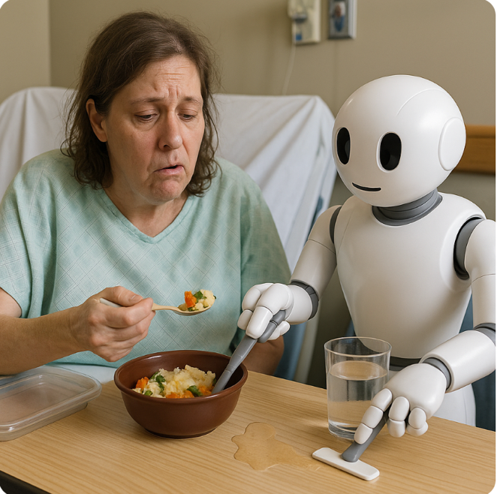

**Two new Assisted-feeding robots’ benefits**

**Figure 4**

*Illustrate a 40-year-old woman who has experienced a stroke, showing right-sided facial droop and weakness in her right arm, in a hospital setting as she is interacting with an assisted-feeding robot and expressing gratitude for her independence with the assisted-feeding robot's help (OpenAI, 2023).*

**Figure 5**

*Illustrate a 40-year-old woman who has suffered a stroke, exhibiting right-sided facial droop and weakness in her right arm, in a home environment as she is standing on a weighing scale with a cheerful expression, holding a completed calorie intake checklist, with an assisted-feeding robot beside her and thankful for not having to be readmitted to the hospital(OpenAI, 2023).*

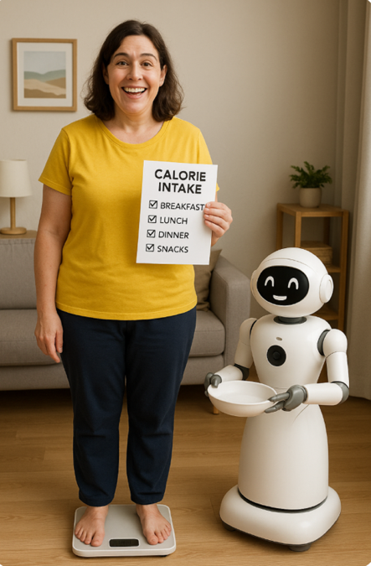

**Two new Assisted-feeding robots’ challenges**

**Figure 6**

*Illustrate a 40-year-old woman who had suffered a stroke, exhibiting right-sided facial droop and weakness in her right arm, in a home environment, sitting with an assisted-feeding robot in distress holding hospital loan program bill* *(OpenAI, 2023)*.



**Figure 7**

*Illustrate a 40-year-old woman sitting at the dinner table in a home setting with her family, while an assisted-feeding robot is positioned between the chairs, solely focused on feeding her and interrupting the family gathering and conversations* *(OpenAI, 2023).*

**Google search to find any updated information**

The United States has emerged as a global leader in the utilization of assisted-feeding robot technology understood from previous Google search (Obi, 2025). In contrast, Sweden and Canada have begun to implement these robots, but their usage remains limited (Medical Expo, 2025; Uhlarik, 2025).

A recent systematic review highlighted that while assisted-feeding robots can significantly enhance the independence of individuals, several challenges including adaptability, safety, and cost continue to pose significant barriers (Liu et al., 2025). These issues may explain the hesitancy of various countries to fully embrace this technology. However, there have been no recent developments regarding new robots or new countries adopting this technology based on updated Google search.

**Feedback**

Google search has been updated as per rubric and did not have any constructive feedback.

**References**

Liu, F., Li, Z., & Hu, M. (2025). Robot-assisted feeding: A systematic review and future prospects. *Technology and Health Care: Official Journal of the European Society for Engineering and Medicine, 0*(0), 1-22. <https://doi.org/10.1177/09287329251342392>

Medical Expo. (2025). *Bestic, the eating assistance device.* <https://trends.medicalexpo.com/medicalexpo-e-magazine/project-118905-423917.html>

Obi. (2025). *What is Obi.* <https://meetobi.com/?srsltid=AfmBOooUM0EJkGCtyLv8vkbhn6fN5xcaoEl7X4SNB-5_6BY5Ie_QKJwd>

OpenAI. (2023). *ChatGPT* (May 23 version). <https://chatgpt.com>

Uhlarik, M. (2025). Restoring mealtime independence: Robotic feeders empower people. *Canadian Healthcare Technology*. <https://www.canhealth.com/2025/02/28/restoring-mealtime-independence-robotic-feeders-empower-people/>