**Vitallink: A Model for Inclusive, AI-Integrated Triage Pods.**

**Part B.**

Esther Ojo-Tirimi

Thompson Rivers University

HLTH 5500: Integrating IT in Healthcare

Dr. Anila Virani

June 14th, 2025.

**Google Search Documentation and Analysis (Follow-Up – Part B)**

To reassess the novelty and current relevance of the VitalLink Pod concept, a follow-up investigation was conducted to determine whether any significant new technologies, pilot programs, or implementations have emerged since the original search was carried out in Part A. This review aligns with the Part B guideline to re-explore the search landscape, verifying if there have been new developments or overlooked elements that might alter the innovation’s perceived uniqueness.

Search Strategy and Terms

Searches were carried out using Google, Google Scholar, and the TRU Library databases. Priority was given to peer-reviewed publications, government reports, recent pilot programs, tech innovation press releases, and reputable media outlets. Search terms were consistent with those from Part A to ensure comparison:

General Concept Terms:

* AI triage booth British Columbia
* Health triage pod and booth in Canada
* Community health kiosk BC
* Walk-in health pod innovation Canada

Vital Signs and Smart Chair:

* Smart chair vital sign monitor kiosk
* Public blood pressure health kiosk Canada
* Automated BMI blood pressure station BC

AI & Language Interface:

* Multilingual AI health assistant
* Healthcare kiosk language translation Canada
* Voice assistant for health triage kiosk

EHR Integration and Telehealth:

* Electronic health record kiosk integration Canada
* Telemedicine kiosk with EHR Canada
* Remote nurse video consultation pod

Cross-Component Queries:

* Fully integrated telehealth pod
* Clinic-in-a-box AI kiosk healthcare
* OnMed Station Canada
* UniDoc Health Cube pilot Ontario pharmacy

**Key Findings**

**Component 1: AI-Guided Triage Pods**

The search revealed no new AI triage booths fully implemented in BC or Canada since the last report. The Baüne Autonomous Care Unit (Montreal) remains a leading innovation using wearable tech and AI triage, but not as a standalone walk-in pod . Global references to Italy’s CAPSULA Pods and text-based AI chatbot platforms (e.g., Ada, Babylon) continue to show promise but remain unintegrated into Canadian infrastructure .

**Component 2: Smart Chair / Vital Sign Monitoring**

There are no newly piloted smart chairs in BC integrating full vital checks (e.g., blood pressure, SpO₂, BMI, temperature). OnMed and PharmaSmart remain the leading systems with partial functionality, but these systems are either not AI-guided or not used in public walk-in settings .

**Component 3: Multilingual Voice-Based AI Interface**

No newly introduced multilingual AI health kiosks were found in BC. Infermedica, Teslon CareNation, and LanguageLine Solutions remain the most referenced tools, yet none fully meet the voice-based, autonomous multilingual support imagined in the VitalLink Pod. These systems still largely rely on human interpreters or text-based AI.

**Component 4: EHR Integration and Automated Patient Profile Generation**

There is no update to suggest province-wide adoption of booths that create automated EHR profiles from walk-in data input. The UniDoc H3 Cube continues to demonstrate promise, with limited integration in Ontario pharmacies and no BC-wide rollout to date.

**Component 5: Remote Nurse/Provider Consultation**

Telus Health’s CloudMD service continues in select locations but is not widely paired with autonomous AI triage booths. No new fully autonomous booths offering video consultation linked to EHR and AI triage have been piloted in BC.

**Component 6: Local Health Aides for Support**

Support staff are still required in all pilot locations (e.g., UniDoc, Sihat Xpress), with no new models introducing autonomous local support paired with AI navigation.

**AI-Generated Images and Descriptions**

The following AI-generated images were created using prompts based on the VitalLink Pod concept. While each image underwent several rounds of refinement to ensure accuracy, realism, and alignment with the intended healthcare scenario, only the first and final prompts used in the image generation process have been documented below. AI-generated images were used, but consistency across characters and scenes could not be maintained due to current limitations of the tools.

1. 1st prompt: Generate an image of a middle-aged man in a wheelchair entering the VitalLink Pod through an automatic sliding door with accessibility symbols. Let the man be on a sliding floor between the stairs.

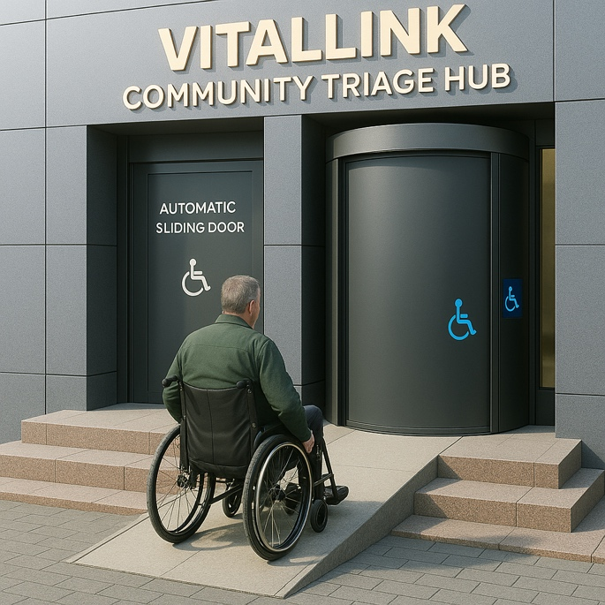Final: Thinking as if you’re a smart architect, what corrections would you make to this, and effect them.

1st prompt: Now an image of a 4-year-old child inside the pod with a parent, with the pod’s interface automatically switching to “Pediatric Mode.” Display child-friendly icons, animation-like characters, and a calming color palette on screen.

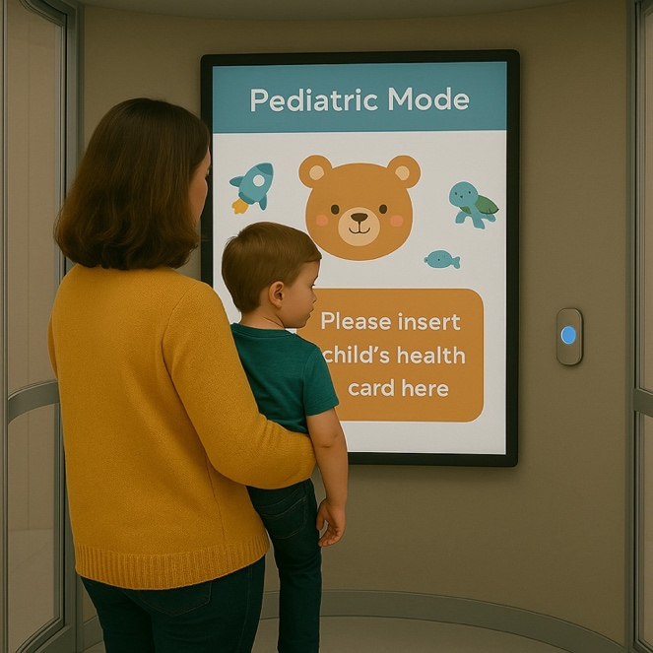Final: Let the mum be standing and carrying her son.

### Benefit: Promotes Inclusive Accessibility Across Diverse User Needs

The VitalLink Pod is designed with universal accessibility in mind, ensuring that individuals of varying physical abilities, ages, and communication needs can independently access healthcare services. For patients with mobility limitations, such as those using wheelchairs or walkers, the pod includes automated sliding doors, low-threshold entryways, and adjustable smart chairs that conform to body size, accommodating both adults and pediatric users. For those with hearing impairments, the interface includes closed captioning, on-screen American Sign Language (ASL) interpreters, and visual alerts. The pod also features voice-guided prompts in multiple languages for individuals with low literacy or visual impairments. These inclusive design elements reflect a commitment to equitable care and align with global best practices in health technology accessibility (WHO, 2022; Squires, 2018). By minimizing the need for assistance and empowering independent use, the VitalLink Pod contributes to a healthcare experience that is truly barrier-free.

1. 1st prompt: multicultural crowd in a low-income neighborhood uses a sleek VitalLink Pod stationed outside a community grocery store. Signs show 24/7 availability, and posters highlight 'No Appointments

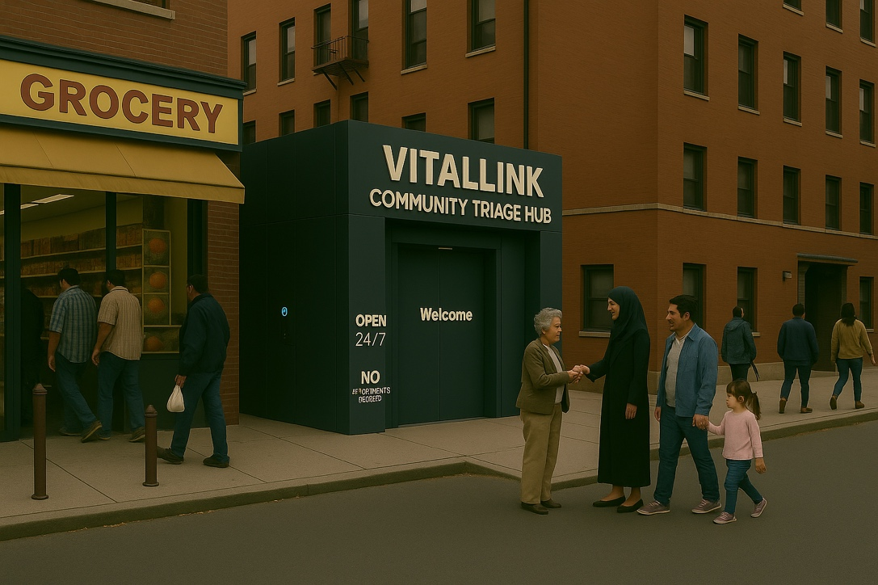Final: Change the word I circled in red to no appointments needed.

Benefit: Increases Access to Care for Underserved Populations

The VitalLink Pod enhances healthcare accessibility by positioning care directly within underserved communities, effectively bypassing common barriers such as geographic remoteness, linguistic differences, and lack of internet connectivity. Research indicates that more than half of the global population lacks access to essential health services, a disparity that persists even in high-income countries (World Health Organization [WHO], 2023). Community-based telehealth kiosks have been particularly effective in extending services to marginalized groups, including low-income individuals and recent immigrants, many of whom face systemic barriers to care (Clove, 2023). Programs that integrate multilingual and walk-in features in physical settings, like community centers, offer accessible alternatives for those with limited digital literacy or personal technology (Maramba et al., 2022).

1. 1st prompt: Generate an image where the vital signs on the pod screen show an error message (e.g., 'Heart rate sensor error'). A remote nurse appears on the video call screen. A technician standing near trying to fix the issue

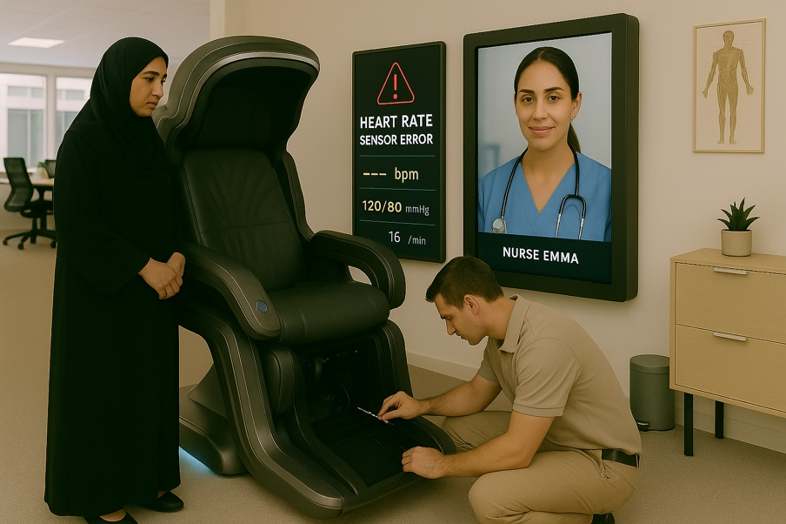Final: I only need one technician to be working on the chair, and the one that is down is okay. So you can take out the one that is sitting on the chair. Let the name of the nurse also be Emma

Challenge: Technical Malfunctions or Sensor Inaccuracies

The reliance on biometric sensors and AI algorithms introduces the risk of technical failures or misreadings. Inaccuracy in vital signs due to calibration drift, environmental interference, or user error can compromise the quality of triage and potentially delay appropriate care (Bhutani et al., 2025). Moreover, a lack of regular maintenance can increase system downtime, further straining healthcare access in already underserved regions. Ensuring system reliability requires investment in ongoing technical support and quality assurance protocols (Maramba et al., 2022).

1. 1st prompt: An image of an older woman stands in front of the pod, unsure and confused, holding a paper referral. A staff member gently explains how to use the system.

Final: Remove the screen showing the vitals Let the woman be carrying a bag

Challenge: Patient Trust and Digital Literacy Concerns

While the VitalLink Pod is designed to be user-friendly, not all patients possess the digital literacy required to navigate even simplified systems. Older adults, those with cognitive impairments, or patients unfamiliar with technology may feel intimidated by automated health services (Niu, Hong, & Ma, 2024). Moreover, privacy concerns, particularly in public or semi-public kiosk settings, can hinder adoption. Studies have shown that patients are more likely to engage with telehealth tools when they trust the technology and perceive it as secure and respectful of their privacy (U.S. Department of Health & Human Services [HHS], n.d.; Squires, 2018).

1. 1st prompt: Hospital administrators sit around a boardroom table reviewing a chart titled ‘VitalLink Pod Budget Breakdown.’ One person has a concerned expression, pointing to the high installation cost.

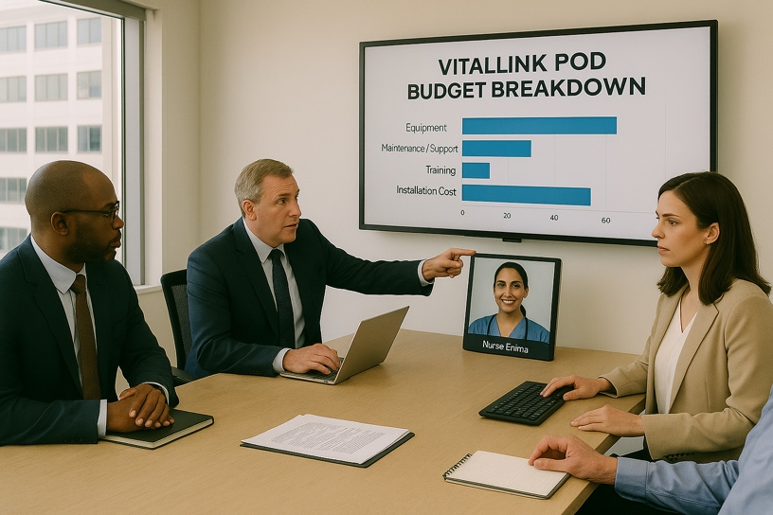Final: let the woman have a keyboard and mouse on her side of the table.

Challenge: Upfront Infrastructure and Implementation Costs

A major barrier to implementing the VitalLink Pod at scale is the significant initial investment required for hardware procurement, customization, software development, and system integration. Financial constraints are particularly acute in underfunded regions or rural communities (Global Growth Insights, 2024). The cost of deploying healthcare kiosks has been cited as a deterrent in multiple health system reviews, with some estimates indicating up to 30% higher costs compared to traditional check-in systems due to infrastructure needs and staff training requirements (Maramba et al., 2022).

**Narration**

It is 7:30 on a chilly Thursday morning when Mariam notices that her four-year-old son, Noah, has barely touched his breakfast. His breathing sounds heavier than usual, and his cough, which began yesterday, has gotten worse. As a recent immigrant to Canada without a family doctor and with limited experience navigating the healthcare system, Mariam feels stuck. The emergency department would take hours, and the last walk-in clinic she tried had already closed its queue by 9:00 a.m. Then she remembers the VitalLink Pod she saw last weekend beside the community grocery store. She quickly bundles Noah in a jacket, grabs his BC Services Card, and heads out.

The pod stands quietly, sleek and welcoming, at the edge of the plaza. As Mariam approaches, the automatic doors slide open, and a soft chime plays. Inside, a tall screen lights up immediately with the message: “Welcome. Please select your preferred language.”

Mariam taps English, and the interface transitions. A soft, friendly voice begins to guide her: “Thank you. We will now begin the check-in process. Please scan your health card to continue.”

She holds Noah’s BC Services Card against the scanner. The system accepts it with a quiet beep and displays the next prompt: “Who is here to be seen today?” Mariam selects “A child”, and the system asks Noah’s age: 4.

As soon as the age is entered, the screen interface becomes more animated, with cheerful music and simple, colorful icons. The voice now addresses the patient more directly: “Hi Noah! You’re in the right place. Let’s take care of you. You have now been assigned Number A103. Please follow your guide to the waiting area.”

A small robot assistant rolls forward from the inner door. On its chest screen, it displays the name: “Tiko – Your Care Guide” Tiko gives a gentle nod and says, “Welcome to VitalLink Noah. I’ll take you to the waiting area now. When your room is ready, I’ll come get you.”

Tiko leads them to a family-friendly waiting area with cushioned benches, children’s books, and pastel wall decals of stars and animals. A screen nearby displays current appointments. After a few minutes, the screen lights up: “Now Serving A103”

Tiko returns and says: “Room 2 is ready. I’ll take you there now.” Mariam and Noah follow him through a softly lit hallway to a door marked “Pediatric Room 2.”

Inside, a smart pediatric chair reshapes to Noah’s size as he climbs in. The screen animates a friendly cartoon heart, and the voice says: “Hi Noah! You’ve been so brave. Let’s do a few quick checks to see how you’re feeling.”

With Mariam’s help, Noah places his finger on a scanner. Contactless sensors in the walls and chair measure his temperature, heart rate, oxygen saturation, and respiratory rate. Cheerful visuals pop up on screen, making the process easy to follow. The system then displays a few simple symptom questions like “Has he had a fever?,” which Mariam answers.

A message appears: “We’re now connecting you with a nurse.”

Within seconds, a video call screen appears with Nurse Emma, who smiles warmly. Her name appears clearly in the top-left corner. “Hi there, Noah. Hi Mariam. Thanks for coming in.”

Nurse Emma goes over Noah’s vitals and listens carefully to Mariam’s concerns. She reassures her that Noah’s symptoms suggest a mild respiratory infection that can be managed at home. “I’ll also send a referral to a pediatric clinic just in case you need further follow-up.”

Before the call ends, she explains: “Tiko will guide you now to the discharge booth. There, you’ll meet Nurse Anya. She’ll give you a printout of today’s visit and your referral slip. Also, someone from our team will give you a quick call next week to check on how Noah is doing.”

After the session, they step out of the room and Tiko reappears: “Let’s head to the discharge booth together!”

They follow him again through the hallway to a transparent booth near the pod exit. Inside, a friendly human nurse sits behind a small desk. Her badge reads: “Nurse Anya.” She smiles, greets them, and gently passes Mariam a printed summary of the visit, including home care instructions, prescriptions, and the referral.

“You did everything right today,” she says kindly. “Here’s a sticker for Noah, he was amazing.” She hands Noah a VitalLink cartoon sticker featuring Tiko holding a stethoscope.

Mariam thanks her sincerely and steps outside with Noah. It’s barely been twenty minutes. She feels calm, informed, and respected. No confusion, no frustration, no delay, just a caring process that responded to her and her son’s needs, from language to guidance to human follow-up.

The VitalLink Pod gave her a new sense of trust, in technology, in care, and in herself.

**References**

Bhutani, S., Alian, A., Fletcher, R. R., Bomberg, H., Eichenberger, U., Menon, C., … Elgendi, M. (2025). Vital signs-based healthcare kiosks for screening chronic and infectious diseases: A systematic review. *Communications Medicine, 5*, Article 28. <https://doi.org/10.1038/s43856-025-00228-x>

Clove, D. (2023). Healthcare access disparities among rural populations in the United States. *Ballard Brief, 2023*(1). <https://scholarsarchive.byu.edu/ballardbrief/vol2023/iss1/5>

Global Growth Insights. (2024). *Healthcare kiosk market size, share & outlook to 2033.* <https://www.globalgrowthinsights.com/market-reports/healthcare-kiosk-market-107746>

Institute for Healthcare Improvement. (2022, June 23). *Telemedicine and the challenge of diagnostic accuracy.* <https://www.ihi.org/insights/telemedicine-and-challenge-diagnostic-accuracy>

LanguageLine Solutions. (2020, June 12). *Kiosk program provides limited English speakers with virtual care*. <https://www.languageline.com/blog/case-study-virtual-care-kiosk-program-with-anthem-blue-cross>

Maramba, I. D., Smith, M. D., Parimbelli, E., et al. (2022). The role of health kiosks: Scoping review. *JMIR Medical Informatics, 10*(6), e38262. <https://doi.org/10.2196/38262>

Niu, S., Hong, W., & Ma, Y. (2024). How expectations and trust in telemedicine contribute to older adults’ sense of control. *Healthcare (Basel), 12*(17), 1685. <https://doi.org/10.3390/healthcare12171685>

Squires, A. (2018). Strategies for overcoming language barriers in healthcare. *Nursing Management (Springhouse), 49*(4), 20–27. <https://doi.org/10.1097/01.NUMA.0000531166.24481.15>

U.S. Department of Health & Human Services. (n.d.). *Telehealth privacy and security tips for patients.* <https://www.hhs.gov/hipaa/for-professionals/privacy/guidance/telehealth-privacy-security/index.html>

World Health Organization. (2022). *Global report on health equity for persons with disabilities. World Health Organization.* <https://www.who.int/publications/i/item/9789240063600>

World Health Organization. (2023). *Universal health coverage (UHC).* <https://www.who.int/news-room/fact-sheets/detail/universal-health-coverage-(uhc)>