Part B: Presentation on Technology Driven Healthcare Solutions: NurseLens

Shubhneet Grewal
Student ID: T00752718
Thompson Rivers University
HLTH 5500: Integrating Information Technology in Healthcare
Dr. Anila Virani
June 11, 2025

Population Change
In Part A of the Technology-Driven Healthcare Solutions assignment, NurseLens was primarily designed for frontline nurses and critical care staff, enabling them to use headsets to access real-time data, vital signs, medication orders, and clinical decision support tools. These technologies enhance workflow efficiency, reduce cognitive load, and provide simulation training for high-risk tasks such as sepsis management and ventilator titration, making them especially valuable in Intensive Care Units, Emergency Departments, Medical-Surgical, step-down units, and telemetry settings (Saab et al., 2021). Nursing students and new graduates can also benefit from NurseLens through simulation-based training, procedural walkthroughs, and immersive learning environments that build confidence and critical thinking before entering high-pressure clinical roles (Saab et al., 2021). These tools are ideal for academic nursing programs, clinical practicums, and hospital onboarding processes. Additionally, NurseLens can support interdisciplinary care teams by enabling collaborative handoffs, shared visualization of patient data, and improved communication among nurses, physicians, pharmacists, and allied health professionals, particularly during rounds, rapid response, and multidisciplinary meetings. Lastly, hospital administrators and nurse educators can leverage NurseLens to standardize training, assess competencies, and reduce dependence on physical simulation labs, offering a scalable and cost-effective solution for staff education and quality improvement across healthcare systems.
In Part B of the presentation on Technology-Driven Healthcare Solutions, NurseLens will be reimagined to support patients, family caregivers, and community-based healthcare providers, extending its impact beyond the hospital setting. For patients, NurseLens can offer immersive tools that enhance understanding of diagnoses, procedures, and self-care routines, reducing anxiety and promoting engagement in their health journey (van der Kruk et al., 2022). These tools are especially beneficial in preparing patients for complex treatments or managing chronic conditions from home. Family caregivers can benefit from guided simulations and real-time virtual coaching that teach essential tasks such as wound care, medication administration, and mobility assistance while building confidence and reducing the risk of errors (Foronda et al., 2023). In community settings, NurseLens may support public health nurses, home care providers, and rural clinicians by enabling remote training, clinical assessment simulations, and virtual interdisciplinary collaboration. This technology can improve care continuity, empower self-management, and may bridge the gap where in-person services may be limited. As healthcare increasingly shifts toward community-based models, NurseLens can serve as a valuable tool for promoting autonomy, safety, and connectedness outside of traditional hospital walls.
AI-generated pictures
Benefits #1 Prompt: Create an image of augmented and virtual reality technologies showcasing interdisciplinary collaboration, with all healthcare team members wearing matching headsets and smiling as they work together.
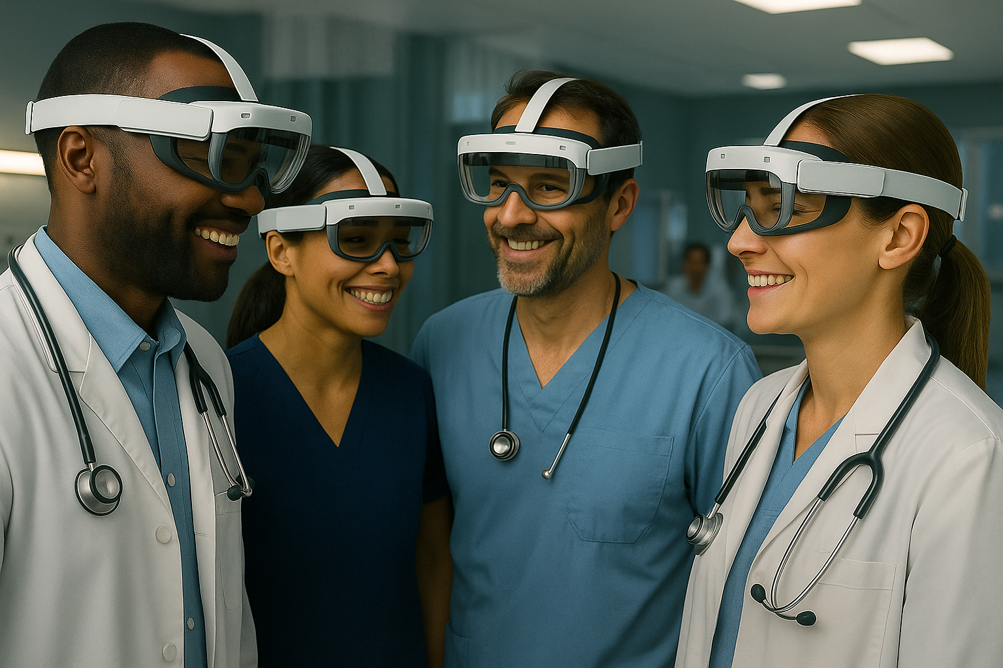
Note. AI-generated image from OpenAI (2025a). Retrieved from ChatGPT.
NurseLens can enhance interdisciplinary collaboration in healthcare. By allowing nurses, physicians, pharmacists, and allied health professionals to access shared virtual interfaces, NurseLens supports better communication, coordinated care planning, and efficient handoffs. When all team members use the same technology, it fosters teamwork, mutual understanding, and a more unified approach to patient care, ultimately improving safety, efficiency, and staff satisfaction (Bai & Fusco, 2011).
Challenges #1 Prompt: Create an image of a nurse who is primarily focused on responding to augmented and virtual reality prompts—such as vital signs, lab values, and physician orders—rather than engaging with the patient. The nurse should appear distracted, with a visibly upset patient in the background to highlight the emotional disconnect.
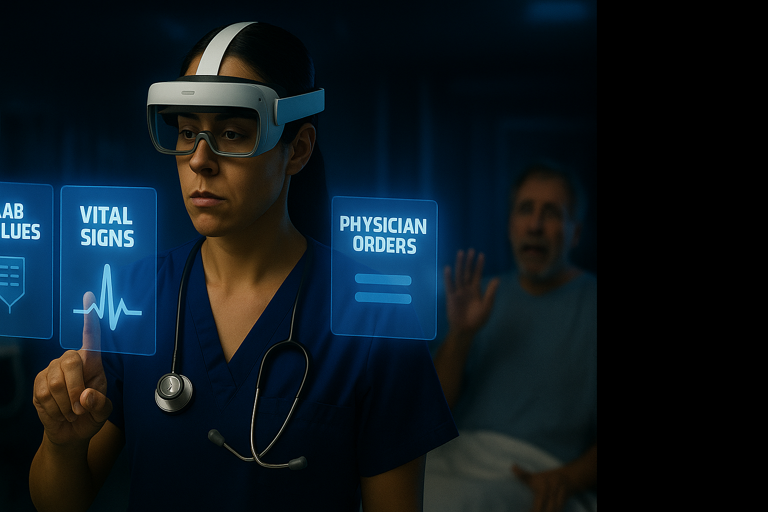
Note. AI-generated image from OpenAI (2025b). Retrieved from ChatGPT.
One key risk of over-relying on NurseLens in clinical care is the potential erosion of human connection between nurses and patients. When nurses become overly focused on digital prompts such as lab values, vital signs, and physician orders, they may unintentionally overlook the emotional and relational needs of their patients. This distraction can lead to reduced empathy, missed cues, and a patient experience that feels impersonal or isolating, especially in moments when compassion and presence matter most.
Challenges #2 Prompt: Use the patient in the background from the image above to create a scene showing an upset individual who feels neglected due to the increasing reliance on augmented and virtual reality technologies. The patient longs for the nurse’s presence, attention, and empathetic care, which now feels diminished.
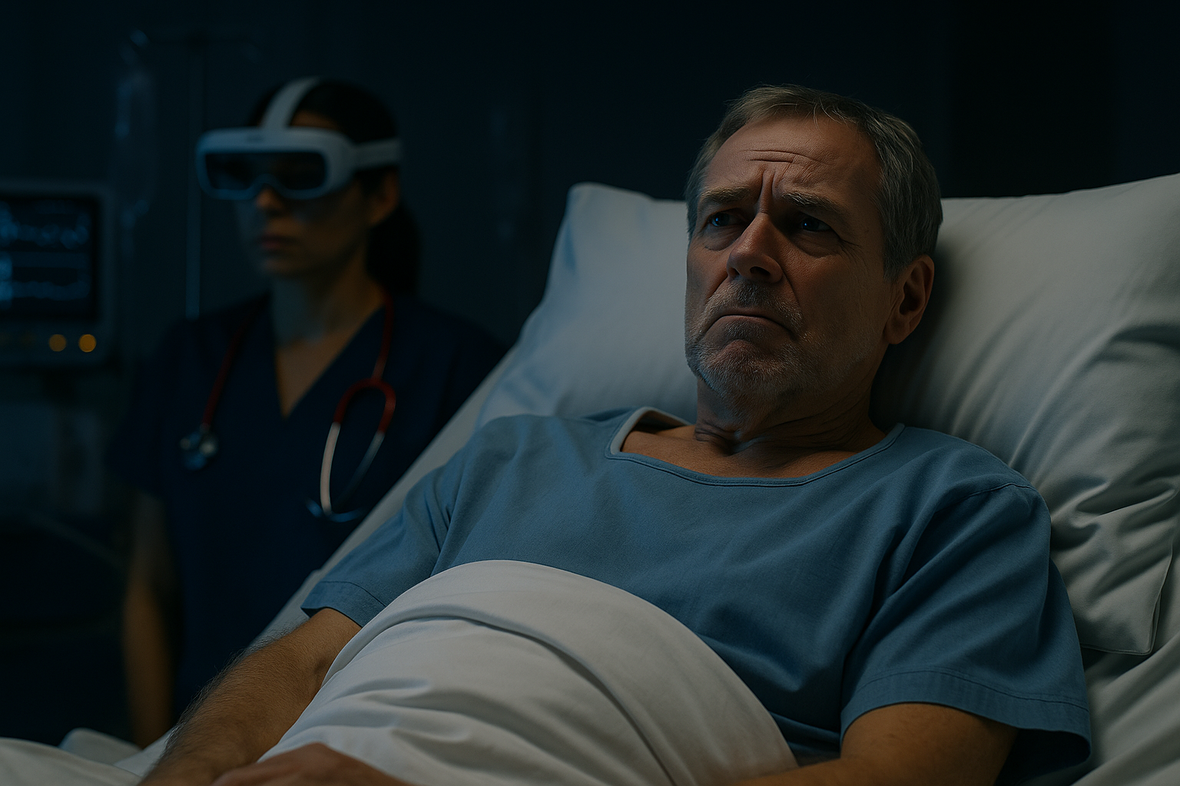
Note. AI-generated image from OpenAI (2025c). Retrieved from ChatGPT.
This challenge highlights the loss of human touch in care as NurseLens become more prominent. The image of the visibly upset patient represents those who feel overlooked or emotionally disconnected when nurses are absorbed by digital tools. While NurseLens can enhance clinical efficiency, it can also unintentionally distance nurses from the bedside, reducing opportunities for eye contact, emotional support, and compassionate presence. The patient’s expression reflects a longing for the empathy and attentiveness that once defined the nurse-patient relationship.
Benefits #2 Prompt: Create an image of augmented and virtual reality technologies supporting nurses’ well-being through guided relaxation, mindfulness, or exposure therapy after stressful shifts or traumatic events. Depict the nurse in a calm and relaxed state to reflect the therapeutic effect.
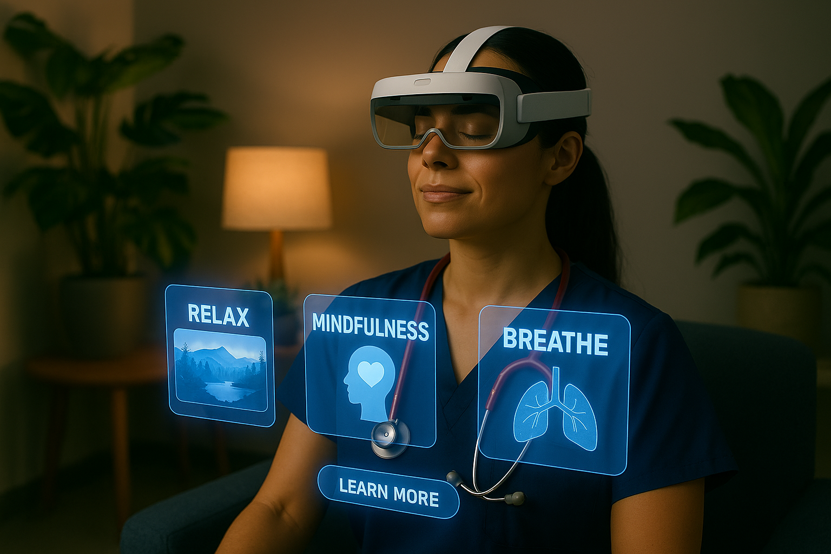
Note. AI-generated image from OpenAI (2025d). Retrieved from ChatGPT.
NurseLens can support nurses’ mental health and emotional resilience. By offering guided relaxation, mindfulness exercises, or exposure therapy, these tools help nurses decompress after stressful shifts or traumatic events. The immersive environments, such as calming nature scenes or breathing prompts, promote rest, reduce anxiety, and combat burnout, allowing nurses to reset and return to patient care with greater focus and emotional balance.
Prompt: Create an image of augmented and virtual reality technologies enabling critical care nurses to practice complex, high-risk scenarios such as code blues, ventilator management, sepsis protocols, and titration of vasoactive drips within a safe and immersive simulation environment.
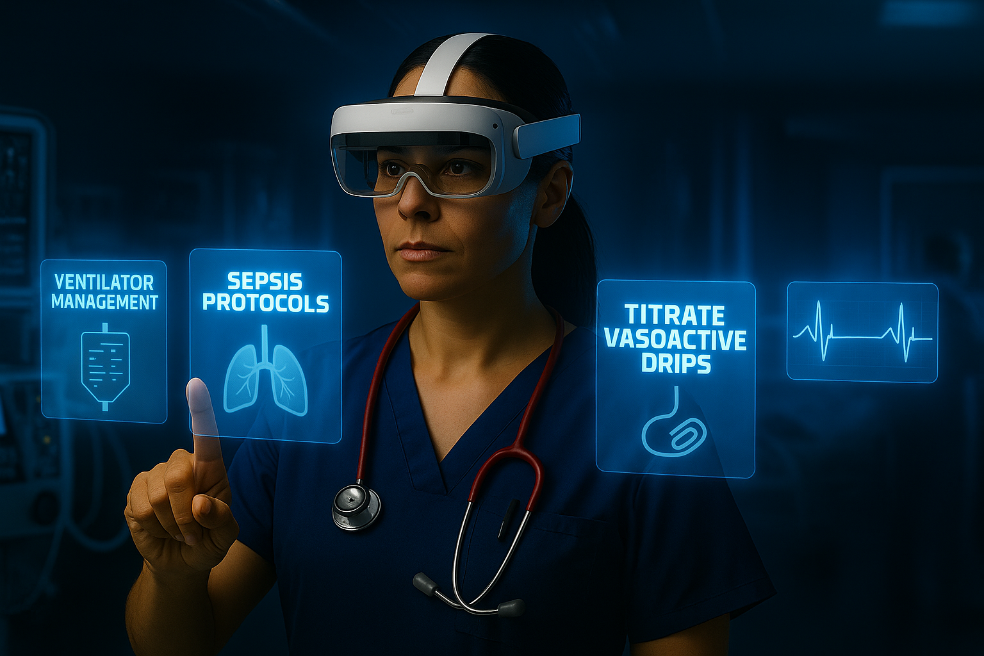
Note. AI-generated image from OpenAI (2025e). Retrieved from ChatGPT.
Google Search Update
In Part A of the Technology-Driven Healthcare Solutions assignment after conducting a comprehensive search, there was no evidence of an existing system named "NurseLens" or any fully integrated AR solution with comparable functionality currently implemented in clinical nursing practice, particularly within British Columbia, Canada. The search process included the use of various search engines and academic databases, employing keywords such as "NurseLens augmented reality nursing assistant," "AR nursing assistant smart glasses," and "augmented reality nursing assistant British Columbia." In addition, I reviewed academic journals, healthcare technology publications, and industry reports for mentions of similar AR applications in nursing. Institutional research was also conducted, focusing on British Columbia based organizations such as the University of British Columbia and the British Columbia Institute of Technology, to examine whether AR technology was being used in clinical settings. While these institutions are exploring AR and virtual reality technologies, their efforts are primarily focused on education and training, such as nursing simulations, rather than point-of-care clinical tools. No current initiatives reflect a fully integrated AR system supporting bedside nursing practice as envisioned by NurseLens. Therefore, NurseLens is an original and innovative concept, offering a unique opportunity to pioneer the integration of AR technology into the daily clinical workflow of nurses in British Columbia.
In Part B of the presentation on Technology-Driven Healthcare Solutions, a thorough search was conducted using targeted queries such as “NurseLens AR VR healthcare British Columbia” and broader terms like “AR/VR support patients caregivers community healthcare BC,” “VR caregiver training British Columbia,” and “AR/VR rural home care BC.” The findings revealed several promising initiatives across the province. The University of British Columbia (UBC) and other local institutions are using virtual reality for pain management and dementia care in long-term and home-based settings. Additionally, Island Health’s Community Virtual Care program provides virtual support for chronic disease monitoring and caregiver counseling, although it does not utilize AR/VR headset technology.
In terms of interdisciplinary collaboration and remote clinical training, British Columbia’s Real-Time Virtual Support network delivers real-time virtual assistance to clinicians in rural, remote, and Indigenous communities during urgent care events. Furthermore, mixed reality tele-ultrasound trials have successfully connected remote healthcare providers with specialists, for example linking Haida Gwaii with UBC, highlighting the potential of augmented reality to enhance diagnostic support. However, despite these developments, no platform under the name “NurseLens” or a comparable, fully integrated AR/VR solution that supports patients, family caregivers, and community-based healthcare providers holistically was found. The UBC AR/VR Health Applications site confirms broad exploration of immersive technologies in healthcare but does not showcase a unified tool like NurseLens. In conclusion, while British Columbia is advancing in the use of AR/VR for specific healthcare applications, there is currently no comprehensive solution like NurseLens implemented in the province. This underscores its novelty and potential as an innovative, untapped opportunity to bridge the gap between hospital care and community-based support using immersive technology.
Narration
Maria had been caring for her father, John, since his Alzheimer’s diagnosis two years ago. At first, the tasks were simple, such as reminding him to eat and offering a little help with getting dressed. But as his condition progressed, so did Maria’s exhaustion. She often felt unprepared, especially during the nighttime episodes when John would become disoriented or aggressive. Her confidence as a caregiver was fading. That changed when her local health center introduced her to NurseLens, a new virtual reality program designed specifically for family caregivers. With a lightweight headset and simple instructions, Maria entered immersive scenarios that taught her how to gently reorient someone experiencing confusion, how to safely assist with bathing, and even how to apply basic wound care. The simulations were realistic yet safe. She could pause, repeat, and try again without fear of doing harm. One day, John fell and scraped his elbow. Instead of panicking, Maria calmly followed the steps she had practiced on NurseLens. Clean, dress, comfort. John winced, but her hands didn’t shake this time. That night, she used the mindfulness module to calm her own nerves before bed. The technology didn’t replace her care. It empowered it. For the first time in months, Maria didn’t feel alone. She felt capable.

References
Bai, X., & Fusco, D. (2011). Interdisciplinary collaboration through designing 3D simulation case studies. arXiv preprint arXiv:1103.0065. https://doi.org/10.48550/arXiv.1103.0065
Foronda, Cynthia PhD, RN, CNE, CHSE, ANEF, FAAN; Lee, Jiye MSN, CPNP-AC; Santiesteban, Zaily MSN, APRN, AGPCNP-BC. Use of Virtual Reality in Family Caregiver Education: A Literature Review. CIN: Computers, Informatics, Nursing 41(3):p 125-127, March 2023. | DOI: 10.1097/CIN.0000000000001004
OpenAI. (2025a). A group of interdisciplinary healthcare professionals wearing AR headsets, collaborating in a hospital setting [AI-generated image]. ChatGPT. https://chat.openai.com/
OpenAI. (2025b). A nurse using AR/VR technology to access lab values, vital signs, and physician orders, while a visibly upset patient is in the background [AI-generated image]. ChatGPT. https://chat.openai.com/
OpenAI. (2025c). A nurse using augmented and virtual reality technologies to support patient care, with an upset patient in the background reflecting loss of empathetic interaction [AI-generated image]. ChatGPT. https://chat.openai.com/
OpenAI. (2025d). A nurse using augmented reality for guided relaxation, mindfulness, and breathing exercises following a stressful shift [AI-generated image]. ChatGPT. https://chat.openai.com/
OpenAI. (2025e). A nurse using augmented reality to simulate critical care procedures including ventilator management, sepsis protocols, and titration of vasoactive drips [AI-generated image]. ChatGPT. https://chat.openai.com/
Saab, M. M., Hegarty, J., Murphy, D., & Landers, M. (2021). Incorporating virtual reality in nurse education: a qualitative study of nursing students' perspectives. Nurse Education Today, 105, 105045. https://doi.org/10.1016/j.nedt.2021.105045
van der Kruk, S. R., Zielinski, R., MacDougall, H., Hughes-Barton, D., & Gunn, K. M. (2022). Virtual reality as a patient education tool in healthcare: A scoping review. Patient Education and Counseling, 105(7), 1928-1942. https://doi.org/10.1016/j.pec.2022.02.005
Wister, A., Pauly, T., & Hoppmann, C. (2022). Virtual reality in long-term care: The VR Immersive Program (VIP) for individuals living with dementia. University of British Columbia, IDEA Lab. https://idealab.sites.olt.ubc.ca/research/vr-immersive-program-vip/

