QuickScan: The Handheld Diagnostic Tool

Jamie Steele
T00745105
Thompson Rivers University
HLTH 5500 Integrating IT in Healthcare
Dr Anila Virani
June 13th, 2025

QuickScan: The Handheld Diagnostic Tool
QuickScan is a versatile diagnostic device suitable for individuals across all age groups. Initially, it was used in a pediatric population (ages 3 to 10) to identify signs of infection in skin injuries and recommend home-based treatment options, thereby reducing unnecessary emergency room visits. However, its application can be extended to other populations, such as adults with chronic conditions. This group is at greater risk for complications and typically requires more frequent healthcare access than those without chronic illnesses (Polanco et al., 2025). Addressing these needs in the comfort of patients' homes presents an opportunity for improved healthcare delivery. This report discusses the shift in target population, highlighting the new benefits and challenges associated with using QuickScan in adults with chronic conditions.
Population Change
Adults aged 45 to 75 are among the highest at risk for developing chronic conditions that place increasing demands on the healthcare system (Geda et al., 2021). Common conditions within this age group include diabetes, hypertension, arthritis, chronic obstructive pulmonary disease (COPD), and asthma, among others (Andreacchi et al., 2025). These conditions are often the result of age-related physiological changes, compounded by sociodemographic and lifestyle factors such as reduced physical activity, smoking, alcohol consumption, and elevated body mass index (BMI) (Geda et al., 2021).
Multimorbidity, the presence of two or more chronic conditions, is also prevalent in this population. Geda et al. (2021) report that 33% of the study population experienced multimorbidity, highlighting the significant burden this group places on healthcare resources. Additional factors such as lower income and living in rural versus urban areas further impact access to care (Andreacchi et al., 2025). Many of these individuals may lack consistent access to primary care and instead rely on emergency room services for the management of chronic conditions. Chronic conditions also increase the risk of infection and delay wound healing. According to Polanco et al. (2025), individuals with chronic conditions have an average of four or more additional emergency room visits per year. This not only strains the healthcare system but also adds significant financial cost.
QuickScan offers a valuable solution for this population. For the purpose of this report, the focus will be on diabetes as the primary chronic condition. QuickScan’s ability to diagnose skin injuries and provide treatment recommendations from home can help reduce unnecessary emergency room visits. The device also supports telehealth consultations, which are especially beneficial for patients in rural areas. By enabling real-time wound assessment and remote infection management, QuickScan has the potential to improve outcomes while reducing strain on the healthcare system
New Benefits
Chronic conditions and multimorbidity often require patients to see multiple healthcare providers. QuickScan supports continuity of care by providing a centralized platform where information can be shared across providers. For example, it can be used not only to monitor a diabetic patient’s foot ulcer but also to track blood sugar levels, diet, and exercise—ensuring healthcare providers have a comprehensive view of the patient’s health. In cases where a different provider is covering for the primary care provider, they can access the QuickScan interface to review the patient’s progress and any notes left by others. This promotes continuity and enhances clinical decision-making.
Transportation to and from appointments can be a significant barrier for this population, particularly as age or disability may limit their ability to drive. Patients may depend on family members for transportation but hesitate to ask for frequent trips to healthcare facilities. QuickScan allows for remote symptom tracking, wound assessment, and follow-up care from home, reducing the need for in-person visits. As mentioned in Part A, this is especially beneficial in rural areas where clinics may be hours away.
New Challenges
As with most modern technologies, there may be initial hesitation to adopt QuickScan until users become comfortable with its capabilities and understand how its features can benefit patients. Another challenge is the integration of QuickScan into the existing healthcare system, which may require adjustments and training for clinicians and telehealth coordinators. As emphasized throughout this course, proper implementation is crucial to gaining buy-in and ensuring successful adoption by all users.
A further concern is the cost associated with the device, not only the initial purchase but also ongoing maintenance, software updates, and potential replacement of worn components. While insurance reimbursement may eventually offset some of these expenses, the process might be lengthy. For low-income individuals or those with limited resources, who might benefit the most from QuickScan, the upfront cost could pose a significant barrier.
Updated Google Search
A Google search was completed with the following search terms:
‘Scan device for assessment of diabetic wounds in Canada’
‘Is there a scanning device for diabetic wounds in Canada?’
‘Adult wound scanner British Columbia’
‘Is there a wound scanner for adults in British Columbia?’
One of the tools that came up during the Google search was the Inlow’s Foot Screen Tool from Diabetes Healthy Feet (2017–2025). Although it is not an electronic device, it provides a 60-second, in-depth assessment of a diabetic foot that leads into a diabetic wound care pathway. A particularly relevant point it emphasizes is that regardless of the tool being used, “it is only as effective as the clinician using it” (Diabetes Healthy Feet, 2017–2025, para. 1).
During the second Google search, an interesting article came up about St. Michael’s Hospital in Toronto, which is receiving funding for a device called MIMOSA. This tool appears to be very similar to QuickScan. It is described as a portable, compact device capable of non-invasively assessing tissue and uploading images to a secure web portal, where they can be accessed by any healthcare professional (MIMOSA Diagnostics, 2025).
AI Generated Images
The following AI generated images were created using Microsoft Co-Pilot. Please see the included prompts following the image as well.

Continuity of Care: Enables All Healthcare Providers to Access and Document Findings for Informed Clinical Decision-Making
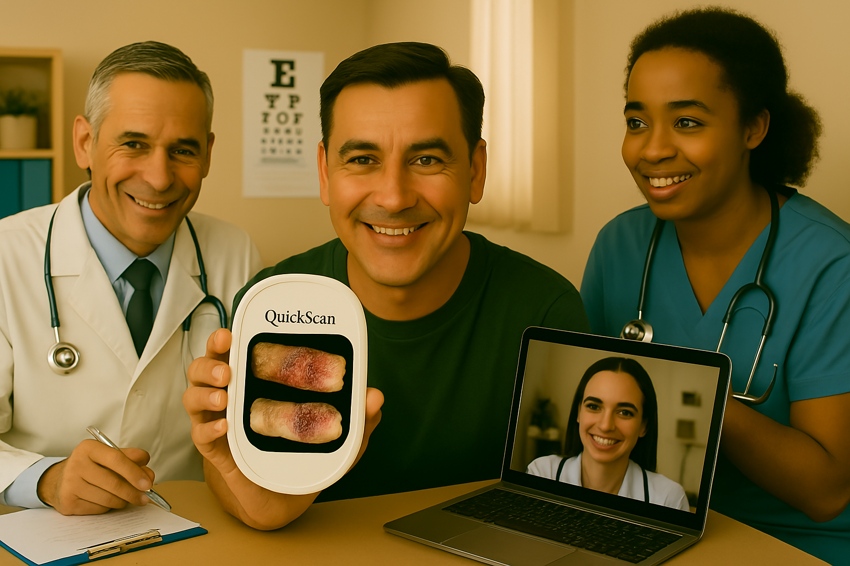
Prompt: A realistic depiction of continuity of care for a consistent middle-aged man with diabetes. Healthcare professionals from various settings—primary care, specialist visits, and telehealth—review the same digital wound data, ensuring seamless integration of treatment plans. The QuickScan screen displays images of diabetic ulcer progression, reinforcing its role in comprehensive care.

QuickScan Benefit: Reduces the Need for Stressful Travel

Prompt: Create an image of the same middle-aged man running after the bus trying to catch it as he needs a ride. He has a frustrated expression on his face and is actively tired from running. Depict a pleasant street and sunny weather.

Challenge: Integration into Existing Healthcare Workflow
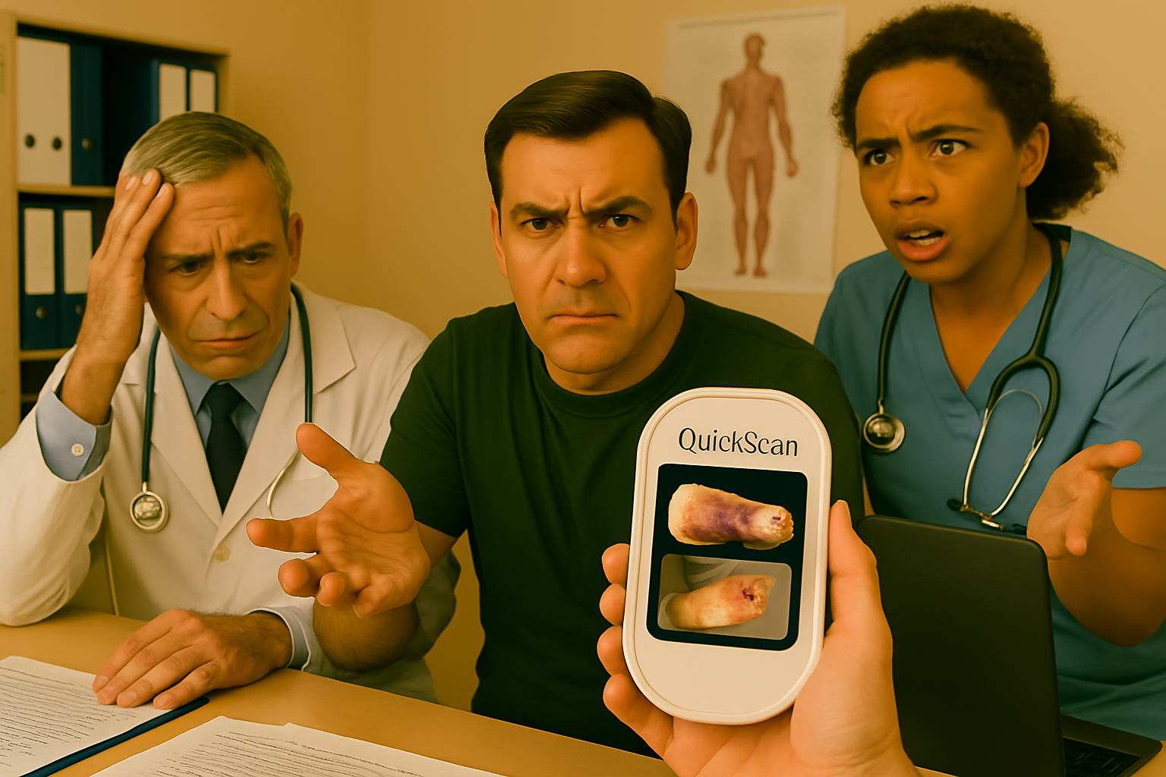

Prompt: A depiction of the challenges in integrating the QuickScan device into the existing healthcare system. The scene includes frustrated healthcare professionals, looking overwhelmed and frustrated. The QuickScan device screen displays two images of diabetic wound ulcers, emphasizing its capability, while background elements show a clinic setting.

The Cost of Implementing and Maintaining the QuickScan Device Poses a Significant Challenge

Prompt: Create an image of the same middle-aged man sitting in a well-lit kitchen at the table. He has papers that appear to be bills and a calculator in front of him, using the calculator. He has a furrowed brow and is concentrating on a bill held in his hand.
QuickScan Allows Patients to Take Control of Wound Care Early by Starting Assessment at Home.
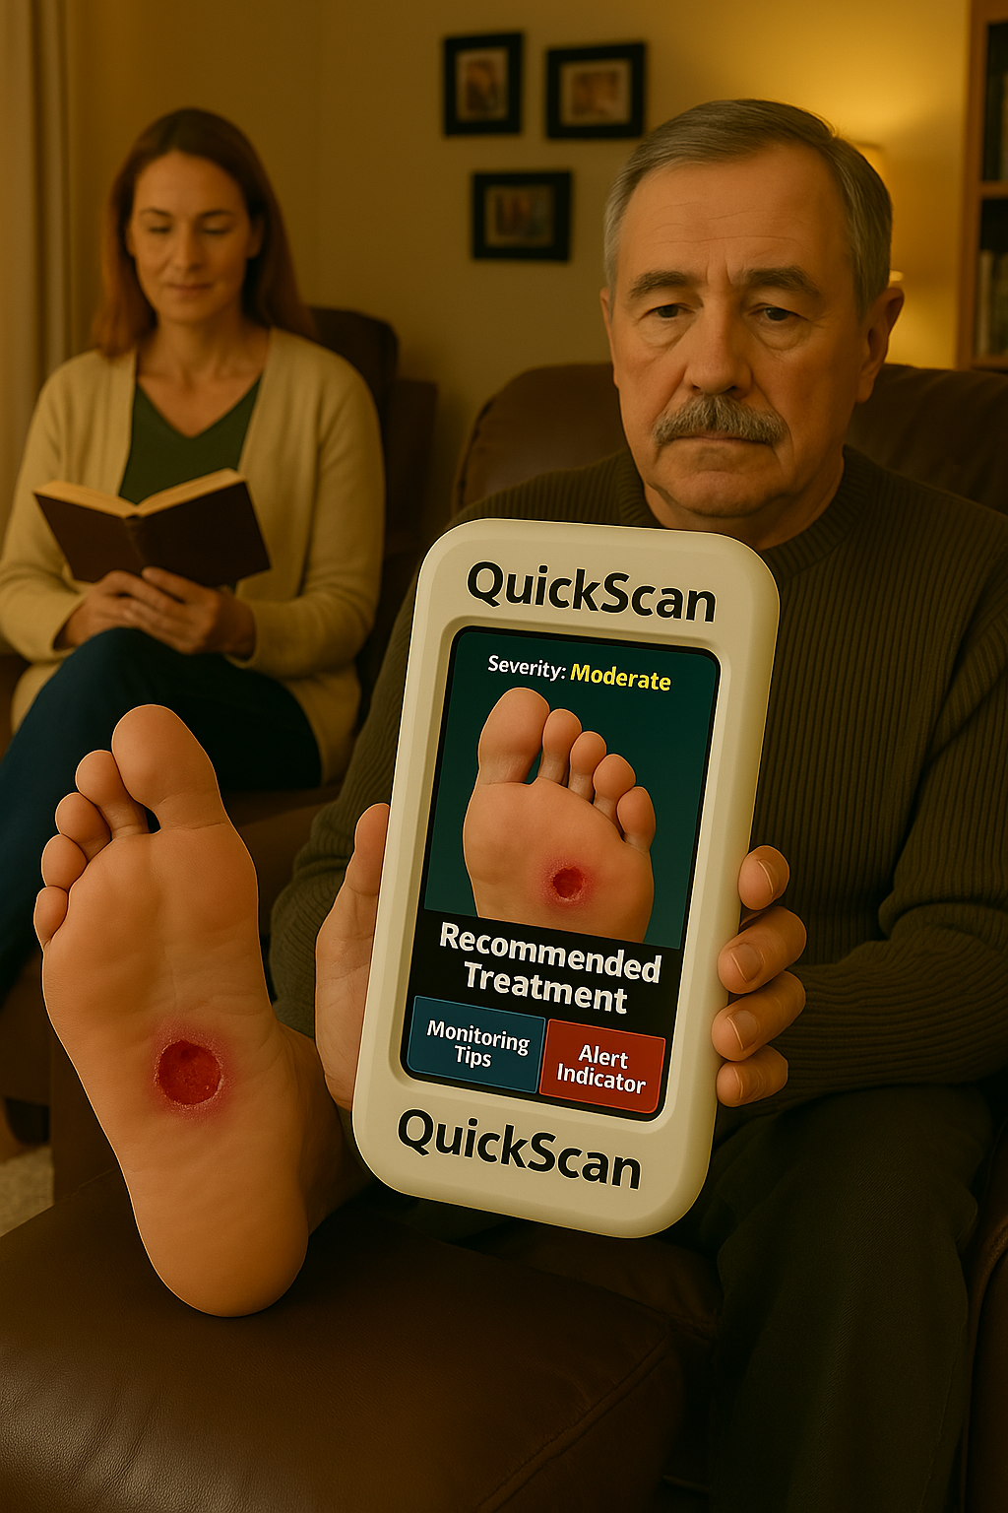
Prompt: A cozy, well-lit living room scene featuring the same middle-aged man, sitting in a soft brown recliner chair. He has his left foot propped up on an ottoman with no sock, revealing a visible diabetic foot ulcer on the sole. He holds a handheld medical device labeled “QuickScan” facing forward toward the viewer, with the screen clearly displaying an identical close-up image of his foot ulcer and labeled buttons: “Recommended Treatment,” “Monitoring Tips,” and “Alert Indicator.” The man appears calm and focused, looking at the screen. His wife sits nearby in a comfortable armchair reading a book.
Narration
David is a middle-aged man living in a rural community in British Columbia. He was recently diagnosed with type II diabetes; a diagnosis made more difficult to accept due to his limited access to healthcare. To see the nearest physician, David must travel nearly 45 minutes by bus to reach a local clinic, an ongoing challenge for managing his chronic condition.
David also struggles with self-care at times, and his wife is constantly worried about him. One day, while working on his truck, David begins to feel a strange sensation in the bottom of his foot. That evening, when he removes his socks before dinner, he and his wife discover the early signs of a diabetic foot ulcer. Concerned, they travel to the clinic, where the physician introduces them to the QuickScan device. The doctor guides them on how to use it and sends them home with the necessary supplies and the device to monitor David’s wound. At their follow-up appointment the following week, David’s foot ulcer shows significant improvement. Although a different physician is now covering the clinic, continuity of care is maintained, thanks to the wound tracking data collected through QuickScan. The new physician can easily assess David’s progress without needing to search through fragmented records. However, the clinic’s outdated system causes challenges when the receptionist tries to upload the physician’s report. Later that evening, David receives a phone call from his insurance provider, followed by a bill the next day outlining the cost breakdown for owning the QuickScan device. He and his wife sit down to rework their budget to accommodate the expense. Despite the cost, they both agree it is a necessary tool, as it has already made a meaningful impact on managing his diabetes.

Conclusion
The QuickScan device is a versatile tool with potential for use across various populations. This report explored its application among adults with chronic conditions, highlighting both additional benefits and challenges. Future recommendations based on feedback could include enhancements to the device’s programming to enable broader capabilities, such as identifying a wider range of skin injuries, poison ingestions, or even concussions resulting from falls. Ultimately, the goal is to reduce emergency room overcrowding by empowering individuals to manage their health at home and make confident, informed decisions for themselves and their families.

References
Andreacchi, A. T., Brini, A., Van den Heuvel, E., Muniz-Terrera, G., Mayhew, A., St John, P., Stirland, L. E., & Griffith, L. E. (2025). An Exploration of Methods to Resolve Inconsistent Self-Reporting of Chronic Conditions and Impact on Multimorbidity in the Canadian Longitudinal Study on Aging. Journal of Aging & Health, 37(1/2), 40–53. https://doi.org/10.1177/08982643231215476
Diabetes Healthy Feet. (2017-2025). Foot scan. Retrieved from: https://www.woundscanada.ca/about-us/19-healthcare-professional/resources-health-care-professionals/25-foot-screen
Geda, N. R., Janzen, B., & Pahwa, P. (2021). Chronic disease multimorbidity among the Canadian population: prevalence and associated lifestyle factors. Archives of Public Health, 79(1), 1–11. https://doi.org/10.1186/s13690-021-00583-7
MIMOSA Diagnostics. (2025). Making the invisible visible. Retrieved from: https://www.mimosadiagnostics.com/
Polanco, B., Oña, A., Gemperli, A., & Barzallo, D. P. (2025). Excess healthcare utilization and costs linked to chronic conditions: a comparative study of nine European countries. European Journal of Public Health, 35(2), 216–227. https://doi.org/10.1093/eurpub/ckaf012

